Mould
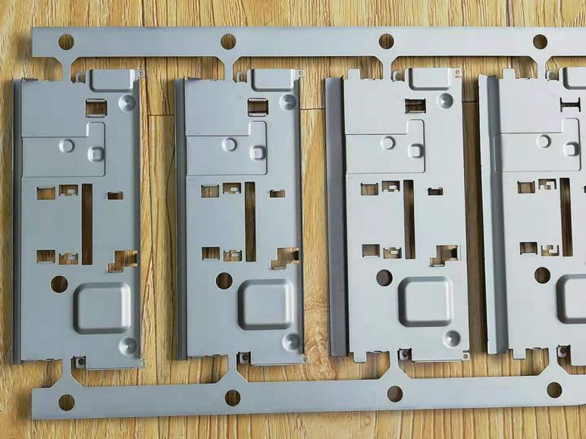

Molds, various molds and tools used in industrial production to obtain the desired product by injection molding, blow molding, extrusion, die casting or forging, smelting, stamping and other methods. In short, a mold is a tool used to make molded articles. This tool is composed of various parts, and different molds are composed of different parts. It mainly realizes the shape processing of the article by changing the physical state of the formed material. Known as the "Mother of Industry" title.
A tool for making a blank into a part with a specific shape and size under the action of external forces. Widely used in punching, die forging, cold heading, extrusion, powder metallurgy parts pressing, pressure casting, and engineering plastics, rubber, ceramics and other products in compression molding or injection molding processing. The mold has a specific contour or cavity shape, and the contour shape with the cutting edge can be used to separate the blank according to the contour line shape (punching). Applying the shape of the inner cavity can obtain the corresponding three-dimensional shape of the blank. The mold generally includes two parts: a movable mold and a fixed mold (or a convex mold and a concave mold), which can be divided and combined. Take out the part when separated, and inject the blank into the mold cavity when closed. The mold is a precision tool with complex shape and bearing the expansion force of the blank. It has high requirements for structural strength, stiffness, surface hardness, surface roughness, and processing accuracy. The development level of mold production is one of the important signs of the level of mechanical manufacturing.
