Machining parts and moulds
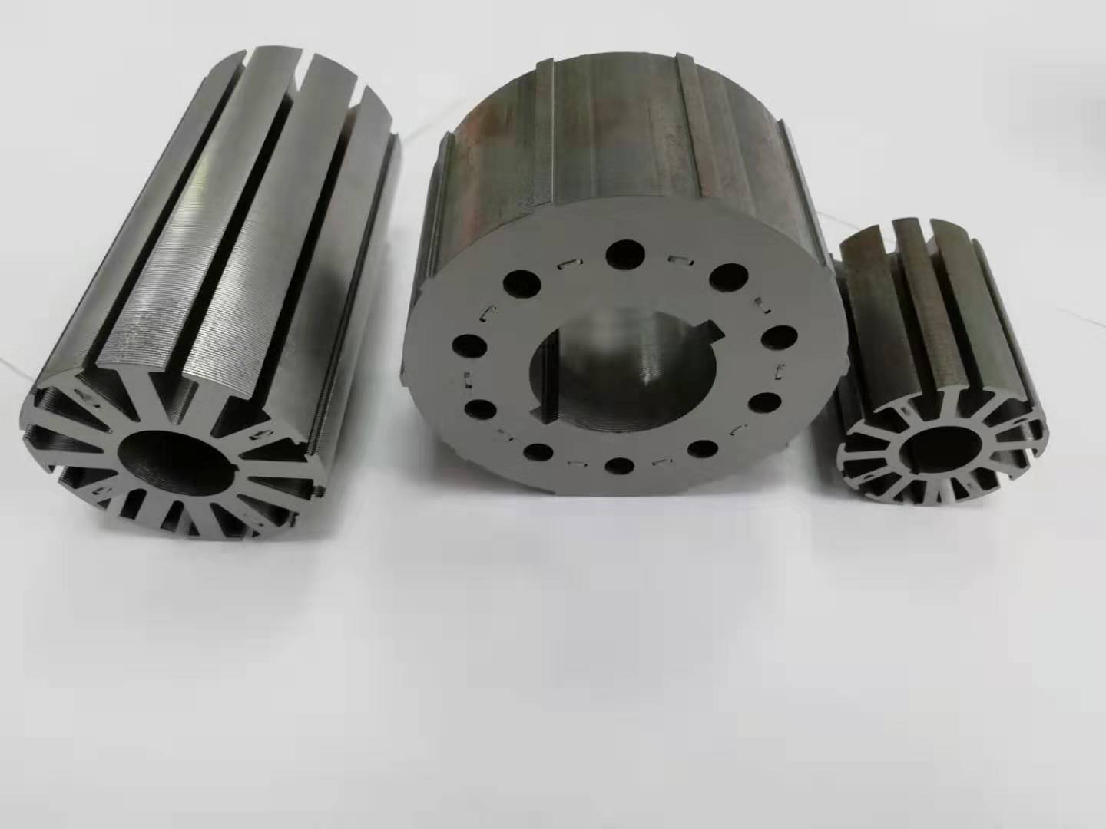
Application scope:
1. All kinds of metal parts processing;
2. Sheet metal, box and metal structure;
3. Titanium alloy, high temperature alloy, nonmetal and other mechanical processing;
4. Design and manufacture of marine combustion chamber;
5. Design and manufacture of non-standard equipment;
6. Mold design and manufacturing.

