Container house
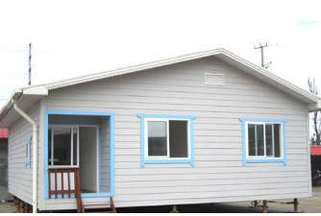

Container mobile house, also called container house, refers to a house with windows and doors, which is mainly made of containers as the basic materials. It can be moved to various places anytime and anywhere, bringing people a more convenient and comfortable life. Solar photovoltaic panels can be used for indoor electricity, solar water heaters can provide heating and water supply, and the discharge of indoor showers and domestic water will be purified by the sewage treatment system for reuse. Depending on the number of personnel, container houses of different sizes can be made. This type of container house is often used as a worker's dormitory on construction sites, and some people use it as a rental house. It is durable and easy to build. Therefore, container houses are also called residential containers.
Container mobile houses have the following uses:
1. The high-end demand for temporary construction products at construction sites, such as the office of the project manager, accommodation, meeting rooms, etc.;
2. Due to site restrictions, the construction site can only install box-type modular housing products;
3. Housing for field operations; such as mobile office and dormitory for field exploration and construction;
4. Emergency rooms; such as: military mobile command center, rescue mobile command center, disaster relief mobile command center, etc.
The container house produced by our company has the following characteristics:
1. Convenient transportation, especially suitable for units that frequently change construction sites.
2. Rugged and durable, all made of steel, with strong shock resistance and deformation resistance.
3. Good sealing performance, strict manufacturing process makes this kind of mobile room have good water tightness.
4. The activity room is environmentally friendly, flexible and reusable.
