Light Steel Villa
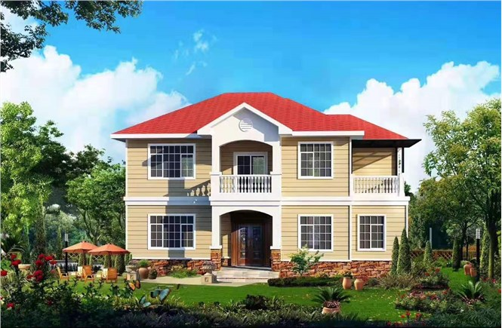

A building assembled from prefabricated parts on the site is called a prefabricated building. Light steel villas are also called light steel structure houses. The main material is light steel keel synthesized by hot-dip galvanized steel strip and cold-rolled technology. The light steel villa has a good seismic effect and can adapt to strong environmental stimuli from the outside world. In addition, compared with traditional reinforced concrete houses, the design, production, and construction of light steel villas tend to be integrated, and the site is wet-free, which is conducive to shortening the cycle and speeding up the circulation of funds. Of course, in addition to these advantages, the light steel villas built by Dalian Guangtong Steel Structure Co., Ltd. have many other advantages. Let's take a look!
1. Good seismic resistance: Due to the light weight of the light steel structure building, the properties of metal materials and the necessary shear wall structure determine the natural seismic performance of the light steel structure system.
2. Fast construction speed: The design, production, and construction of light steel villas tend to be integrated, and the site is mainly dry work, which is conducive to speeding up the construction speed, accelerating the circulation of funds, and conducive to civilized construction.
3. Heat preservation and heat insulation: thick glass fiber cotton is added to the wall of light steel house, which has good sound insulation and heat preservation effect, excellent fire resistance and excellent quality. Now the whole industry is vigorously developing prefabricated buildings.
4. the layout is flexible: the space layout is flexible, which can meet the multi-functional requirements of the residents.
- Environmental protection and energy saving: The steel structure of the light steel villa is an environmentally-friendly and sustainable product, and the materials can be 100% recycled, making it truly green and pollution-free.

