Engineering project

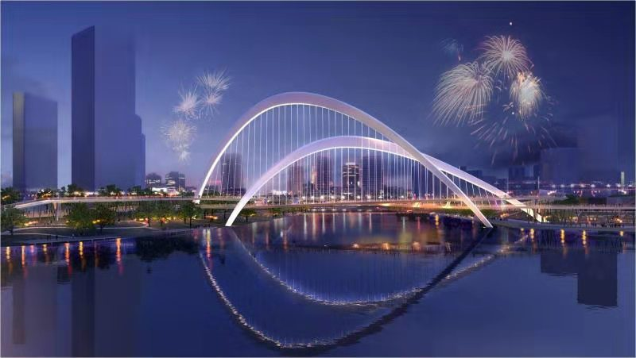
Engineering project is a kind of engineering project with engineering construction as carrier and one-time engineering construction task as management object. It takes buildings or structures as the target output, needs to pay a certain fee according to certain procedures, complete in a certain period of time, and should meet the quality requirements.

The project contracted by Dalian Guangtong Steel Structure Co., Ltd. is as follows:

1.Steel structure billboard: Q235B material, 24m long, 24m wide, 17m high or customized. It can strengthen corporate image, establish brand leadership, and improve public awareness of the company and products. Steel structure billboard can be used for outdoor advertising. It is widely used in schools, hospitals, enterprises, construction sites, markets, business halls, highways and other places.
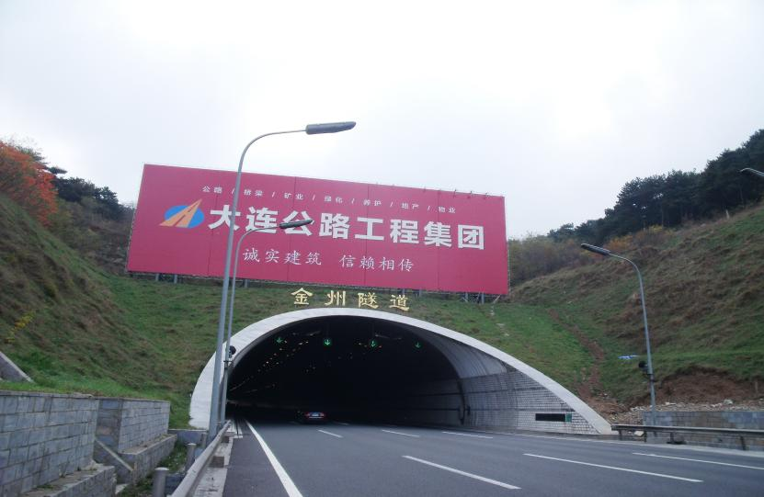

2.Steel structure landscape bridge:Q345qD material, composed of prefabricated metal components, with single and double ears as the connection mode. It is mainly used for all kinds of vehicles crossing obstacles such as rivers and valleys, and can be used to build bridges on dangerous bridges and broken bridges. Moreover, it has beautiful shape, strong spanning ability and good landscape effect.
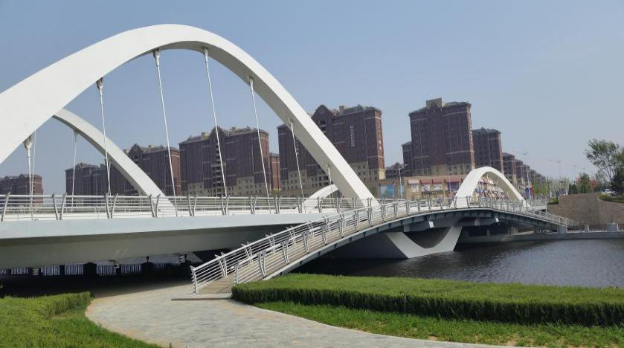

3. Pier Formwork: the formwork is a new concrete model. The formwork system is composed of formwork, supporting members and fasteners. It can be used in railway, pier, dam, wharf, anti-collision wall and other places.
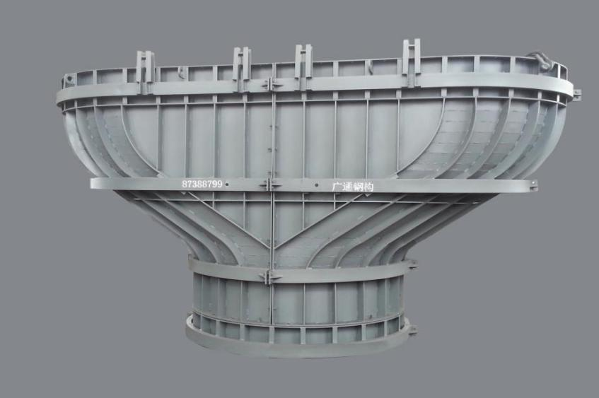

- Equipment platform: Q235B material, composed of steel structure components, used for climbing, standing and walking platform. It is suitable for outdoor operation equipment rack of various chemical industry and special environment.
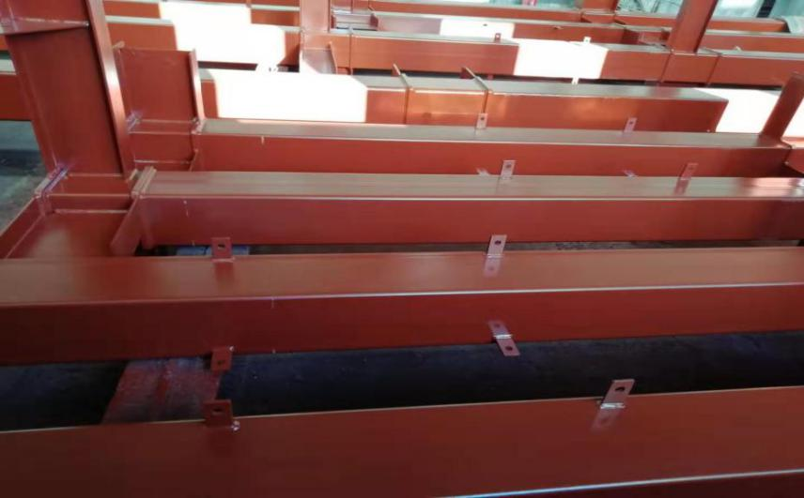

5. Steel structure workshop: Q355B material, steel structure beam and floor bearing plate fabrication and field installation. Steel structure workshop can be used as factory, warehouse, hotel, shop, logistics warehouse, office building, gymnasium, hangar and other places. It is suitable for single story and large span buildings, as well as multi-storey or high-rise buildings.
