Equipment rack

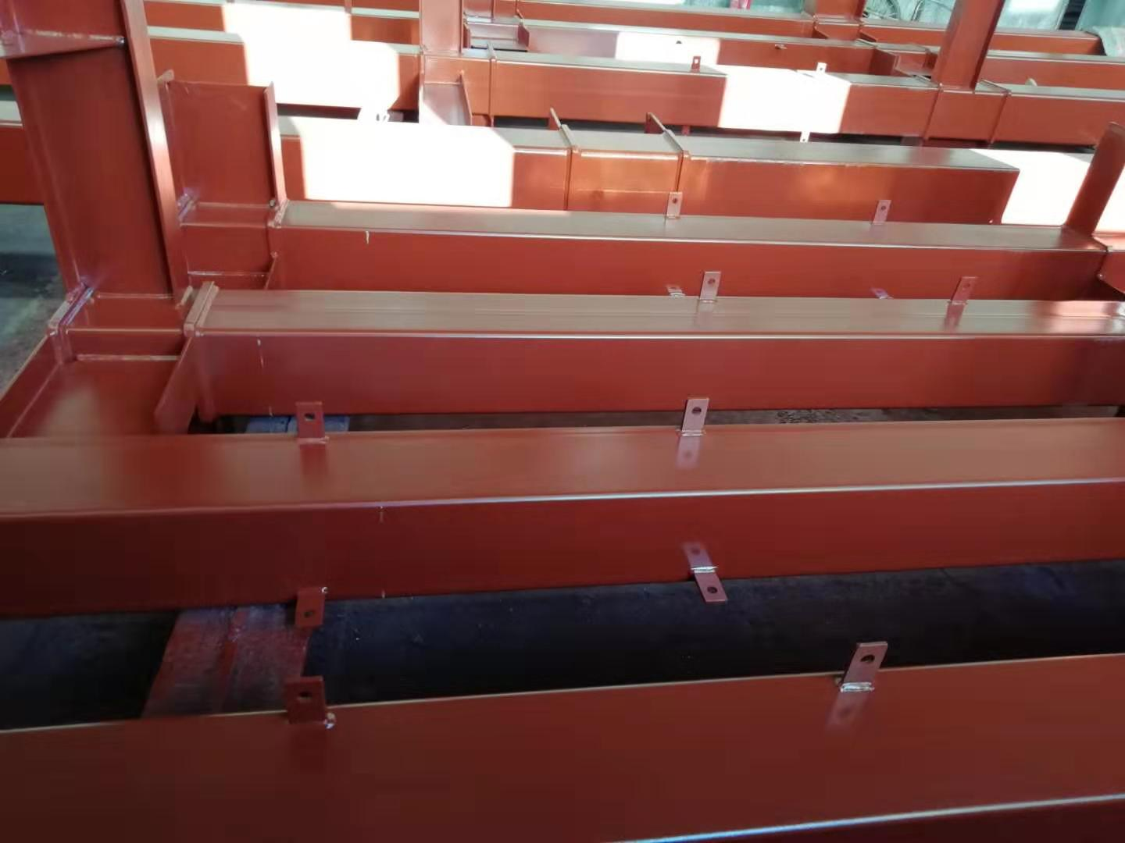

Equipment rack products suitable for indoor and outdoor operations in special environments, including support columns, flat panels, mobile ladders, guardrails, etc.; multiple support columns are supported on the ground together, and a flat panel is installed above the support columns, and the mobile ladder is set on the flat panel Install guardrails on the sides and edges of the plane board.

The steel equipment frame made by Dalian Guangtong Steel Structure Co., Ltd. uses high-quality Q235B material. The specifications can be customized according to customer requirements. The product uses sandblasting, rust removal and Sad3 surface treatment, and the anticorrosion treatment uses paint epoxy resin. Primer, polyurethane topcoat.

The equipment stand has 1. Large space, light weight and small volume. 2. The safety performance is good, the frame is stable, the load-bearing capacity is strong, and the seismic capacity is strong. 3. Clean and environmentally friendly, recyclable. 4. It occupies a small space, convenient troubleshooting, and easy maintenance. It is suitable for automatic batching in rubber, chemical, metallurgy, food, medicine and other industries.
