Prefabricated building
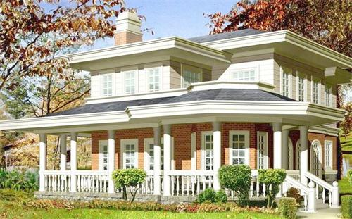

Prefabricated building refers to the transfer of a large number of site work in the traditional construction methods to the factory, where the construction components and accessories (such as floor, wall panels, stairs, balconies, etc.) are processed and manufactured, transported to the construction site, and assembled and installed on site through reliable connection.Compared with traditional residence, prefabricated light steel structure building has outstanding advantages.

The prefabricated light steel structure building is also used as the prefabricated light steel structure housing. Its main material is the light steel keel synthesized by cold rolling technology. After accurate calculation and supporting support and combination, it exerts a reasonable bearing capacity and replaces the traditional housing.

Prefabricated building has the following advantages：
1. Convenient transportation, suitable for frequent change of construction site;
2.rugged, all made of steel, with strong seismic, deformation resistance;
3. Good sealing performance and strict manufacturing technology make the mobile room with good water tightness;
4. mobile housing green environmental protection, save time and effort, flexible;
5. The container room is easy to disassemble and assemble, stable and firm, with good shockproof performance, waterproof, fireproof and anti-corrosion, and light weight.
6. Mobile homes can be used for indoor electricity through solar photovoltaic panels. Solar water heaters can be used for heating and water supply.
7. Container rooms of different sizes can be made according to the number of personnel.

