Engineering equipment
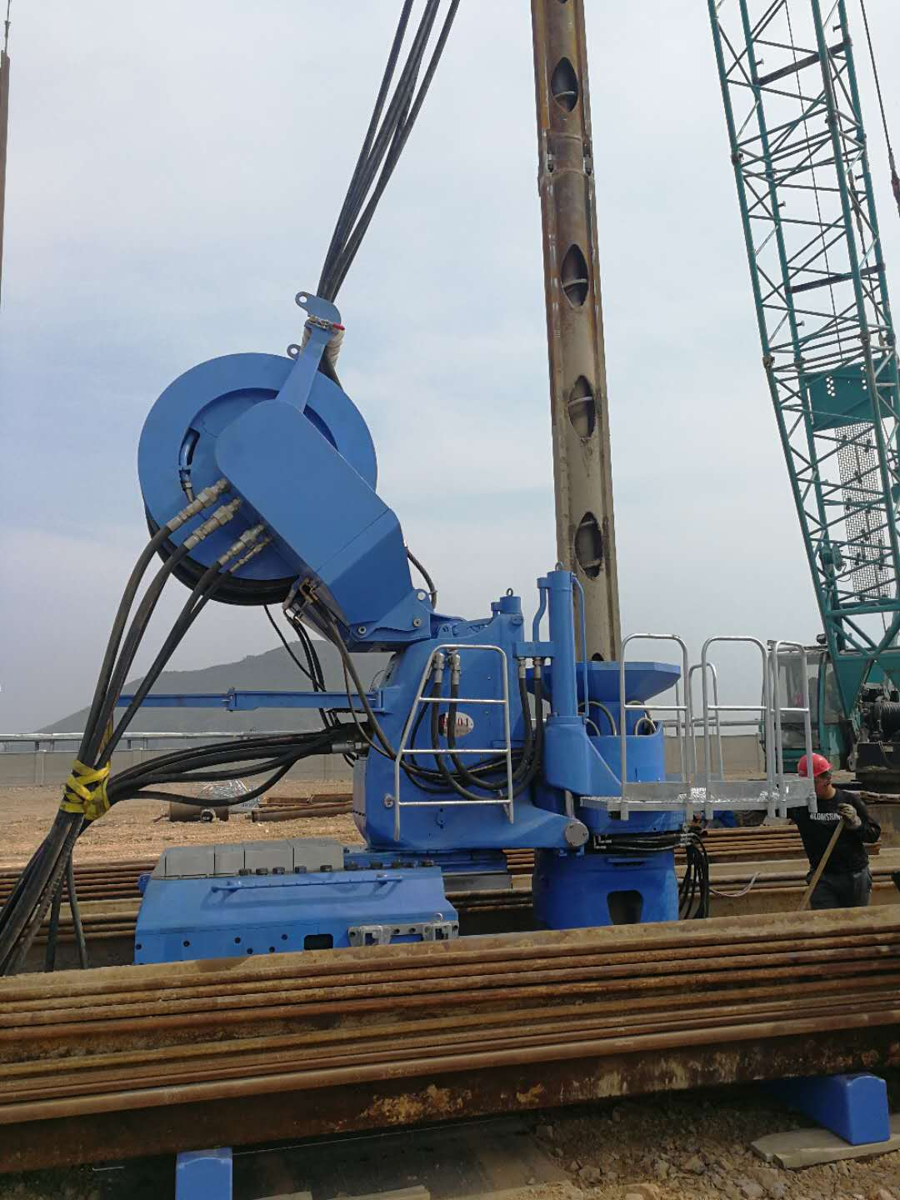

The mechanical equipment necessary for the comprehensive mechanized construction engineering of earthwork construction engineering, pavement construction and maintenance, mobile crane loading and unloading operation and various construction engineering is called engineering machinery.
It is mainly used in national defense construction projects, transportation construction, energy industry construction and production, mining and other raw materials industry construction and production, agriculture, forestry and water conservancy construction, industrial and civil construction, urban construction, environmental protection and other fields.
The main products of the machinery industry include the following 12 categories:
(1) Agricultural machinery: tractors, seeders, harvesting machinery, etc.
(2) Heavy mining machinery: metallurgical machinery, mining machinery, hoisting machinery, loading and unloading machinery, industrial and mining vehicles, cement equipment, etc.
(3) Construction machinery: shovel transport machinery, compaction machinery, concrete machinery, etc.
(4) General petrochemical machinery: petroleum drilling and production machinery, oil refining machinery, chemical machinery, pumps, fans, valves, gas compressors, refrigeration and air conditioning machinery, paper-making machinery, printing machinery, plastic processing machinery, pharmaceutical machinery, etc.
(5) Electrical machinery: power generation machinery, transformer, high and low voltage switch, wire and cable, battery, welding machine, household appliances, etc.
(6) Machine tools: metal cutting machine, forging machinery, casting machinery, woodworking machinery, etc.
(7) Automobile: truck, road bus, car, refitted car, motorcycle, etc.
(8) Instruments and meters: automation instruments, electrical instruments, optical instruments, composition analyzer, automobile instruments and meters, electrical equipment, electrical equipment, camera, etc.
(9) Basic machinery: bearings, hydraulic parts, seals, P / M products, standard fasteners, industrial chains, gears, molds, etc.
(10) Packaging machinery: packaging machine, packing machine, conveyor, etc.
(11) Environmental protection machinery: water pollution prevention and control equipment, air pollution prevention and control equipment, solid waste treatment equipment, etc.
(12) Mining machinery.

