Weld structure

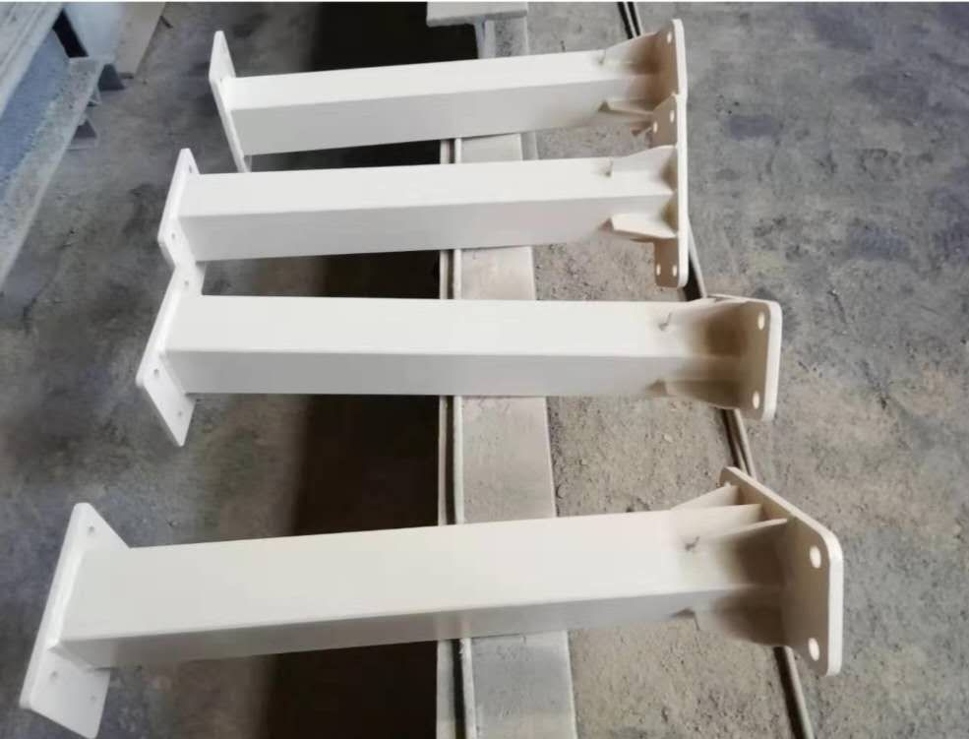

The welding structure has a series of advantages that other structures Can Not compare, mainly reflected in the following aspects:
1. The welding structure has strong integrity. Because welding is a kind of connection between metal atoms, with large rigidity and good integrity, it will not produce excessive deformation due to the change of clearance like other mechanical connections under the action of external force, so the strength and rigidity of welded joints can generally reach the same or similar to the base metal, and can bear various loads with the basic metal.
2. The welding structure has high strength and light weight. The welded structure is mostly made of rolled material, which has a strong ability to bear the impact load, and the strength of steel is many times higher than that of masonry, concrete and other building materials. The strength of the welded joint made by modern welding technology is higher than that of the base metal.
Parts or components of welded structure can be directly connected by welding without any additional connectors. Compared with riveted structure, the mass with the same structure can be reduced by 10% - 20%.
3. The welding structure has high safety performance. Due to the good plasticity of steel, in general, it will not cause sudden fracture damage due to accidental overload or partial overload, but there is a large deformation omen in advance, so as to take remedial measures. The steel also has good toughness and strong adaptability to the dynamic load acting on the structure, which provides a reliable guarantee for the safe use of the welded structure.
In a certain stress range, the steel is in an ideal elastic state, which is more consistent with the basic assumption adopted by engineering mechanics, so the calculation results are accurate and reliable to ensure the safe use of the welded structure.
4. The welding structure has good compactness. Due to the compactness of the weld, the welding structure can ensure the air tightness and water tightness requirements of the product, which is an indispensable and important condition for the normal operation of pressure vessels such as boilers, gas tanks, oil tanks, etc.
5. The economic benefit of welding structure is good. Welded structures are more economical than rolling when some profiles are used.
Welding structure production generally does not need large-scale, special and expensive equipment, with less investment and quick effect. It is easy to adapt to the production of different batches of products. The product updating is fast and convenient, and the economic benefit is good.

