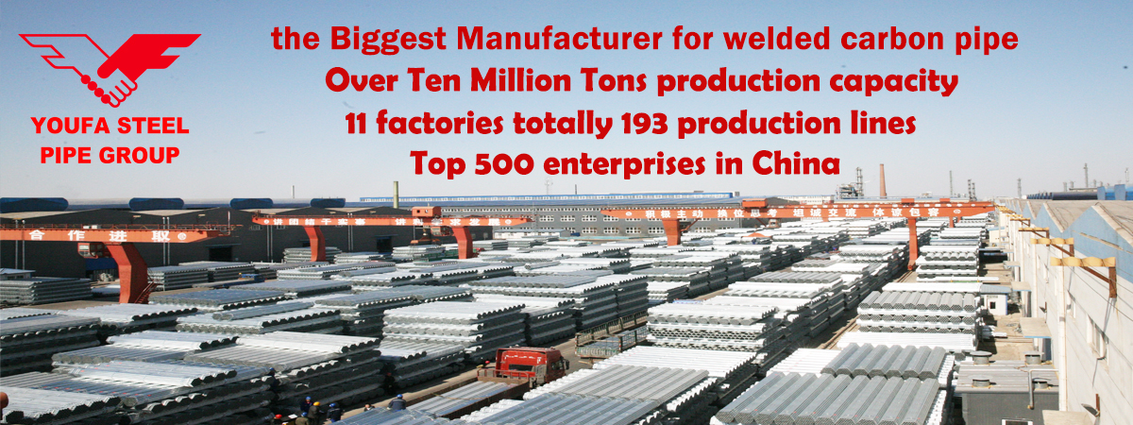
Our Advantange
1. 100% after-sales quality and quantity assurance.
2. Quick reply within 24 hours.
3. Large Stock for regular sizes.
4. Free sample 20cm high quality.
5. Strong produce capability and capital flow.
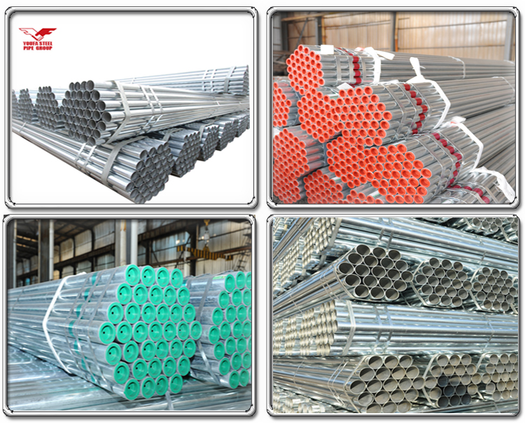
Model | 1/2''-8''
Product Name | Galvanized steel pipe price, galvanized tube, gi pipe standard length
Material | Q195,Q215,Q235,Q345,S235JR,S355J0
Standard | ASTM A500,ASTM A53,API 5L ,BS1387, EN39, JIS 3466;  EN10219,GB/T 13793-1992
Feature | Low and middle pressure fluid pipeline, boiler, petroleum and natural gas industry, drilling, chemical industry, electric industry, shipbuilding, fertilizer equipment and pipeline, structure, petrochemical, pharmaceutical industry
Color | black steel pipe
Shape | Round; Square; Rectangular, Special Pipe available
Technique | ERW, Hot Rolled, Cold Rolled, Cold drawn
Design | OEM & ODM
Certification | CE,ISO 9001:2008 certification
Free Sample | Yes
Function Description | 1.competitive price  2.high quality  3.delivery timely  4.package according to client's requirement
MOQ | 5 tons
payment terms | LC OR TT
Packaging details | as required package

Product Application:
1. Fence, greenhouse, door pipe
2. Low pressure liquid, water, gas, oil, line pipe
3. For both indoor and outdoor the building construction
4. Widely used in scaffolding construction which is much cheaper and convenient

Subtle ends treatment:
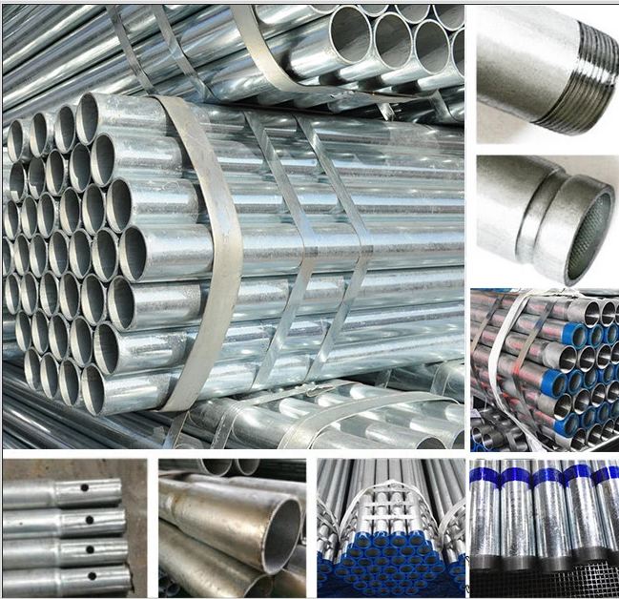
Company Information:

Tianjin Youfa Steel Pipe Group
Products are exported to more than 100 countires,such as North America ,South America ,Europe, Africa,Southeast Aisa,Middle East .
What We own?
8000 employees.
64 ERW steel pipe production lines
42 hot dipped galvanized steel pipe production lines
33 square and rectangular steel pipe production lines
15 hot dip galvanized square and rectangular steel pipe production lines
9 SSAW steel pipe production lines
25 steel-plastic complex steel pipe production lines
5 high way material production lines
3 national accredited laboratory with CNAS Certificates
1 Tianjin government accreditd business technology center

YOUFA STEEL PIPE GROUP including 9 factories:
1.Tianjin Production Base-Tianjin Youfa Steel Pipe Group Co.,Ltd .-No.1 Branch;
Tianjin Youfa Steel Pipe Group Co.,Ltd .-No.2 Branch;
Tianjin Youfa Dezhong Steel Pipe Co.,Ltd;
Tianjin Youfa Pipeline Technology Co.,Ltd;
Tianjin Youfa Ruida Traffic Facilities Co.,Ltd
2.Tangshan Production Base-- Tangshan Zhengyuan Steel Pipe Co.,Ltd;
Tangshan Youfa Steel Pipe Manufacture Co.,Ltd;
3.Handan Production Base-- Handan Youfa Steel Pipe Co.,Ltd;
4.Shanxi Production Base- Shanxi Youfa Steel Pipe Co., Ltd
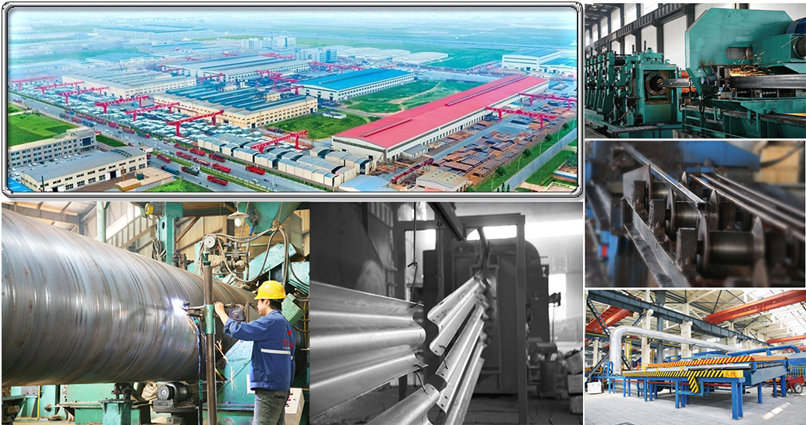
Certificate:
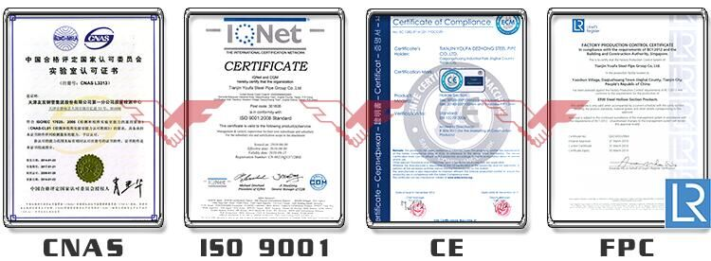

Customer & Exhibition cooperation:
