Brief introduction
Tianjin Youfa Steel Pipe Group Co., Ltd were founded on July 1st, 2000, located at Daqiuzhuang Village, Tianjin city, which is a large-scale steel pipe manufacturing enterprise producing ERW steel pipe, hot-dipped galvanized steel pipe, seamless pipe, SSAW steel pipe, square/rectangular steel pipe.
Youfa brand was affirmed as a China renowned brand by SAIC trademark bureau in March 2008. Youfa brand of ERW steel pipes, hot-dipped galvanized steel pipes, and SSAW steel pipes, has been awarded as "famous-brand product of Tianjin" by Tianjin government for many consecutive years. In six consecutive years, Youfa Group have been rated as top 500 enterprises of China in the same industry, and as top 500 manufacturing of China. In 2012, Youfa Group was rank No.375 in top 500 enterprises of China, and No. 200 in top 500 manufacturing of China, and No.3 in top 100 private enterprises of Tianjin.

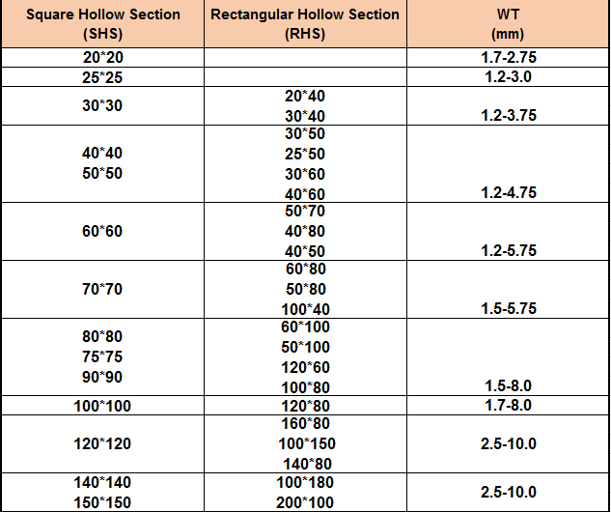
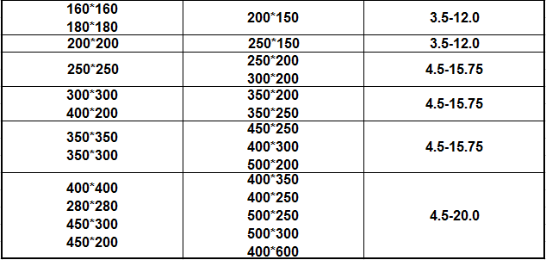

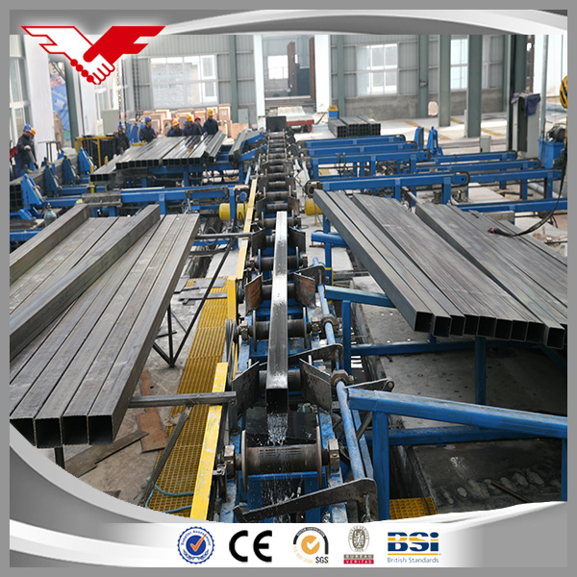
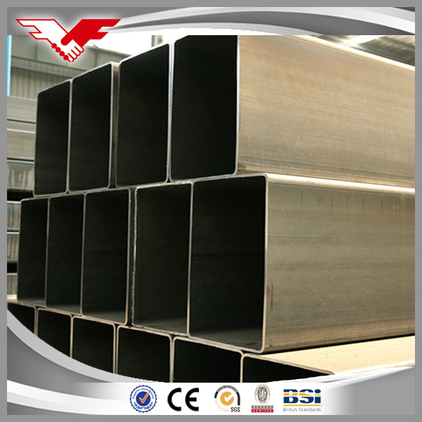
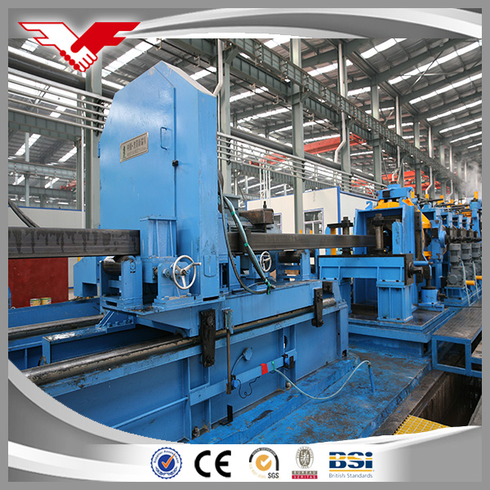

We attend fairs both in overseas and in China, we welcome client visit to our mills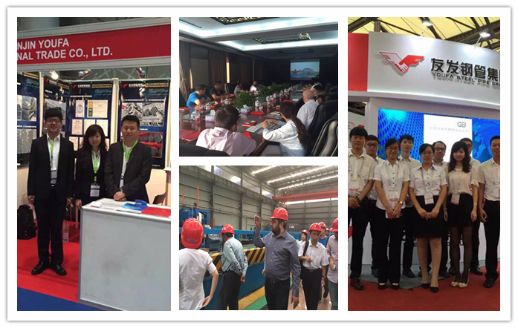

Who We are?
(1) China Top 500 Enterprises Industry Leading Brands
(2) 15 years experience in manufacturing and exporting steel products since 2000.
(3) For 10 Consecutive Years of The First Production and Sales

What We own?
8000 employees.
59 ERW steel pipe production lines
36 hot-dipped galvanized steel pipe production lines
24 square and rectangular steel pipe production lines
18 SSAW steel pipe production lines
16 steel-plastic complex steel pipe production lines
9 hot-dipped galvanized square and rectangular steel pipe production lines
5 Seamless steel pipe production lines
3 national accredited laboratory
1 Tianjin government accredited business technology center

Why choose Tianjin Youfa steel pipe group?
1. Strong strength
As the largest steel pipe manufacturer in Tianjin, China, we give more support about the orders, customers will have more confidence to cooperate with our group
2. Quality guarantee
Youfa group specialized in producing carbon steel pipes for many years, own experienced workers and advantage machine
3. Flexible terms
Flexible clause not only to protect the benefit of supplier, but also the buyers
4. Delivery lead time
To satisfied the urgency need of customers
5. Competitive price
We offer better price based on the support of our whole group with low price and better quality

