Vitamin C /Ascorbic Acid

优势Advantages
Lower than market price and stable and immediate supply
GMP certificate
Available stock in USA and door to door service

2.产品参数 COA
Item | Standard
Appearance | White or almost white, crystalline powder or colourless crystals
Melting point | About 190℃. with decomposition
Infrared absorption spectrum | Infrared absorption spectrum accord with the referance spectrum of ascorbic acid CRS
PH(With 5% water solution) | 2.1~2.6
PH(With 2% water solution) | 2.4~2.8
Appearance of solution | Clarity; clear; colour: ≤BY₇
Specific optical rotation | ﹢20.5℃~﹢21.5℃
Loss on drying | ≤0.4%
Impurity E | ≤0.2%
Related substance | Impurity C: ≤0.15%
 | Impurity D: ≤0.15%
 | Unpecified impurities:≤0.10%
 | Total impurities:≤0.20%
Copper | ≤5.0ppm
Iron | ≤2.0ppm
Arisenic | ≤3.0ppm
Lead | ≤2.0ppm
Mercury | ≤1.0ppm
Cadmium | ≤1.0ppm
Heavy metals | ≤10ppm
Sulphated ash | ≤0.1%
Assay | 99.0% ~ 100.5%

3.产品细节Detail
CAS No.:50-81-7
Other Names: Ascorbic acid
MF:C6H8O6
EINECS No.:200-066-2
Place of Origin: China (Mainland)
Grade Standard: Cosmetic Grade, Feed Grade, Food Grade, Medicine Grade
Usage: Animal Pharmaceuticals
Brand Name: TNN
Model Number: BP USP EP
Purity:99% min

4．产品包装 Packing & Delivery
25kg Carton box ,1 FCL=20MT

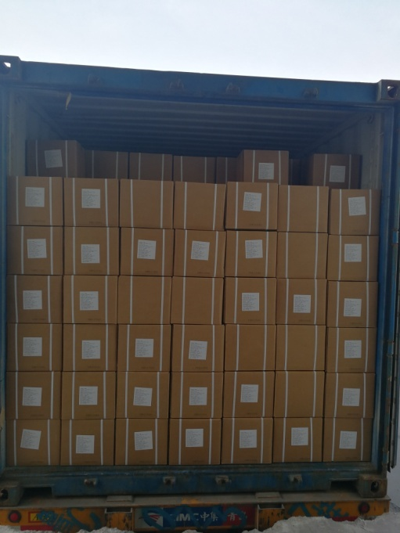

5.产品应用 Application
- Ascorbic acid (vitamin C) is used to prevent or treat low levels of vitamin C in people who do not get enough of the vitamin from their diets.
- Ascorbic acid and its sodium, potassium, and calcium salts are commonly used as antioxidant food additives.
- Ascorbic acid is easily oxidized and so is used as a reductant in photographic developer solutions(among others)and as a preservative.

