γ－Aminobutyric Acid (GABA)

优势Advantages
Different production method of natural fermentation and chemical synthesis for different usage as food and feed additives

Different content of 20%,98% and 99% meets the requests.
Production line strictly conforms with GMP standards.
GABA DC grade is available for direct tablet.

产品参数 COA

γ－Aminobutyric Acid (GABA) Powder 98%
Items | Standard
Description | Light yellow or white loose powder,granules,crystal
Odor | Should be no odor
Moisture | ≤0.5%
Ash | ≤0.1%
Assay | ≥98%

γ－Aminobutyric Acid (GABA) Powder 20%
Items | Standard
Description | Light yellow or white loose powder,granules,crystal
Odor | Should be no odor
Moisture | ≤10%
Ash | ≤10%
Assay | ≥20%

γ－Aminobutyric Acid (GABA) DC
Items | Specification
Appearance | White flowing paticles
Assay | ≥ 90%
Sieve analysis | ≥ 95% through a USS#20
 | ≤ 75% through a USS#60
 | ≤ 15% through a USS#100
Loss on Drying | ≤10%
Heavy Metal | ≤20ppm
Total Plate Count | ≤1000cfu/g
Yeast & Mold | ≤100cfu/g
E.Coli | Negative
Salmonella | Negative
Staphylococcus | Negative

3.产品细节Detail
CAS No.:56-12-2
Other Names: γ－Aminobutyric Acid
EINECS No.:200-258-6
Place of Origin: China (Mainland)
Grade Standard:Food Grade
Usage: health supplement raw material
Brand Name: TNN
Purity:20%,98% and 99%

4．产品包装 Packing & Delivery
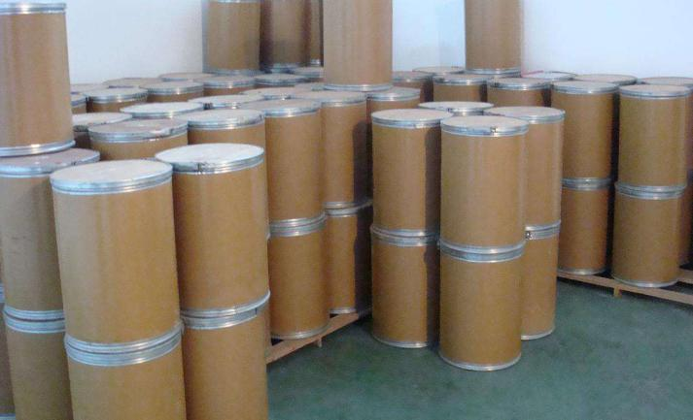

5.产品应用 Application
Used in functional beverage.

Used in producing health supplement tablet

