Stevia Powder

1.优势Advantages
1.Low calori,natural and healthy
2.Different mesh size and different active ingredient Stevia RA,RB,RC,RD
3.Less cost on using stevia,just 30-40% comparing with sucrose
4.Good solubility in water

产品参数 COA Stevia Powder RA 98%
Item | Specification
Appearance | Powder
Color | white
Oder | Characteristic
Total Glucoside Content/% | ≥98
Rebaudioside A /% | ≥98
Stevioside/% | ----
Rebaudioside C /% | ----
Sweetness | ≥440
Specific Rotation | -30°~ -38°
Absorbency | ≤0.05
PH | 4.5-7.0
Burned residue/% | ≤0.2
Loss on Drying/% | ≤5
Lead(Pb)/(mg/kg) | ≤1
Arsenic/(mg/kg) | ≤1
methanol/(mg/kg) | ≤ 200
ethanol/(mg/kg) | ≤ 5000
Microbiological Analysis
TABC | ＜1000cfu/g
Yeast/Mold | ＜100 cfu/g
其他规格

Other Spec.:
Stevia RA90%,RA95%,RA98%,RA99%
SG 95% RA40% ,RA50%,RA60%,RA80%,RA90%
SG 90% RA40%,RA50%,RA60%
STV 90%%,98%
RD 95%-98%

3.产品细节Detail
CAS No.:57817-89-7
Place of Origin: China (Mainland)
Type:Sweeteners
Brand Name:TNN
Purity:

Stevia RA90%,RA95%,RA98%,RA99%
SG 95% RA40% ,RA50%,RA60%,RA80%,RA90%
SG 90% RA40%,RA50%,RA60%
STV 90%%,98%
RD 95%-98%

Appearance:White crystals

4．产品包装 Packing & Delivery
20kg/carton
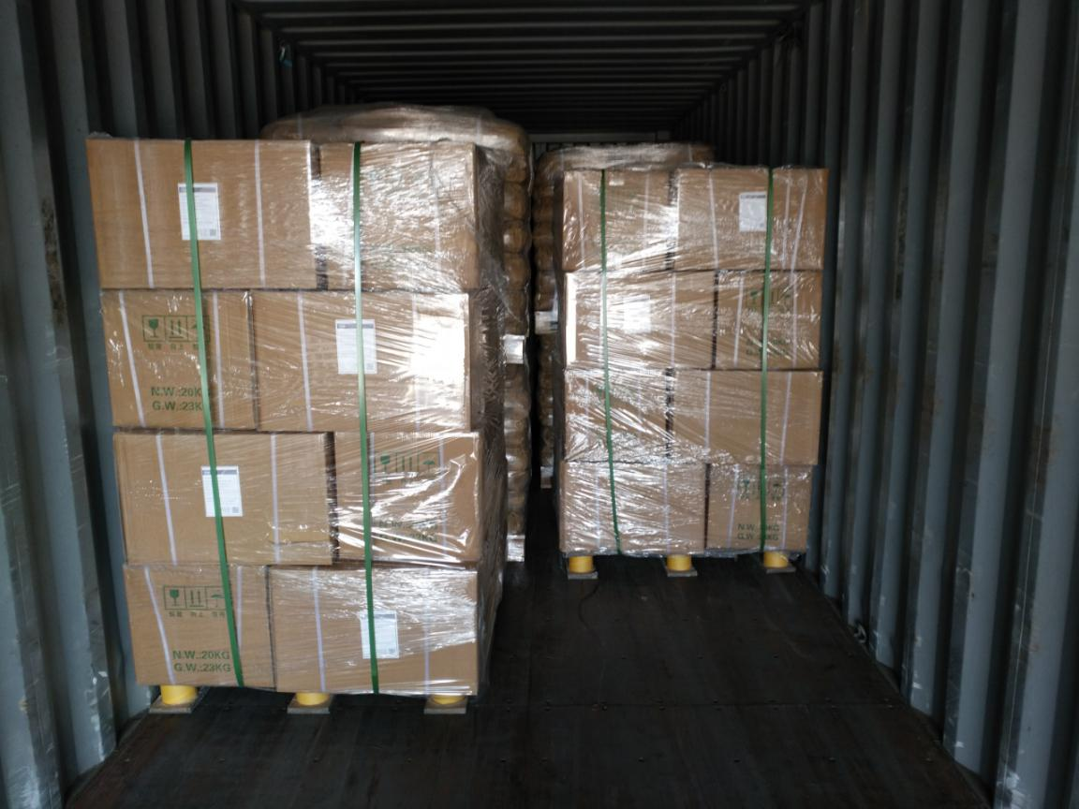

5.产品应用 Application
It is a natural low-calorie sweetener. The caloric value of stevioside is only 1/300 of that of sucrose. It is not absorbed after ingestion into the human body and does not produce heat. It is a sweetener suitable for patients with diabetes and obesity. When stevioside is mixed with sucrose fructose or other sugar, it can increase its sweetness and taste. Used in confectionery, cakes, beverages, solid beverages, fried snacks, seasonings, preserves. Appropriate use according to production needs

