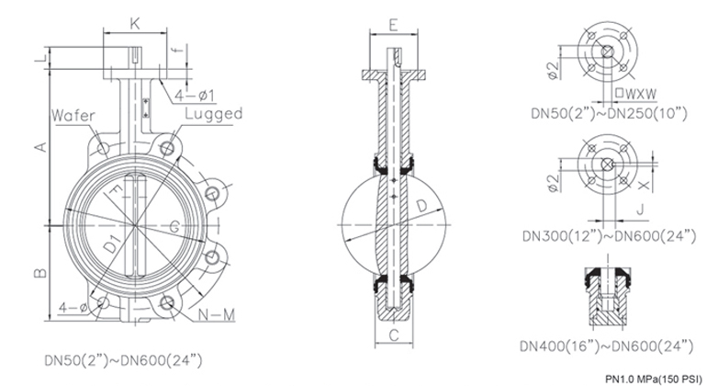
Size |  | A | B | C | D | L | D1 | Φ | K | E | N-M | Φ1 | Φ2 | G | F | f | □wxw | J | X | Weight(kg)
(mm) | inch |  |  |  |  |  |  |  |  |  |  |  |  |  |  |  |  |  |  | wafer | lug
50 | 2 | 161 | 80 | 43 | 53 | 28 | 125 | 18 | 65 | 50 | 4-M16 | 7 | 12.6 | 89 | 155 | 13 | 9*9 | ─ | ─ | 2.7 | 4.1
65 | 2.5 | 175 | 89 | 46 | 64 | 28 | 145 | 18 | 65 | 50 | 4-M16 | 7 | 12.6 | 105 | 179 | 13 | 9*9 | ─ | ─ | 3.5 | 4.5
80 | 3 | 181 | 95 | 46 | 79 | 28 | 160 | 18 | 65 | 50 | 8-M16 | 7 | 12.6 | 120 | 190 | 13 | 9*9 | ─ | ─ | 3.9 | 5.1
100 | 4 | 200 | 114 | 52 | 104 | 28 | 180 | 18 | 90 | 70 | 8-M16 | 10 | 15.8 | 148 | 220 | 13 | 11*11 | ─ | ─ | 5.3 | 9.7
125 | 5 | 213 | 127 | 56 | 123 | 28 | 210 | 18 | 90 | 70 | 8-M16 | 10 | 18.9 | 170 | 254 | 13 | 14*14 | ─ | ─ | 7.6 | 11.8
150 | 6 | 226 | 139 | 56 | 156 | 28 | 240 | 22 | 90 | 70 | 8-M20 | 10 | 18.9 | 203 | 285 | 13 | 14*14 | ─ | ─ | 8.4 | 15.3
200 | 8 | 260 | 175 | 60 | 202 | 38 | 295 | 22 | 125 | 102 | 8-M20 | 12 | 22.1 | 255 | 339 | 15 | 17*17 | ─ | ─ | 14.3 | 36.2
250 | 10 | 292 | 203 | 68 | 250 | 38 | 350 | 22 | 125 | 102 | 12-M20 | 12 | 28.5 | 303 | 406 | 15 | 22*22 | ─ | ─ | 20.7 | 28.9
300 | 12 | 337 | 242 | 78 | 302 | 38 | 400 | 22 | 125 | 102 | 12-M20 | 12 | 31.6 | 355 | 477 | 20 | ─ | 34.6 | 8 | 35.1 | 43.2
350 | 14 | 368 | 267 | 78 | 333 | 45 | 460 | 23 | 125 | 102 | 16-M20 | 12 | 31.6 | 429 | 515 | 20 | ─ | 34.6 | 8 | 49.6 | 67.5
400 | 16 | 400 | 325 | 102 | 390 | 51 | 515 | 28 | 175 | 140 | 16-M24 | 18 | 33.2 | 480 | 579 | 22 | ─ | 36.15 | 10 | 73.2 | 115.2
450 | 18 | 422 | 345 | 114 | 441 | 51 | 565 | 28 | 175 | 140 | 20-M24 | 18 | 38 | 530 | 627 | 22 | ─ | 40.95 | 10 | 94.8 | 134.4
500 | 20 | 480 | 378 | 127 | 492 | 57 | 620 | 28 | 210 | 165 | 20-M24 | 23 | 41.1 | 582 | 696 | 22 | ─ | 44.12 | 10 | 153.6 | 242.4
600 | 24 | 562 | 475 | 154 | 593 | 70 | 725 | 31 | 210 | 165 | 20-M27 | 23 | 50.7 | 682 | 821 | 22 | ─ | 54.65 | 16 | 225.6 | 324

