Product description
Ozone Aging Test Chamber provide accurate ozone concentration environment for electric wire, rubber and polymer test, ect. It widely applied to (1) Accelerated ageing research (2) Quality control and assurance tests and (3) R&D laboratory formula experiments for cracking resistance.

Technical parameter:
Model | OA-100 | OA-150
Internal dimension (WxDxH) | 400*500*500 mm | 500x600x500 mm
External dimension (WxDxH) | 900*970*1600 mm | 1000x1000x1750 mm
Temperature range | RT+10~ 60℃ (suggest to use 40±2℃)
Temperature Fluctuation | ±1℃
Ozone concentration | 50~1000 pphm, adjustable
Ozone concentration deviation | ±10%
Sample holder | 2pcs removable sample tray, SUSStainless steel 304
Turntable sample holder (optional) | Built-in 360 degree rotation sample holder, including 3 sets static tensile fixture and 3 sets dynamic tensile fixture.
Controller | LCD programmable controller, , Touch Screen
Ozone generator | High pressure silence discharge type
Power Supply | Single phase , AC 220V 50/60HZ

Chamber Structure And Features
1, Internal material is imported high quality mirror stainless steel plate.
2, External material adopts stainless steel with paint spray.
3, Insulation material: high-density glass fiber
3, Use long axial fan motor and high and low temperature resistant aluminum alloy wing type wind turbines to force vertical air circulation.
4, Chamber door adopts double layer high and low temperature resistant silicone seal ensure the airtight test area.
5, Chamber bottom has high quality universal wheel and fixed foot cup.
6, Observation window uses multilayer hollow tempered glass.
7, Exhaust system: exhaust the high concentration ozone from the test chamber to avoid to poison.
8, Optional: Built-in 360 degree rotation sample holder, including 3 sets static tensile fixture and 3 sets dynamic tensile fixture.

Control System
1, With imported micro-computer LCD controller to control the temperature.
2, PID control
3, With auto calculation function to reduce the setting inconvenience.
4, Heater: fin type radiator pipe nickel-chromium alloy u-shaped heater, auto calculate with high accuracy PID + SSR control
5, Temperature measurement: SUS#304, PT 100

Standard Configuration
1, Power line x 1pc
2, Sample holder x 1set
3, Fuse x 1set
4, Operation manual x 1set

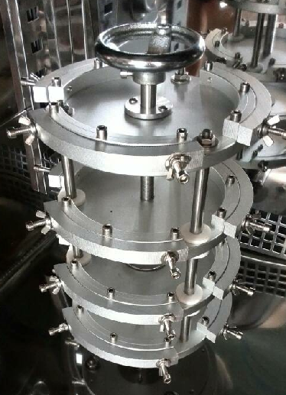
Rotating disc

