Product introduction:
UV Weathering Test Chamber can simulate the sun, rain spray and condensation resulting damage to test the materials by exposure to sunlight with moisture and temperature.
This test machine can get the results of damage after several days or weeks which is equal to expose to outside for a few months. The damages include fading, discoloration, brightness down, powder, crack, blur, brittle, strength decreases and oxidation. It provides the reference with testing data for improvement of existing materials, or to assess the impact of changes in product durability and other aspects.

Production parameters:
Model | DTK-UVA  DTK-UVB | DTK-UVA  DTK-UVB
Internal chamber design | standard chamber | Flat type chamber
Internal dimension(W*D*H) | N/A | 1140*650*500 mm
External dimension (W*D*H) | 1300*500*1460 mm | 1340*700*1800 mm
Temperature range | RT~ 70℃
Temperature fluctuation | ±2℃
Internal & External chamber material | Stainless steel 304
Control system | Programmable controller, LCD touch screen Illumination, condensation and water spray test cycles are programmable
UV lamp | Atlas UV-A: 315-400nm/ UV-B: 380-315nm (8pcs, 1200h lifetime)
Irradiance meter | 0.45~0.85W/cm2 can be adjusted (Optional)
Distance from sample to lamp | 50±2mm
Sample dimension  (Standard chamber) | 75×290mm (24pcs) or 75x150mm (48pcs), max. thickness 5mm
Sample dimension  (Flat type chamber) | Irregular test samples
Power | Single phase ,AC 220V 50/60HZ

Function:

Meet Specifications
* Meet customer requirements
* Stay ahead of government regulations

Prevent Field Failures
* Improve quality and durability
* Enhance reputation
* Assure product performance

Gain a Competitive Edge
* Save on material costs
* Expand product lines
* Enter new markets
* Outrun the competition

design criteria:General:
•ASTM G151
• ASTM G154
Coating:
• ASTM D3794
• ASTM D4587
• ISO 11507
• ISO 20340
Adhesive:
• ASTM C1184
• ASTM C1442
• ASTM D904
• ASTM D5215
Plastic:
• ASTM D4329
• ASTM D4674
• ASTM D5208
• ASTM D6662
• ISO 4892-3 …
Q-test Controller
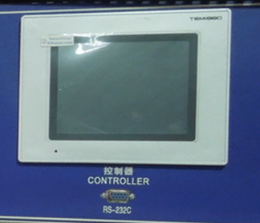
Programmable LCD controller, can do cyclic test with temp, humid, water spray and condensation.
UV lamps
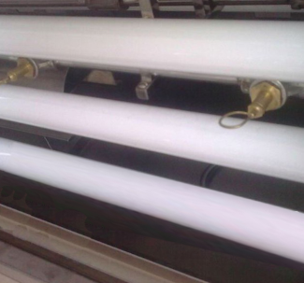
UV-A and UV-B lamps for option
Sample Holder
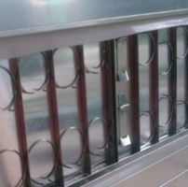
Test specimens are mounted on both the front and back side of the UV Tester, providing a large sample capacity.
Sample holder can be customized.

