Product profile:
series water spray test chamber is performing tests according to various standards; UL, EN 60529 and for protection code testing (IP-Code) for spray and splash water systems. It performs test for the protection of housings against ingress of water. It has an automatic option where a timer will be set from 1 sec. to 999 h. The apparatus offers integrated circulation equipment that reduces the water consumption of the tests. it can also be applied to IP X1/X2 drip device, IP X3/X4 swiveling tube, IP X3/X4 spray head, IP X5/X6 jet nozzle and IP X9K high pressure jet nozzle.
Technical Parameter:
Model | WS-IPX3
 | WS-IPX4
Internal dimension (W*D*H) | 600*600*600mm | 800*800*800mm
External dimension (W*D*H) | 1100*800*1500mm | 1300*1000*1700mm
Oscillating tube | Radius 200mm | Radius 300mm
Internal chamber material | Stainless steel 304
External chamber material | Stainless steel
Observation window | Waterproof Toughened glass
Oscillating angle | IPX3: spray ±60° from vertical line to each side, total 120°  IPX4: spray ±180° from vertical line to each side, total 360°
Oscillating speed | IPX3:for 4s  IPX4:for 12s
Spray nozzle | Diameter: 0.4mm, removable
Distance between two nozzles | 50mm
Turntable diameter | 200mm | 300mm
Turntable rotation speed | 1-3 cycles/min
Water flow of each nozzle | 0.07 L/min +5%
Test duration | 1~999,999min, adjustable
Water pressure | 80-150Kpa
Water cycling system | Built-in chamber bottom for recycling
Power source | Single-phase, AC220V, 50/60HZ

Features:
- Rotating rain and spray nozzles designed to IPX specifications
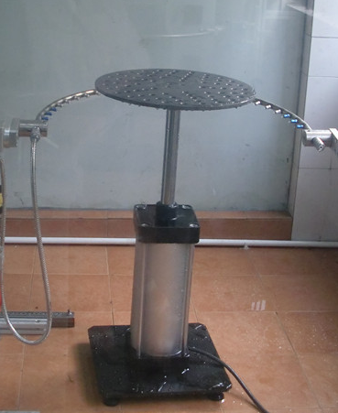
- Speed control for the rotating spray nozzles
- Stationary product shelf - A rotating shelf is optional
- Water pressure regulators, gauges and flow meters
- Water circulation system to reduce water consumption
- Adjustable swivel angle
- Replaceable swivel tubes
- Nozzle fittings can be swiveled
- Exchangeable nozzle fittings
- Adjustable water volume flow
- Measurement of water volume flow

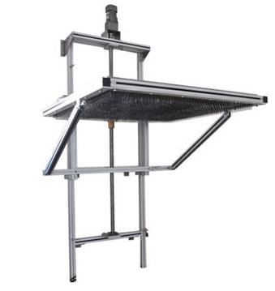
Water Dripping Test (Meet IPX1 and IPX2 test)

- LCD touch screen controller with PLC control
- Drip box size: 1000x1000mm (or 500x500mm) ,
or custom size as option
- Needle diameter: 0.4mm
- Distance between needle: 20mm
- Dropping rate: 1mm+0.5mm/min (IPX1),
3mm+0.5mm/min (IPX2)
- Dropping height: 200mm (adjustable)
- With timer, flow display
- With rotating table, diameter 700mm, 1rpm,
- 15º tilt plate, height adjustable
- Meet IEC60529, IEC60598

Rain Spray System (Meet IPX3 and IPX4, 4K test)
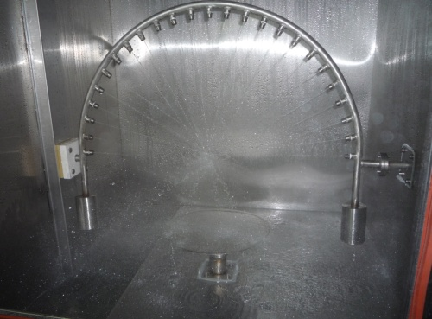
- LCD Touch Screen Display and Control
- Nozzle diameter: 0.4mm
- Nozzle distance: 50mm
- Flow rate: 0.07L/min (IPX3,4), 0.6+/-0.5L/min
(IPX4K)
- Arm Radius: 300mm, 400mm, 600mm, 800mm,
1000mm, 1200mm or 1500mm
- Rotating angle: +/-270, adjustable.
- Rotating speed: adjustable
- Rotating table: speed is adjustable
- Adjustable spray flow and spray time.
- With 0-400kPa adjustable pressure regulator
- All 304 stainless steel design, both interior and exterior
- With chamber as option

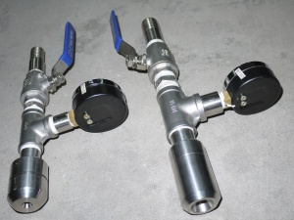
Jet Nozzle (Meet IPX5 and IPX6 test)
- 6.3mm nozzle diameter, for IPX5 test.
Water flow: 12.5L/min.
- 12.5mm nozzle diameter, for IPX6 test.
Water flow: 100L/min.
- Meet IEC60529, IEC60335
- Water Pumping System as option

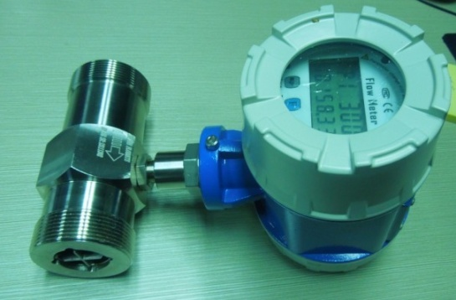
Water Pumping System (For IPX1,2, IPX3,4, IPX5,6)
- Water pump for large flow: 0-7m³/h
- Water pump for small flow: 0-3m3/h
- Water inlet
- With water filters
- Pressure display and water flow display
- Safety overload protection on pump and motor

PLC Controller:
- PLC + touch screen interface
- test parameter setting and monitoring
