Introduction:
The surface of various materials, including coating, electroplating, inorganic and organic coating, cathodic treatment antirust oil corrosion prevention treatment, test the corrosion resistance of their products.
Salt spray test can be divided into two kinds: neutral salt spray and acid salt spray. The difference is that the standard is different from the test method, which is called "NSS" and "CASS" test.

Parameters:
Model | ST-60 | ST-90 | ST-120 | ST-160
Internal dimension(W*D*H) | 600*400*450mm | 900*600*500mm | 1200*1000*500mm | 1600*1000*500mm
External dimension(W*D*H) | 1070*600*1180mm | 1410*880*1280mm | 1900*1300*1400mm | 2300*1300*1400mm
Controller | Touch-tone controller
Temp. range | Ambient ~ +55℃
Temp. uniformity | ±2℃
Temp. fluctuation | ±0.5℃
Salt spray deposition | 1~2ml/80cm²/h
Spray method | Continuous/cycles(optional)
Test time | 1~9999(S,M,H) adjustable
Temperature control | PID+S, S, R microcomputer integrated controller
Temperature sensor | Platinum Resistance PT100Ω/MV
Heating system | All independent system, nickel-chromium alloy electric heating heater
Spray system | Tower spray device and no crystallization nozzle
Machine material | Import corrosion resistance, anti-aging, high strength PVC board
Seal | Adopts water seal device and no salt fog overflowing
Power supply | AC220V ±10% 50HZ

PRODUCT FEATURES
1, Durable hard 8 mm PVC construction, anti-corrosion and easy to clean.
2, Reservoirs with mixing system on stand.
3, Separate heating system apart from salt testing chamber to ensure accurate result and protect circuit.
4, Exposure zone lined with corrosion-resistant PVC sheets.
5, Clear cover allows viewing of test conditions.
6, Peaked cover prevents dripping of condensation onto samples.
7, Water seal and water level protection system.
8, Heated humidifying tower with air relief valve, adjustable tower tip to orient salt fog.
9, Automatic DI water fills to humidifying tower.
10, Digital temperature control.
11, Integral over-protection on heaters.
12, Low water cut-off protection on humidifying tower.

Details:
Control panel | Inner Chamber
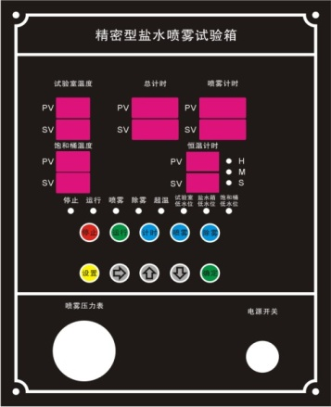 | 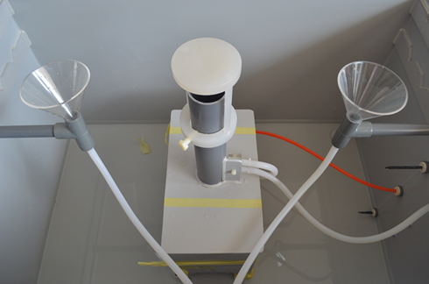
Transparent observation cover | Test Sodium chloride (testing salt)
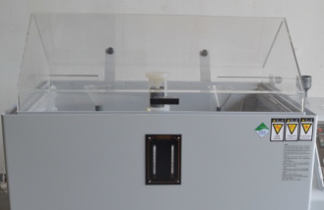 | 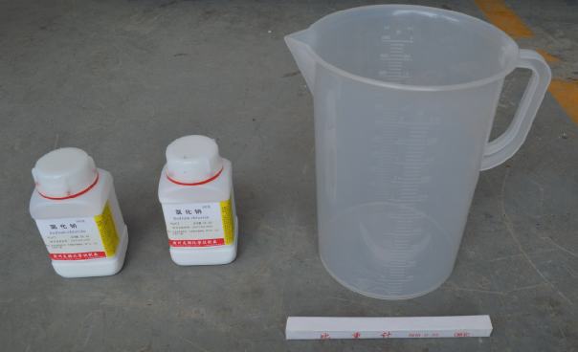
Overtemperature alarm and control valve | Measuring tank
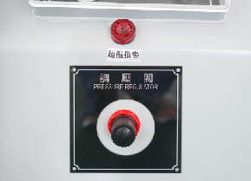 | 