Product introduction:
1 dust testing machine / dust (dust) test box is mainly used for the shell protection level standards in the IP5X and IP6X two levels of testing.
2 Suitable for sealing performance test and reliability test of the product, check the sealing performance of the electronic and electrical products, automobile, motorcycle parts, seals, etc.

Technical Parameter:
Model No. | D-216-5 | D-512-5 |  | D-1000-5
Internal dimension (W*D*H) | 600*600*600mm |  | 800*800*800mm | 1000*1000*1000mm
External dimension (W*D*H) | 1100*900*1650mm |  | 1300*1100*1800 | 1500*1300*2000mm
Internal chamber material | Stainless steel 304
External chamber material | Stainless steel
Controller | PLC controller, touch screen  - Blowing dust time (Stop/Blow) h/m/s  - Cycle time: can be adjusted  - Pre-set test time: 0s ~ 999h99m99s  - Specimen opening: off – on - off
Testing time | 0.1s~ 999hr, adjustable
Dust concentration | 2kg/m³~ 4kg/m³, should be replaced in every 20 tests
Dust type | Powdered cement, talcum powder
Vacuum system | Pressure gauge, air filter, pressure regulating FRL, connecting pipe, vacuum pump
Vacuum pump | 0-30Kpa
Air pressure | 0.5~0.8MPa
Air flow rate | ≤2m/s
Power socket inside chamber | Dust proof power socket for specimen opening
Door material | Tempering glass
Power source | Single-phase, AC220V, 50/60HZ

Detail Image:
- Glass Sash
Installed on the door (toughened glass, with a manual blowing dust), enclosure specimens were observed in the blowing dust stops. 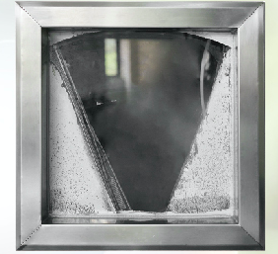
Dust device located in the test, at the bottom is used to replace the test required to dust, dust test 20 times need to be replaced. 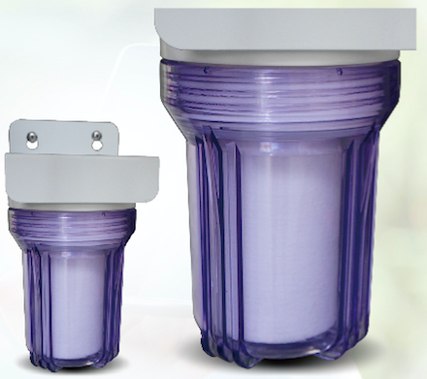
circulating fan Low noise type motor, multi-page type centrifugal rotor. 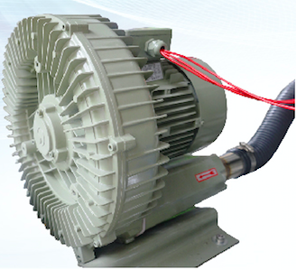
Dustproof plug and vacuum suction nozzle 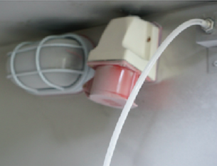
Internal chamber and specimen shelf Shape of a funnel shaped, with adjustable vibration cycle, can float in the sky of dust fall in the open holes in. 