Product introduction:
The Xenon Weathering Test Chamber uses a xenon arc lamp that can simulate full sunlight spectrum to reproduce destructive light waves that exist in different environments. This enables the device to provide the corresponding environment simulations and acceleration tests for scientific research, product development and quality control.
Parameters:
model | X-225 | X-512 | X-1000
test space | 225L | 512L | 1000 L
Internal size  (WxHxD) | 600*750*500MM | 800*800*800MM | 1000*1000*1000MM
External size  (WxHxD) | 1300*1700*1000MM | 1450*2150*1350MM | 1650*2350*1550MM

Internal material | stainless steel 304 , anti-rust, easy to clean
External material | Cold-rolled steel with spray/ Stainless steel
Chamber humidity range | 45%～95% RH (Light cycle)  30%～95% RH (Dark cycle)
Humidity uniformity | ±5 %RH
Chamber temperature | 25℃~90℃, adjustable
Black panel temperature | 40℃~95℃, adjustable
Temperature uniformity | ≤±3℃
Filter | Daylight filter
Light source | Air cooled long arc xenon lamp
Xenon lamp power | 1.8KW * 3pcs = 5.4KW
Irradiance strength | 550~1120W/m²@290~800nm, adjustable
Control system | LCD programmable controller,  auto display irradiance, capacity: 100 groups program, 99 cycles.
Illumination time | 1~999 hours, adjustable
Water spray system | Water spray time 999 minutes settable  Interval spray time, 1~240 minutes settable
Water pressure | 0.12 ~ 0.15kpa
Water spray nozzle | Diameter: 0.8mm
Sample holder | SUSStainless steel 304 , 1pc
Distance from sample  holder to lamp | 250~300mm
Power Supply | Three phase , AC380V 50/60HZ

PLC controller | Other company：TEMI880 Other company:  DETECT: SIEMENS touch screen and PLC control system, independent research and development program for the independent design of xenon lamp, with a user-friendly interface.  Advantage：Independent research and development, programming, more humane, more accurate. Tailored for customers. | 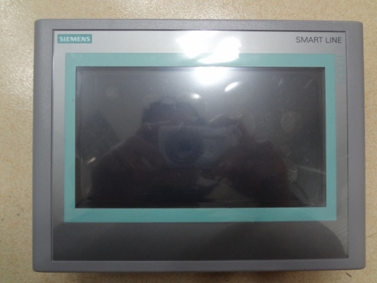
Black panel temperature sensor | Other company: domestic brand  DETECT:Japan SANJAC,Temperature measurement range - 100-200 degrees  Advantage: wide measuring range, high precision. | 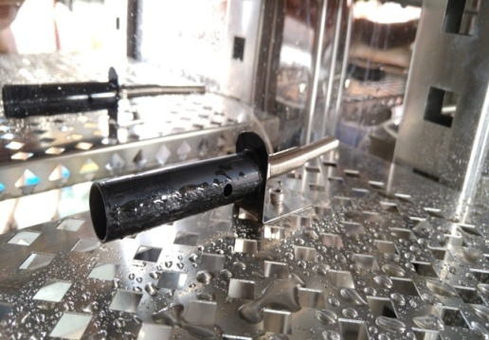
Xenon lamps | Other company：Domestic brand a tube  DETECT: 1.8 KW (air-cooled all solar spectrum long arc xenon lamp) 3, life: 1200 hours  Advantage：Air cooled xenon lamp three tubes placed side by side spacing 100MM, uniform light intensity. | 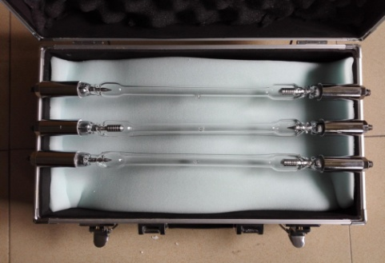
Irradiance meter | DETECT: German chip design  Intelligent irradiation induction loop system. Full spectrum 290-800NM, 575-1120W/m2, ultraviolet 340NM band 0.5-1.2W/m2  Advantage：High temperature, high humidity resistance, shell 304 material design and production. Intelligent automatic radiation intensity compensation, the system can automatically compensate by increasing the power of xenon lamp. | 