Installation Instruction For High Performance

Tools and Material required for installation
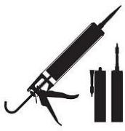
Tools:Tape measure,utility knife (with Razor sharp blade), and straight-edge ruler Materials:Sealant adhesive,caulking gun and super double-sided adhesive.
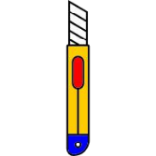
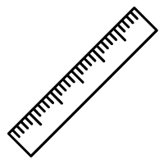
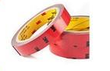

Normal heavy-duty wall covering paste is also available.

Surface Preparation
-All hanging surfaces must be clean,smooth,dry,undamaged,free of
mold,mildew,grease or stains, And structurally intact.Before using Sealant adhesive,use sandpaper to smoothing down the rough surfaces.

Applying to wall & surfaces
-To use Sealant adhesive:
Apply the adhesive to the back of the wall panel using sealant caulking around the border line and the center of the wall panel
-Any kinds of adhesive glue are available,except silicon glue.
-Cutting the wall panel :
  - Measure the necessary cut,and mark it on the face of your wall panel ,using a pencil and straightedge.
  - Set the straight edge on any measurement that needs to be made.Slowly run the razor knife along the straight edge.Don’t try to through the entire thickness of the wall panel at once. Cut about half way down with the first pass. Then make a second pass to cut through completely.
-Dealing with Details:Fix the corners with a super Glue in case of a rise in the edges of the wall panel .
-Arrange the wall panels on floor before installing them on the walls.

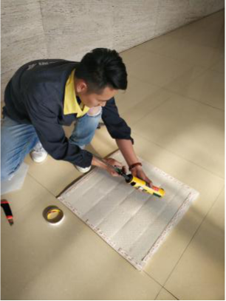
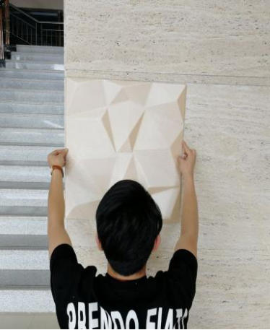
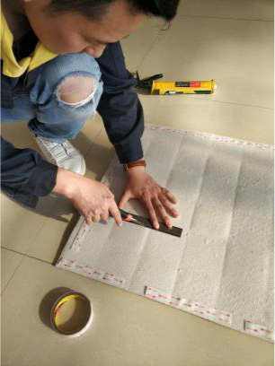
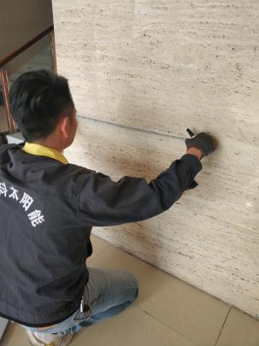

Reference
Silicon adhesives is not recommended for pasting the PU soft wall panel .
-Silicon adhesives :Do not apply an excessive amount of PU sealant adhesive,due to the thickness of the flat wall panel .
-Use of an excessive amount of sealant adhesive will show through on the front surface on the wall panel.

Care & Maintenance
-Dust is washed with a damp cloth and stains are scrubbed with alcohol.

