PRODUCT USE
PEEL & STICK VINYL INSTALLATION INSTRUCTIONS
PRE-GLUED, PEEL AND STICK WOOD LOOK VINYL PLANKS
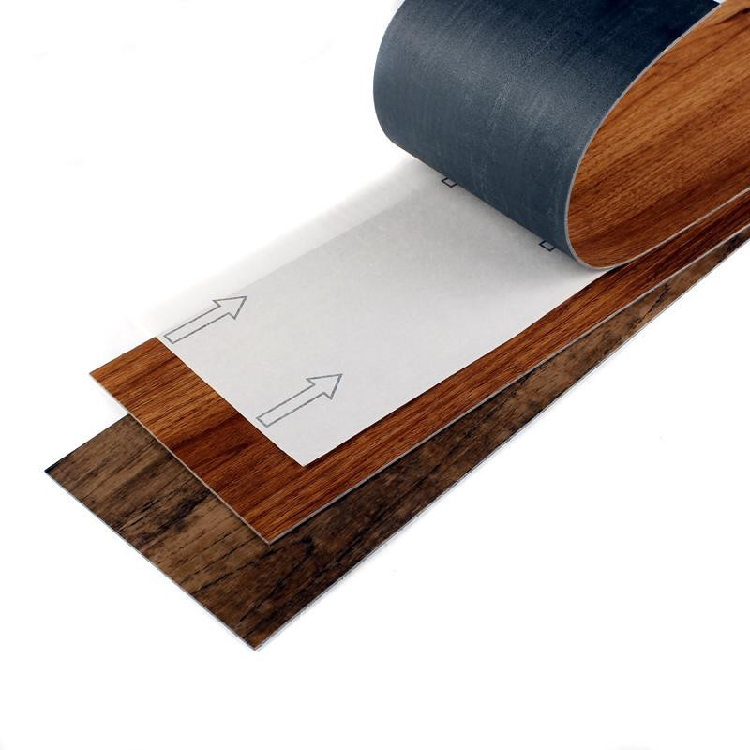

Vinyl Peel and Stick planks are designed for convenient do-it-yourself, residential installations only. Peel and Stick planks must be installed over a smooth, flat, clean, dry, dust free subfloor. Planks are ready for foot traffic immediately after completion. Wait 48 hrs after installation before full cleaning. Never flood-mop Peel and Stick planks. When properly installed and maintained, Vinyl Peel and Stick planks will offer years of good service. Vinyl planks are moisture resistant and make an ideal choice for basements, kitchens, baths and laundry rooms. Our planks are sure to enhance the look and feel of other areas of your home.
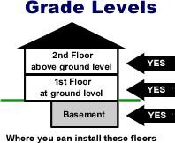

Vinyl Peel and Stick planks can be installed on every level of the home.

STORAGE AND HANDLING

- Protect carton corners from damage.
- Deformed materials or edges can result from improper handling or storage and may prevent proper bonding and fitting and
- Vinyl must be stored flat, horizontally and stacked no more than six cartons high at all times. Improper storage can result in warping and difficult assembly.
- Storage area and Job site should be climate-controlled with temperatures of 65°F-75°F

TOOLS AND MATERIALS

Basic hand tools;
- Tape measure • pencil • chalk line • carpenters square or metal ruler • sharp utility knife • Broom, vacuum,

Special Considerations; see Concrete and Moisture
- For best adhesion remove all grit, wax, dust and other surface contaminates.
- Ensure the substrate is flat
- For rough or uneven wood subfloors use 1/4”-3/8” luan underlayment.
- For uneven concrete subfloors use Cement based leveling compounds.
- Radiant heat is not recommended for Peel and Stick planks

SUBFLOORS
All subfloors must be smooth and flat or imperfections may show-through

Wood subfloors
- Subflooring must be solid, well nailed, and free from dust and flexing.
- Peel and Stick planks are not recommend for use directly over particle, chip board, or OSB oriented strand board. For a smooth surface, apply luan ply-board over wood subflooring.
- Peel and Stick planks are flexible and will conform to irregularities in the subfloor. In order to achieve a smooth installation, it is important that the subfloor be free from cracks, dents and protrusions. All nails and fasteners should be set flush with or slightly below the surface of the wood. All cracks, dents and other irregularities in the subfloor must be sanded out and or leveled using a fast drying leveling compound. (Do not use gypsum-based patching compounds.)
- Base subfloors in poor condition will have to be flat and firm before installing luan ply-board.
- All wax, grease, dirt and dust must be removed to insure proper bond
- Wood subfloors over a crawl space should have a minimum of 18" of cross-ventilated air space between the ground and the floor joists. In an area of high humidity due to ground moisture, a polyethylene plastic film should be laid over the ground in the crawl space with over-lapped widths and lengths, to serve as a moisture barrier in addition to the cross-ventilated air space.

Concrete and Moisture
- The surface must be smooth, clean, dry and free from dust.
- Concrete floors must have polyethylene plastic film moisture barrier installed between the concrete and the ground.
- It is highly recommended that proper moisture tests be carried out on any slab. Although there are several methods that can be used, a (RH) Relative Humidity or calcium chloride method is preferred. Calcium Chloride test results should not exceed 3 lbs per 1,000 sq. ft. in 24hours.
- Peel and Stick planks are water-proof, however high subfloor moisture or flood mopping can adversely affect the glue bond.
- Peel and Stick planks should not be installed on concrete floors where there is danger of hydrostatic pressure or water seepage.
- All cracks in the concrete should be filed with a latex Portland cement-based patching compound. Patching areas need to be primed when dried. (Do not use gypsum-based patching compounds.)
- Old adhesives from a previous installation should be removed by scraping before the new vinyl is installed.
- Peel and Stick planks are not recommend for use over black asphalt cutback adhesives or over light-weight Gypcrete.

Terrazzo or Ceramic Subfloors:
- Old terrazzo or ceramic flooring subfloors shall be treated in the same manner as a concrete subfloor, with additional precautions. Surface coating or sealers must be completely removed by light sanding or other suitable effective methods and shall be filled or flat to a smooth surface with latex Portland cement-based patching compound.
- If these are to be used as a subfloor these must be checked for moisture and bond tests conducted.
- Remove all sealer, varnish, wax, oils and soil to prevent bond interference.
- Make surfaces level and smooth using a latex Portland cement-based patching compound

Existing Resilient Floors:
- Peel and Stick planks may be installed over existing sheet vinyl floors that are well-bonded to the subfloor. NOTE: Cushion, foam- back or perimeter type floors, and VCT floorings are not recommended and should be removed.
- All traces of wax, other surface coatings, or foreign matter must be removed in a way that does not damage the integrity of the existing flooring or hinder a proper bond of the new flooring.
- Heavily embossed floors should be completely removed.

REPAIRS
- Deformed materials or edges can prevent proper bonding. Always store materials flat
- If the plank ends lift after installation, a Heat gun can be used to soften or reactivate the adhesives, apply weights until cool.
- A full plank replacement is recommended for damaged planks. Cut and remove the damaged plank with a utility knife.Ensure the floor is clean and dust free before installing the new plank.
- Waterbase contact cement can be used for repairs

INSTALLATION
DIRTY FLOORS, SURFACE DUST, WAX, MOISTURE OR AN UN-EVEN SUBFLOOR WILL ADVERSELY AFFECT PRODUCT BONDING! CORRECT BEFORE INSTALLING.

- Planks should be placed factory edges to factory edges, place the cut edge along a wall.
- Planks having DIRECTIONAL ARROWS stamped on the back must be installed in the same direction.
- Do not remove protection paper from the back until ready for immediate placement.
- For best appearance, run flooring parallel to the longest foundation wall.
- Peel and Stick planks are best installed from the center or center point of a room, outwards. This will give a better balanced size plank along the wall and reduce the chance of having to cut a narrow length of flooring to place along the wall.

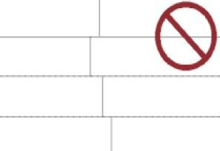

Avoid this plank placement

Room Layout - Establish the center for a well balanced look
  - At each end of the room (A, B) establish the center of the room. Then connect (A, B) using a chalk line, this will be the working line.

  - Next at the center, obtain a 90° angle using a carpenter’s square. Strike a second line; this will divide the room into balanced four equal parts.
  - After removing the protective back paper, carefully place the first plank at the junction of the chalk lines. Continue to lay the planks, making sure each plank is flush against the chalk or working line and tight against the adjoining plank, paying special attention to the seam edges.
  - Planks having DIRECTIONAL ARROWS stamped on the back must be installed in the same direction.

  - Planks can now be installed row by row in repeating length patterns of half or thirds.
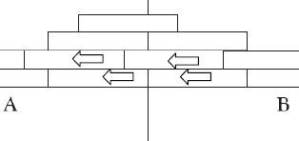

  - Fitting the end pieces. Measure the distance from the last installed plank in the row to the wall. Mark the plank and cut it against the mark. Lay the plank in place making sure that the cut edge is towards the wall.

  - Fitting Around Irregular Objects, Make a pattern out of heavy paper to fit around pipes and other irregularities. Place the pattern on the plank, trace, cutting along the trace lines with scissors or a sharp knife. Place the cut plank into position. For best results, roll installed planks with a minimum 100-lb roller after installation. Use a hand roller in areas not reached with a roller.

MAINTENANCE (Dos and DONTs)

DO
- Sweep or vacuum regularly.
- Use cleaning products safe for vinyl planks.
- TEST cleaning products before use. Mineral spirits applied to a clean rag can be used for spot cleaning.
- Use non-staining casters, floor protectors on chair and table legs to distribute furniture weight and protect against scratches and indentation damage. (Vinyl planks are scratch resistance, not scratch proof).
- Protect your floor against burns. Planks can be damaged by burns from a cigarette, matches, or other extremely hot items.
- Protect your floor from tracked-in dirt and grit particles by using natural-fiber mats at all outside entrances. Take the time to remove any imbedded grit particles from shoe soles before entering the room. Mats with rubber backings can cause permanent discoloration.
- Vinyl planks have good resistance to stains, not affected by most common household spills; however, any spill should be cleaned up immediately. The longer the spilled material is left on the floor, the greater the risk of permanently staining the floor.

DO NOT
- Do not use paste wax or solvent-based polishes.
- Do not use abrasive cleansers or mop with soap-based detergents, these products can leave a sticky film on your floor.
- Track in tar or asphalt from driveways, as this can also discolor vinyl.
- Use caution with stiletto type high heels on your floor, these can cause permanent damage.
- Avoid the use of rubber or latex-backed mats, as certain rubber compounds can permanently stain vinyl

(Consult the mat manufacturer to determine if the backing is safe for vinyl planks).
- Avoid exposure to direct sunlight for prolonged periods; this can result in tile discoloration. Excessive temperatures might cause tile expansion or edge curling. During peak sunlight hours, the use of drapes or blinds is recommended especially on patio doors, etc., that receive intense sunlight.
- (Vinyl Peel and Stick planks are water-proof, however high moisture from the subfloor or flood mopping can adversely affect the glue bond). DO NOT WASH INSTALLATION FOR 48 HOURS

More detail about vinyl peel and stick flooring,pls call us 0086-0573-87817298 Web:www.bocasrb.com
Whatsapp:008613656609288

.

