cheap steel sign fence posts y post from professional manufacturer

http://img1.cdn.tradew.com/Y201701M1571336T6G6353863/W0H0/.jpg

|  |  |
| --- | --- |
| Products | Steel fence post |
| Material | Q235B,Q195 |
| Standard | GB standard |
| SIZE | OD:21.3-219MM,THICKNESS:1.5-12MM,LENGTH:6-12M |
| Application | Fluid Convey,Fence,Structure,EMT, Water pipe |
| Payment Terms | L/C , T/T 、 Western Union ，etc. |

http://img1.cdn.tradew.com/Y201701M1571336T6G6353905/W0H0/.jpg

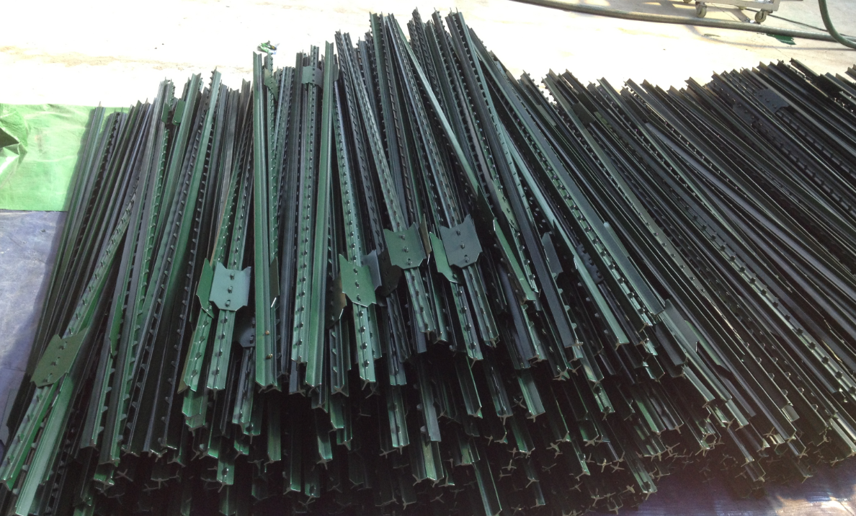

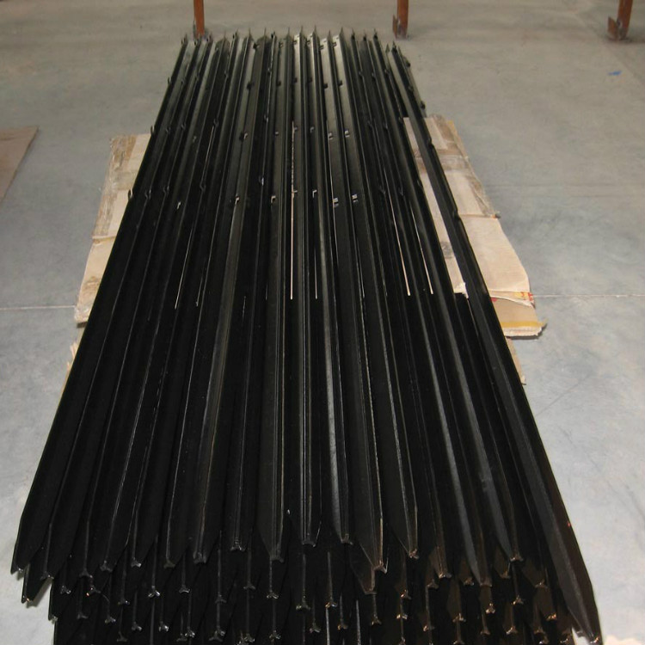

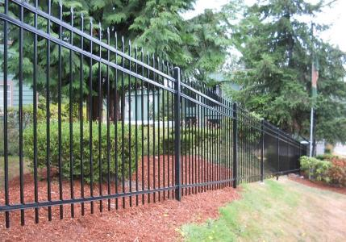

http://img1.cdn.tradew.com/Y201701M1571336T6G6353938/W0H0/.jpg

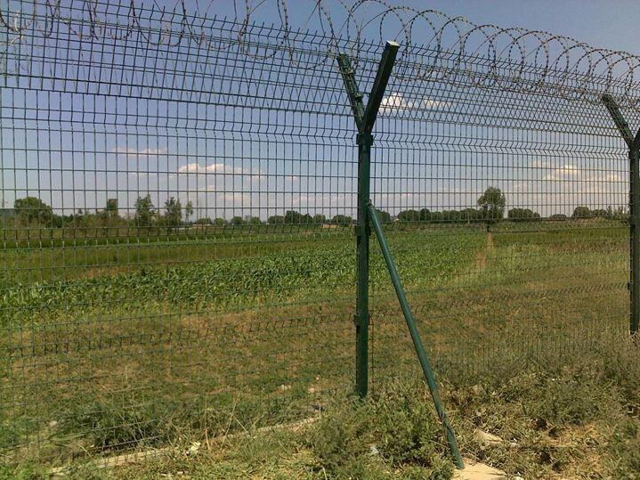             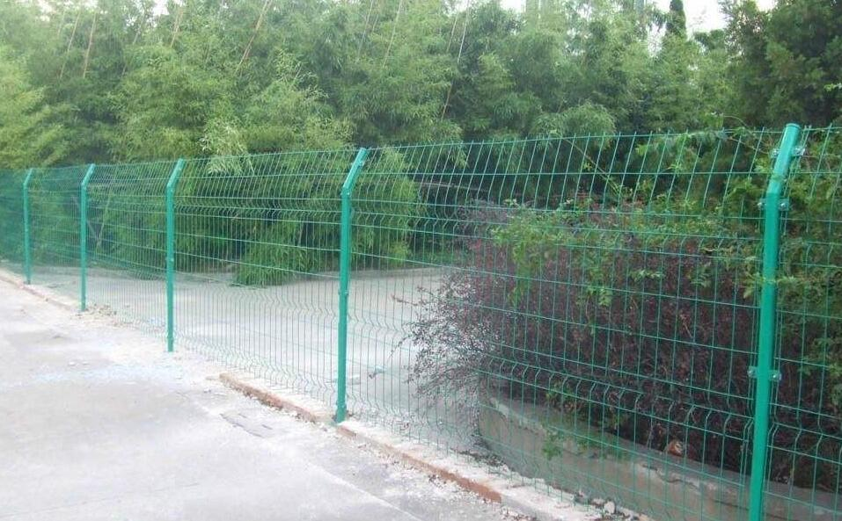

http://img1.cdn.tradew.com/Y201701M1571336T6G6353909/W0H0/.jpg

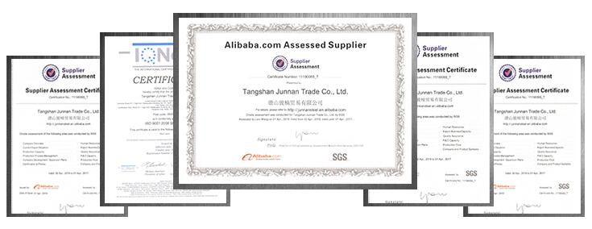

http://img1.cdn.tradew.com/Y201701M1571336T6G6353922/W0H0/.jpg



http://img1.cdn.tradew.com/Y201701M1571336T6G6353942/W0H0/.jpg



[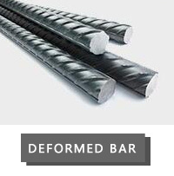](http://www.junnansteel.com/products2076026/Deformed-steel-bar.htm)       [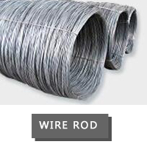](http://www.junnansteel.com/products2076027/Wire-Rod.htm)       [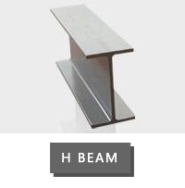](http://www.junnansteel.com/products2076031/H-beam.htm)

[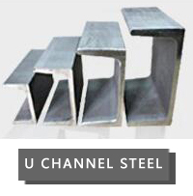](http://www.junnansteel.com/products2076033/U-channel.htm)       [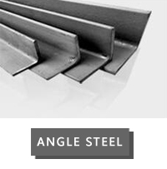](http://www.junnansteel.com/products2076034/Angel-steel.htm)       [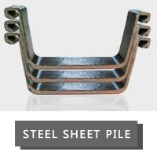](http://www.junnansteel.com/products2076035/Steel-sheet-pile.htm)