http://img1.cdn.tradew.com/Y201701M1571336T6G6344879/W0H0/.jpg**SAE1008 Hot Rolled Steel Wire Rod**

|  |  |
| --- | --- |
| Product Name | Wire rod |
| Wire diameter | 5.5-14mm |
| Material | Q235B,Q195,HPB300 |
| Authentication | SGS |
| Technique | Hot rolled |
| Application | Construction |

http://img1.cdn.tradew.com/Y201701M1571336T6G6344888/W0H0/.jpg

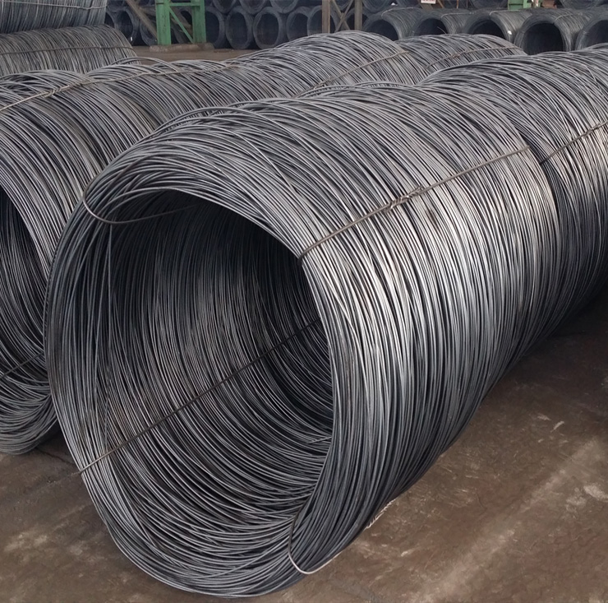

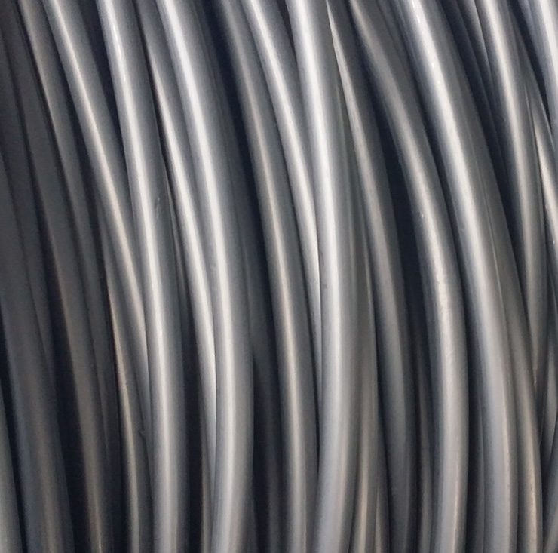

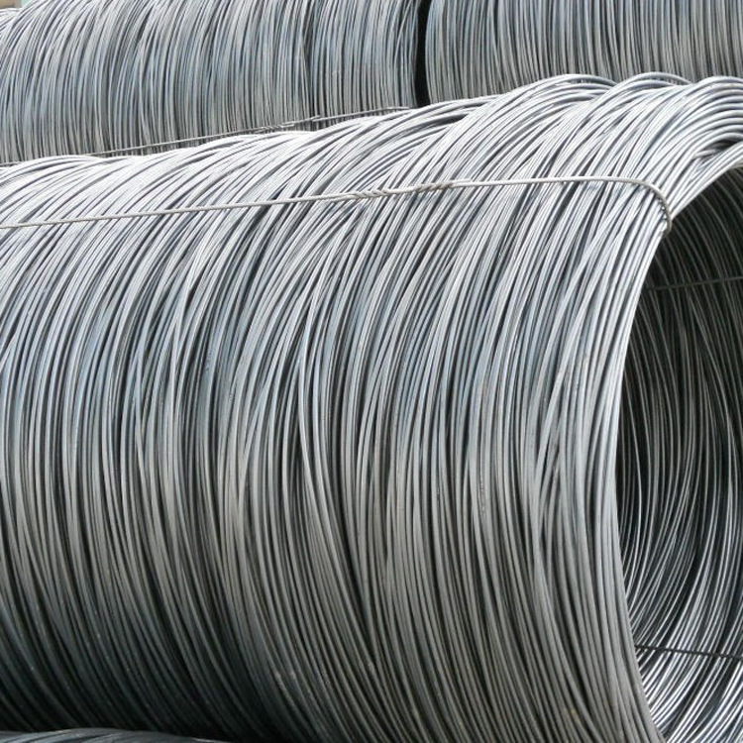

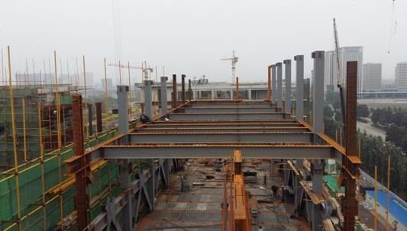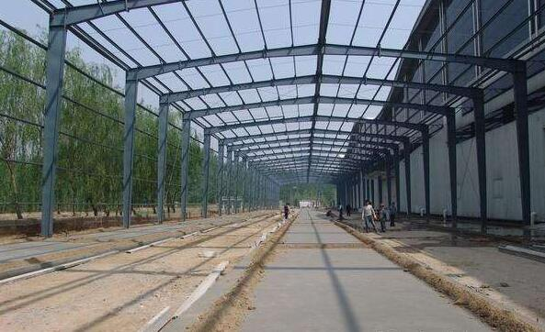http://img1.cdn.tradew.com/Y201701M1571336T6G6344921/W0H0/.jpg

http://img1.cdn.tradew.com/Y201701M1571336T6G6344940/W0H0/.jpg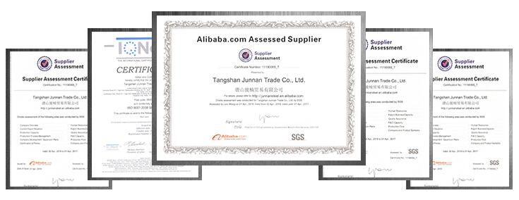http://img1.cdn.tradew.com/Y201701M1571336T6G6344933/W0H0/.jpg