**hot sale hot rolled steel sheet pile used for docks**

http://img1.cdn.tradew.com/Y201701M1571336T6G6344905/W0H0/.jpg

|  |  |
| --- | --- |
| Products | Steel sheet pile |
| Grade | SY295,SY390,Q345B,S355JR,S355JO,SYW295/390 |
| Standard | GB standard,JIS standard,EN standard |
| Length | 6m, 12m,Large quantity can be customized |
| Technique | Hot rolled |
| Application | Products for building harbor, shipyard, port, bridge, cofferdam and so on |
| Payment Terms | L/C , T/T or Western Union |

http://img1.cdn.tradew.com/Y201701M1571336T6G6344907/W0H0/.jpg

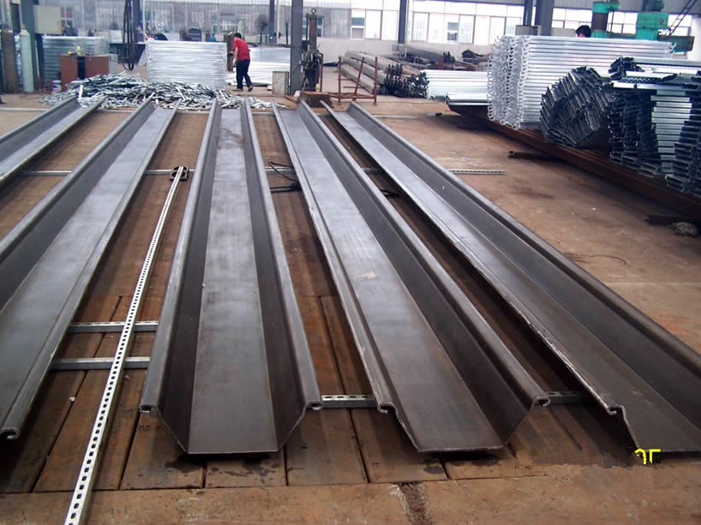

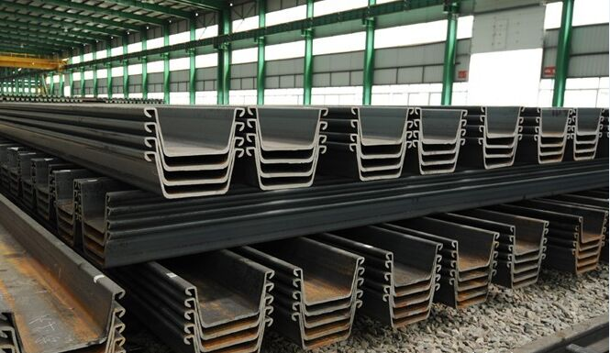

http://img1.cdn.tradew.com/Y201701M1571336T6G6344908/W0H0/.jpg

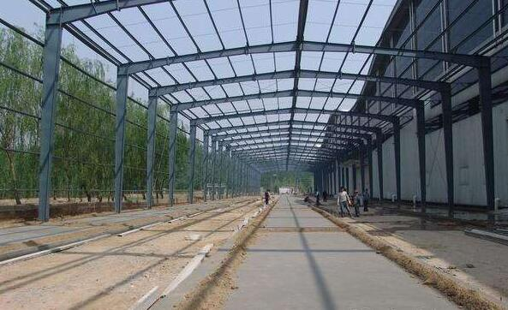          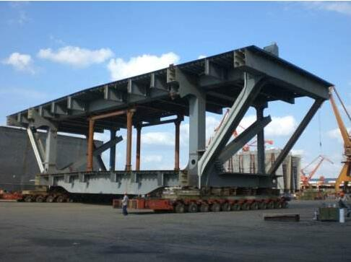

http://img1.cdn.tradew.com/Y201701M1571336T6G6344909/W0H0/.jpg

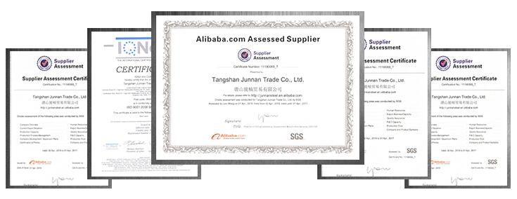

http://img1.cdn.tradew.com/Y201701M1571336T6G6344913/W0H0/.jpg



http://img1.cdn.tradew.com/Y201701M1571336T6G6344914/W0H0/.jpg



[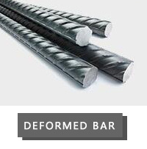](http://www.junnansteel.com/products2076026/Deformed-steel-bar.htm)     [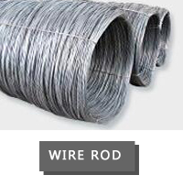](http://www.junnansteel.com/products2076027/Wire-Rod.htm)     [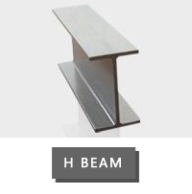](http://www.junnansteel.com/products2076031/H-beam.htm)

[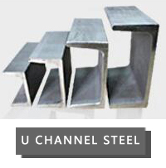](http://www.junnansteel.com/products2076033/U-channel.htm)     [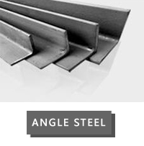](http://www.junnansteel.com/products2076034/Angel-steel.htm)     [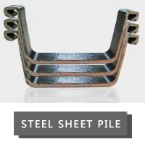](http://www.junnansteel.com/products2076035/Steel-sheet-pile.htm)