fluid pipe st37 mild steel seamless steel pipe
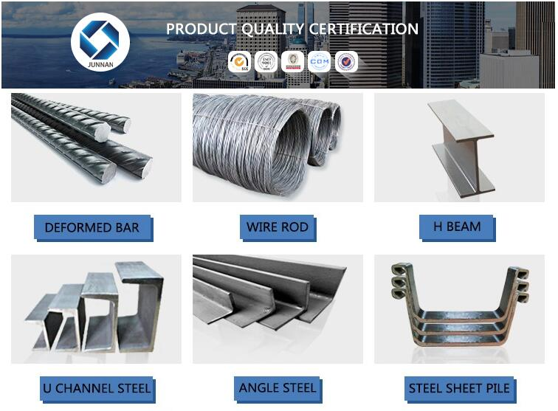

fluid pipe st37 mild steel seamless steel pipe
Name | api 5lb seamless steel pipe
Standard | ASTM A554, A249, A269 and A270, A312
Thickness | 0.3mm to 300mm ( Tolerance +/- 0.02mm )
Outer Diameter | 6mm to 159mm ( Tolerance +/- 0.02mm )
Length | 6m or as customers' request ( Tolerance +/- 5mm )
Application | Petroleum,Chemical enterprise, superheater of boiler, heat exchanger

