Round aisi 4140 alloy steel bars round bar aisi 4140 price for alloy steel round bar 4140
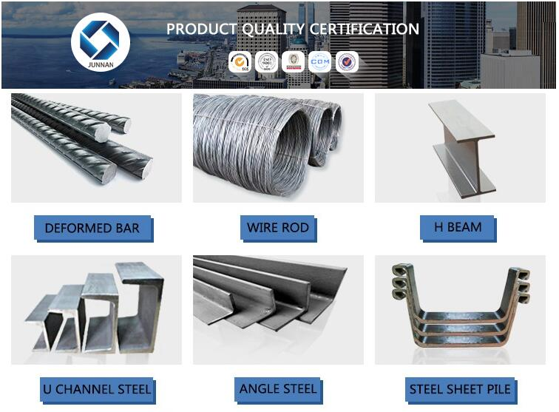

round bar
Products | round bar
Material | SS400 S45C S20C
Standard | ASTM A240,GB/T3280-2007,JIS4304-2005,ASTM A167
Length | 3-12m
Size | 8-400mm
Application | ships building industry,petroleum,chemical industries, war and electricity industries, food processing and medical industry, boiler heat exchanger, machinery and hardware fields.
Payment Terms | L/C , T/T or Western Union

