PPGI color coated galvanized steel plate in coil JIS standard SGCC grade
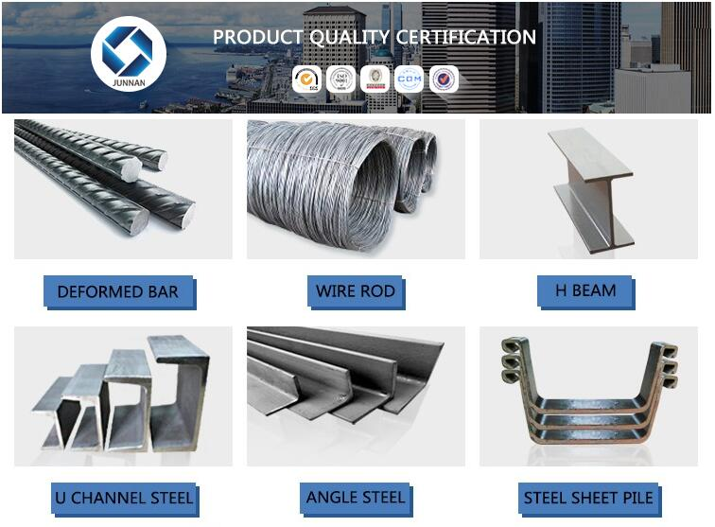

Product Details
Size | (0.13mm-5.0mm )*(600mm-1500mm)*coil
Steel Grade | JIS G3302 SGCC~SGC570,SGCH(FULL HARD-G550),SGHC~SGH540  EN 10346-DX51D+Z,DX53D+Z, S250GD~S550GD  ASTM A653M CS-B, SS255~SS550
Coil Weight | 3MT-14MT
Coil ID | 508mm/610mm
Chemical Treatment | Chromated(Cr 3+,6+,0+)
Surface | chromed / skinpass/ oiled/slightly oiled/ dry/ anti-fingerprint
Oil | Slight Oiled/Dry
Spangle | Regular/Zero/Big
Zinc Coating | Z40-Z300
Capacity | 1,500,000MT/year
Mill Origin | HBIS-Tangsteel,Shandong Zhongguan, Changshu Everbright, WISCO

Standard and Grade of HDG steel sheet/coil PPGI/PPGL
NAME | PPGI | GALVANIZED | GALVALUME/ALUZINC
STANDARD | EN10142  JIS G3302  GB/T-12754-2006 | ASTM A653  JIS G3302  SGCC/SGCH  GB/T2518  European Standard | ASTM A792  JIS G3321  JIS G3317
GRADE | CGCC  CGCH  CGCD1-CGCD3  CGC340-CGC570  GRADE | SS GRADE33-80  SGCC  SGCH  SGCD1-SGCD3  SGC340-SGC570  SGCC  DX51D | GRADE33-80  SGLCC  SGLCD  SGLCDD  SGLC400-SGLC570  SZACC  SZACH  SZAC340R
MODEL NO | 0.16MM-1.5MM*1250MM OR UNDER | (0.12-1.5)*1250MM OR UNDER | 0.16MM-1.5MM*1250MM OR UNDER
TYPE | Steel coil  Steel sheets/plates  Corrugated steel sheets/plates | Steel coil  Steel sheets/plates  Corrugated steel sheets/plates | Steel coil  Steel sheets/plates  Corrugated steel sheets/plates
TECHNIQUE | Hot rolled-cold rolled  -galvalume /galvanized  -PPGI/PPGL | Hot rolled-cold rolled  - galvanized | Hot rolled-cold rolled  -galvalume /Aluzinc
SURFACE  TREATMENT | Mini/regular/big/zero spangle,  Chromate treatment /chromate-free treatment /untreated unoile/oiled,  TENSION LEVELLERT SKIN PASS anti-fingerprint/un-anti-fingerprint,  Coating,color | Mini/regular/big/zero spangle,  Chromate treatment /chromate-free treatment /untreated unoile/oiled,  TENSION LEVELLERT SKIN PASS anti-fingerprint/un-anti-fingerprint,  Coating
APPLICATION | Structural use ,roofing, commercial use, household appliance, industry, family
SPECIAL  APPLICATION | Wear resistant steel, high- strength - steel plate

NAME | PPGI | GALVANIZED | GALVALUME/ALUZINC
STANDARD | EN10142  JIS G3302  GB/T-12754-2006 | ASTM A653  JIS G3302  SGCC/SGCH  GB/T2518  European Standard | ASTM A792  JIS G3321  JIS G3317
GRADE | CGCC  CGCH  CGCD1-CGCD3  CGC340-CGC570  GRADE | SS GRADE33-80  SGCC  SGCH  SGCD1-SGCD3  SGC340-SGC570  SGCC  DX51D | GRADE33-80  SGLCC  SGLCD  SGLCDD  SGLC400-SGLC570  SZACC  SZACH  SZAC340R
MODEL NO | 0.16MM-1.5MM*1250MM OR UNDER | (0.12-1.5)*1250MM OR UNDER | 0.16MM-1.5MM*1250MM OR UNDER
TYPE | Steel coil  Steel sheets/plates  Corrugated steel sheets/plates | Steel coil  Steel sheets/plates  Corrugated steel sheets/plates | Steel coil  Steel sheets/plates  Corrugated steel sheets/plates
TECHNIQUE | Hot rolled-cold rolled  -galvalume /galvanized  -PPGI/PPGL | Hot rolled-cold rolled  - galvanized | Hot rolled-cold rolled  -galvalume /Aluzinc
SURFACE  TREATMENT | Mini/regular/big/zero spangle,  Chromate treatment /chromate-free treatment /untreated unoile/oiled,  TENSION LEVELLERT SKIN PASS anti-fingerprint/un-anti-fingerprint,  Coating,color | Mini/regular/big/zero spangle,  Chromate treatment /chromate-free treatment /untreated unoile/oiled,  TENSION LEVELLERT SKIN PASS anti-fingerprint/un-anti-fingerprint,  Coating
APPLICATION | Structural use ,roofing, commercial use, household appliance, industry, family
SPECIAL  APPLICATION | Wear resistant steel, high- strength - steel plate

