JINXI Brand wide flange steel beam price list and theoretical weight A36 grade
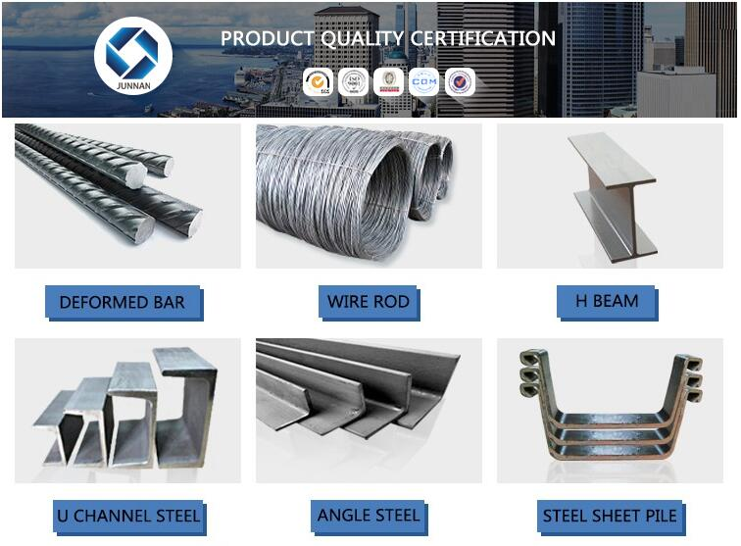

Grade | Q235,Q345,SS400,SS490,S235/S275,A36,A992,A572gr50
H*B | 100*100-900*300mm
T1 | 4.5-21mm
T2 | 7-35mm
Technique | Hot Rolled
Application | Mechanical&manufacture,Steel structure,Shipbuilding,  Bridging, Automobile chassis
MOQ | 20 Metric Ton/Metric Tons
Packaging Details | Bundled with firm steel straps, easy for loading
Delivery Time | 20 days after deposit
Payment Terms | L/C , T/T or Western Union
Supply Ability | 50000 Metric Ton/Metric Tons per Month

