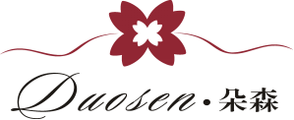

**Dongguan DuoSen Hair Accessory Co.,Ltd**

**Yi Mei Hair Accessory Factory**

Tel:86-0769-81513995 Skype:duosen1 Tax:86-0769-85103291 Email:icey@duosenfashion.com Web.:http://duosenfashion.com/

Add: NO.1 Nanshe Road, Dongfeng Village, Humen town, Dongguan City, Guangdong, China

**❀Silk Flower Hair Accessory❀**

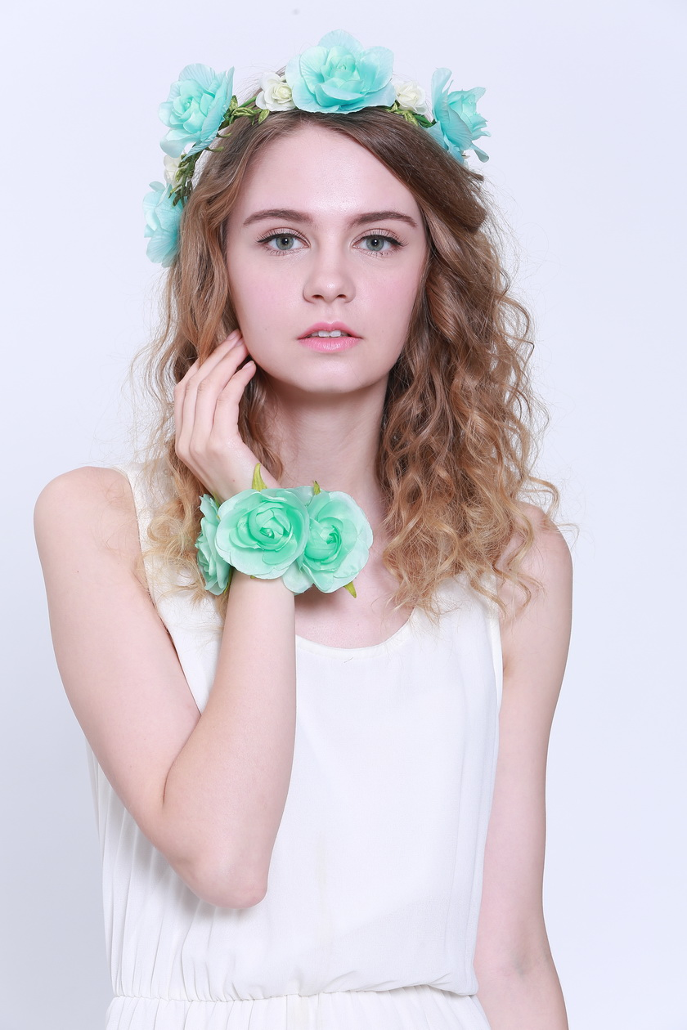

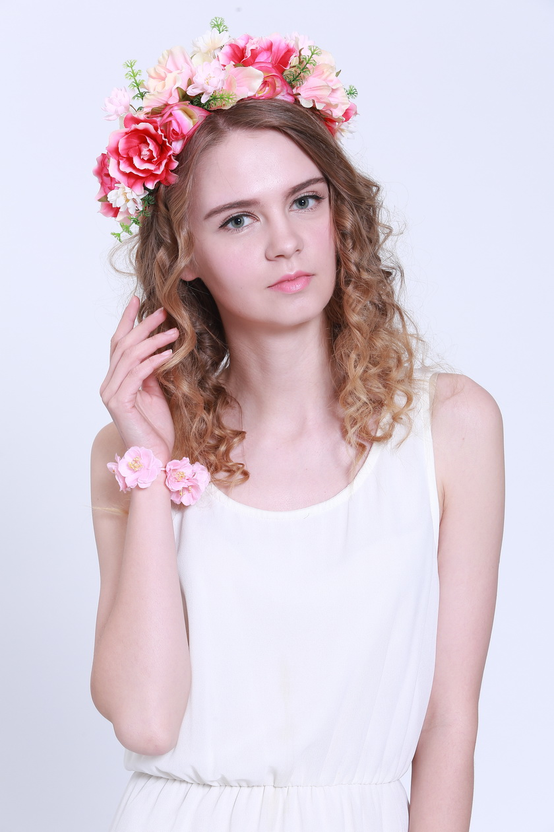

**Flower Crown**

1.**Model No.** DSXS/D-YMXS : Children,Kids,Babies,Toddlers

DS/D-YMTT : Adults,Teenager

2.**Type:**  Adjustable,unadjustable

3.**Dimension:**

|  |  |
| --- | --- |
| **(The size accept customized)** | **Kids / Adult** |
| **Inner crown diameter** | 18 cm |
| **Perimeter of crown** | 57 cm |

4.**Color:** Warm colour tone , cool colour tone ,base on pantone color

5.**Feature: 100%** Handmade

6.**Material:** Korean lining, import plain cloth, brushed fabric, electronic fabric,Ribbon, satin,paper ,soft wire,plaster flower core,wood bead,shell,ect.

7.**Element style:**  Crown ,butterfly,crystal ,ect.

8.**Occasion:** Travel,Party,Wedding,Christmas,Easter,Hallowmas,Daily life

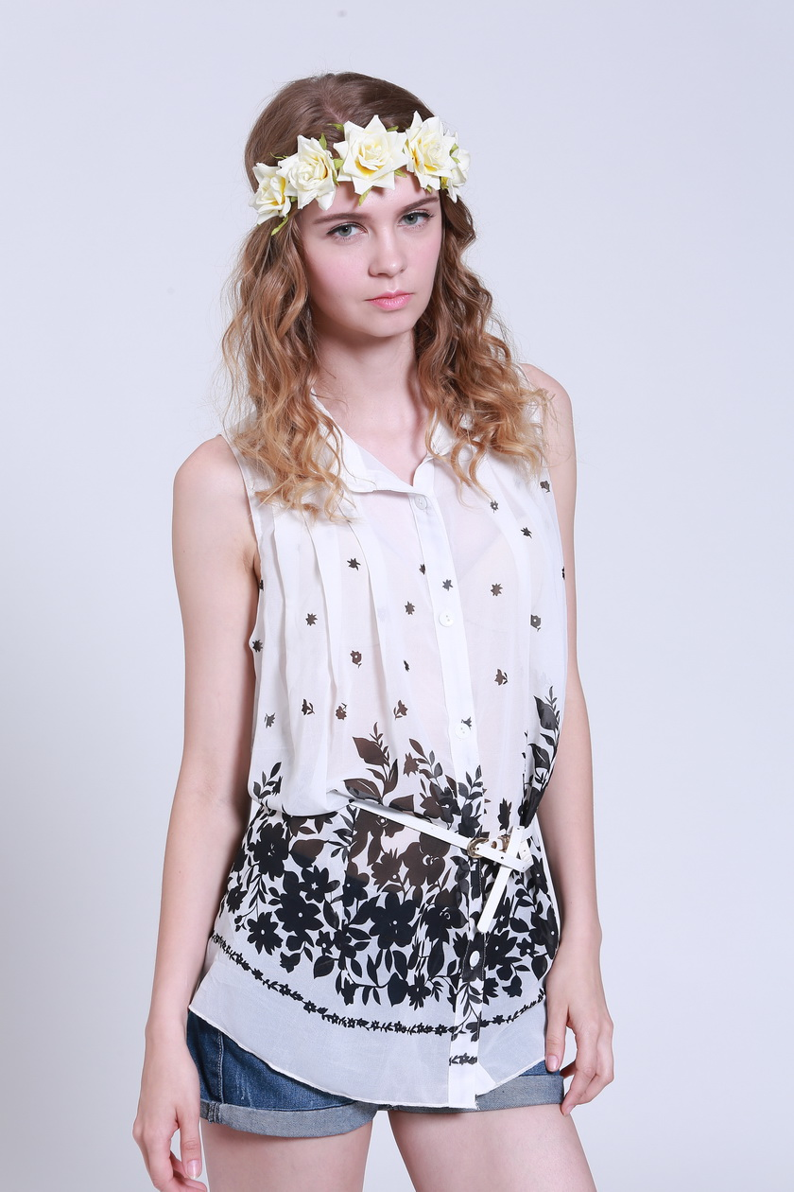

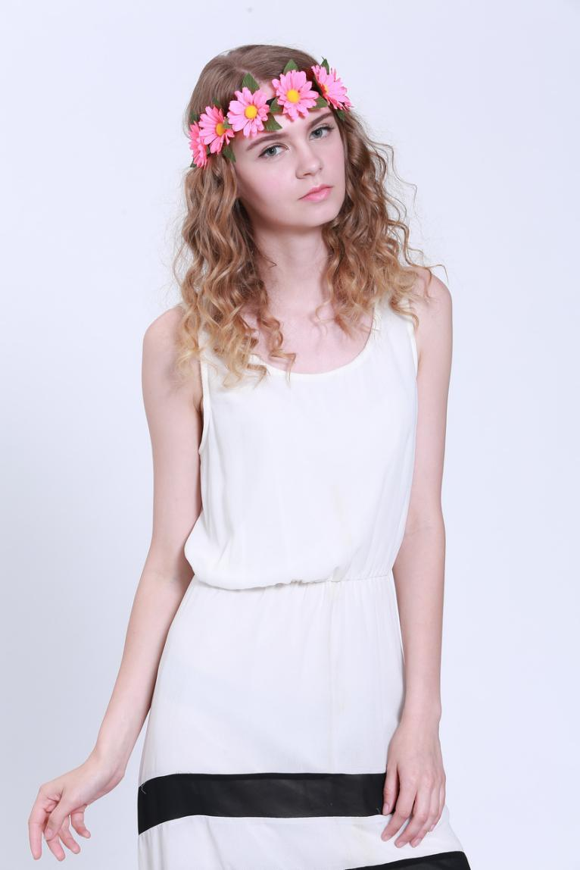

**Silk Flower Headband**

1.**Model No.** DSXS/D-YMXS : Children,Kids,Babies,Toddlers

DS/D-YMTT : Adults,Teenager

2.**Type:**  Adjustable,unadjustable

3.**Dimension** :

|  |  |  |
| --- | --- | --- |
| **(The size accept customized)** | **Kids** | **Adult** |
| **Inner crown diameter** | 22 cm | 26 cm |

4.**Color:** Warm colour tone , cool colour tone ,base on pantone color

5.**Feature: 100%** Handmade

6.**Material:** Korean lining, import plain cloth, brushed fabric, electronic fabric,Ribbon, satin,paper ,soft wire,flower core,wood bead,shell,faux leather rope ,ect.

7.**Element style:** Crown ,butterfly,crystal ,ect.

8.**Occasion:** Travel,Party,Wedding,Christmas,Easter,Hallowmas,Daily life

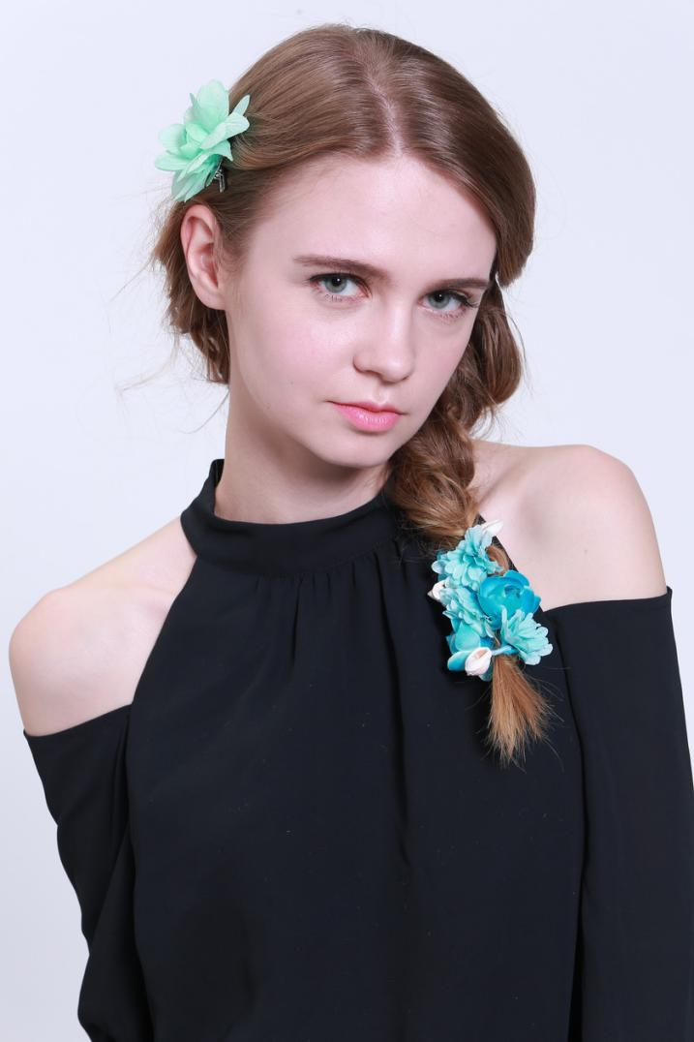

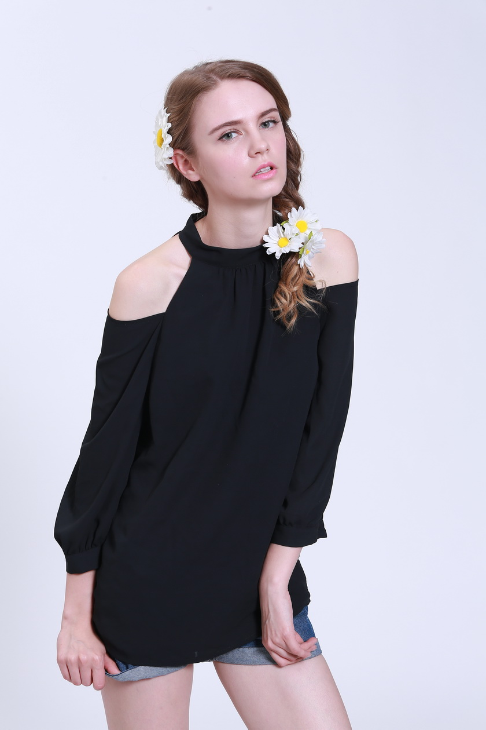

**Silk Flower hair clip & hair bun wrap**

1.**Model No.** DSXS/D-YMXS : Children,Kids,Babies,Toddlers

DS/D-YMTT : Adults,Teenager

2.**Type:**  toothed and toothless hair clip

4.**Color:** Warm colour tone , cool colour tone ,base on pantone color

5.**Feature: 100%** Handmade

6.**Material:** Korean lining, import plain cloth, brushed fabric, electronic fabric,Ribbon, satin,paper ,soft wire,flower core,wood bead,shell,faux leather rope ,ect.

7.**Element style:** Crown ,butterfly,crystal ,ect.

8.**Occasion:** Travel,Party,Wedding,Christmas,Easter,Hallowmas,Daily life

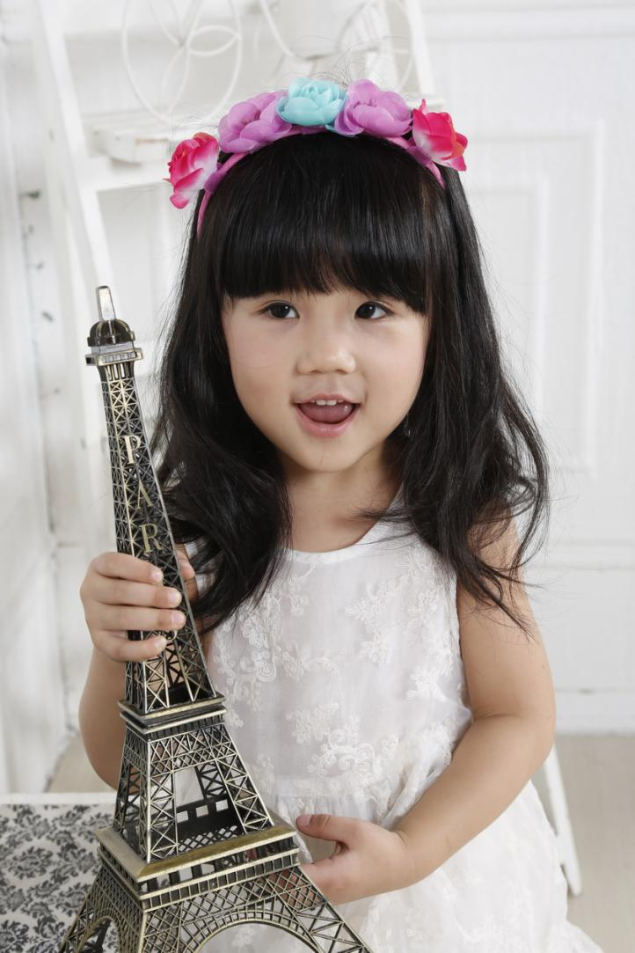

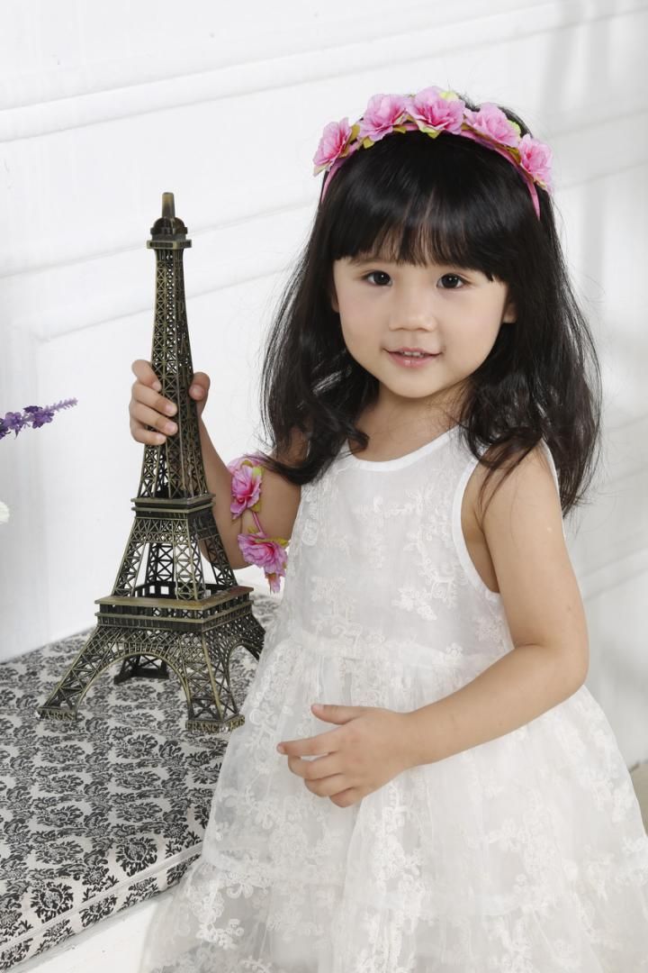

**Silk Flower Hair band / hair hoop / Alice band**

1.**Model No.** DSXS/D-YMXS : Children,Kids,Babies,Toddlers

DS/D-YMTT : Adults,Teenager

2.**Type:**

1. **Hoop wide (cm):** Plastic : 0.5 , 0.7, 1 , 1.2 , 1.5 , 2 , 3.5 , 4 , 5

Metal : 0.3 , 0.5 , 0.7

4.**Hoop material:** Plastic , Metal

5.**Color:** Warm colour tone , cool colour tone ,base on pantone color

6.**Feature: 100%** Handmade

7.**Material:** Korean lining, import plain cloth, brushed fabric, electronic fabric,Ribbon, satin,paper ,soft wire,flower core,wood bead,shell,faux leather rope ,ect.

8.**Element style:** Crown ,bunny ear,cat ear,butterfly,crystal ,ect.

9.**Occasion:** Travel,Party,Wedding,Christmas,Easter,Hallowmas,Daily life

**\*Remark:**

1. The dimension given above are used regularly.We also can make the special dimension of hair clip with your design.

2. If you has any requirement of special tests,please advice in advance,we'll use the material in strict regulations.Such as:

REACH ,EN71 ,AZO ,PH, Tensile test,Flame Retardant Test,ect.

3. We can provide hair clips with any shapes.If you need more designs or customized service for hair clip,please contsct us soon.