Supply Sigmatek Control HMI Accessorie
VICPAS HMI Parts Center supply Sigmatek Control HMI Accessorie for replaced, include touch screen panel, protective film, membrane keypad and LCD Display. Please find the form below for Sigmatek Control HMI model.

HMI Part No. | Size | Description | Accessories
Sigmatek Control HMI Accessories
ETT 732 | 7" |  | Touch Screen Panel Glass
ETT 0833 | 8.4" |  | Touch Screen Panel Glass
ETT 1033 | 10.1" |  | Touch Screen Panel Glass
ETT 1034 | 10.1" |  | Touch Screen Panel Glass
ETT 1044 | 10.1" |  | Touch Screen Panel Glass
TAE 1044 | 12.1" |  | Touch Screen Panel Glass
ETT 1233 | 12.1" |  | Touch Screen Panel Glass
ETT 1234 | 12.1" |  | Touch Screen Panel Glass
ETT 1244 | 12.1" |  | Touch Screen Panel Glass
TAE 1244 | 12.1" |  | Touch Screen Panel Glass
ETT 312 | 3.5" |  | Touch Screen Panel Glass
ETT 352 | 3.5" |  | Touch Screen Panel Glass
ETT 353 | 3.5" |  | Touch Screen Panel Glass
ETT 412 | 4.3" |  | Touch Screen Panel Glass
ETT 731 | 7" |  | Touch Screen Panel Glass
ETT 771 | 7" |  | Touch Screen Panel Glass
ETV 0811 | 8.4" | 12-230-0811 Einbauterminal VARAN ETV0811 | Touch Screen Panel Glass
ETV 1211 | 12.1" | 12-230-1211 Einbauterminal VARAN ETV1211 | Touch Screen Panel Glass
ETV 1221 | 12.1" | 12-230-1221 Einbauterminal VARAN ETV1221 | Touch Screen Panel Glass
ETV 1521 | 15" | 12-230-1521 Einbauterminal VARAN ETV1521 | Touch Screen Panel Glass
ETV 1581 | 15" | 12-230-1581 Einbauterminal VARAN ETV1581 | Touch Screen Panel Glass
ETV 1591 | 15" | 12-230-1591 Einbauterminal VARAN ETV01591 | Touch Screen Panel Glass
ETVA-0501 | 5.7" | 12-230-0501 Einbauterminal VARAN ETV0501 | Touch Screen Panel Glass
ETV0501 | 5.7" | 12-230-0501 Einbauterminal VARAN ETV0501 | Touch Screen Panel Glass
ETV 0551 | 5.7" | 12-230-0551 Einbauterminal VARAN ETV0551 | Touch Screen Panel Glass
ETV 0551-V | 5.7" | 12-230-0551-V Einbauterminal VARAN ETV0551-V | Touch Screen Panel Glass
ETV 0552 | 5.7" | 12-230-0552 Einbauterminal VARAN ETV0552 | Touch Screen Panel Glass
ETV0552-K | 5.7" | 12-230-0552-K Einbauterminal VARAN ETV0552-K | Touch Screen Panel Glass
ETV 0555 | 5.7" | 12-230-0555 Einbauterminal VARAN ETV0555 | Touch Screen Panel Glass
ETV 0833-3 |  |  | Touch Screen Panel Glass
ETV 0853-3 |  |  | Touch Screen Panel Glass
ETV 0851 | 8.4" | 12-230-0851 Einbauterminal VARAN ETV0851 | Touch Screen Panel Glass
ETV 0851-I | 8.4" | 12-230-0851-I Einbauterminal VARAN ETV0851-I | Touch Screen Panel Glass
ETV 0855 | 8.4" | 12-230-0855 Einbauterminal VARAN ETV0855 | Touch Screen Panel Glass
ETV 1251 | 12.1" | 12-230-1251 Einbauterminal VARAN ETV1251 | Touch Screen Panel Glass
ETV1521 | 15" | 12-230-1521 Einbauterminal VARAN ETV1521 | Touch Screen Panel Glass
ETV 1921 | 19" | 12-230-1921 Einbauterminal VARAN ETV1921 | Touch Screen Panel Glass
ETV1941-KD | 19" | 12-230-1941-KD Einbauterminal VARAN ETV1941-KD | Touch Screen Panel Glass
ETV1961-K | 19" | 12-230-1961-K Einbauterminal VARAN ETV1961-K | Touch Screen Panel Glass
ETV 1991 | 19" | 12-230-1991 Elnbauterminal VARAN ETV1991 | Touch Screen Panel Glass
ETV1991-K | 19" | 12-230-1991-K Elnbauterminal VARAN ETV1991-K | Touch Screen Panel Glass
ETV1992-K | 19" | 12-230-1992-K Elnbauterminal VARAN ETV1992-K | Touch Screen Panel Glass
ETT 1533 | 15" |  | Touch Screen Panel Glass
ETT 1534 | 15.6" |  | Touch Screen Panel Glass
ETT 1544 | 15.6" |  | Touch Screen Panel Glass
TAE 1544 | 15.6" |  | Touch Screen Panel Glass
ETT 1834 | 18.5" |  | Touch Screen Panel Glass
ETT 1844 | 18.5" |  | Touch Screen Panel Glass
TAE 1844 | 18.5" |  | Touch Screen Panel Glass
ETT 1933 | 19" |  | Touch Screen Panel Glass
ETT 2134 | 21.5" |  | Touch Screen Panel Glass
ETT 2144 | 21.5" |  | Touch Screen Panel Glass
ETT 2144-W | 21.5" |  | Touch Screen Panel Glass
TAE 2144 | 21.5" |  | Touch Screen Panel Glass
TT 1533 | 15" |  | Touch Screen Panel Glass
TT 1933-S | 18.5" |  | Touch Screen Panel Glass
TAE 2343 | 23.8" |  | Touch Screen Panel Glass
ETT 1561 | 15" |  | Touch Screen Panel Glass
ETT 1962 | 19" |  | Touch Screen Panel Glass
TAE0811 |  | 12-200-0811 Anzeigeeinheit TAE0811 | Touch Screen Panel Glass
TAE121 |  | 12-200-121 Anzeigeeinheit TAE121 | Touch Screen Panel Glass
TAE 151 | 15" | 12-200-151 Touch Anzeigeeinheit TAE151 | Touch Screen Panel Glass
TAE 1921 | 19" | 12-200-1921 Touch Anzeigeeinheit TAE1921 | Touch Screen Panel Glass
TAE1921-K | 19" | 12-200-1921-K Touch Anzeigeeinheit TAE1921-K | Touch Screen Panel Glass
TAE1922-K | 19" | 12-200-1922-K Touch Anzeigeeinheit TAE1922-K | Touch Screen Panel Glass
TAE 1931 | 19" | 12-200-1931 Touch Anzeigeeinheit TAE-1931 | Touch Screen Panel Glass
TAE 1941 | 19" | 12-200-1941 Touch Anzeigeeinheit TAE-1941 | Touch Screen Panel Glass
HGT 1051 | 10.1" |  | Touch Screen Panel Glass
HGW 1033 | 10.1" |  | Touch Screen Panel Glass
HGW 1033-01 | 10.1" |  | Touch Screen Panel Glass
HGW 1033-3 | 10.1" |  | Touch Screen Panel Glass
HGW 1033-32 | 10.1" |  | Touch Screen Panel Glass
BWH 001 |  |  | Touch Screen Panel Glass
BWH 011 |  |  | Touch Screen Panel Glass
HBG 0811 | 8.4" |  | Touch Screen Panel Glass
HBG 1011 | 10.4" |  | Touch Screen Panel Glass
HGT 835 | 8.4" |  | Touch Screen Panel Glass
HGT 1035 | 10.4" |  | Touch Screen Panel Glass
TE 401 | TE401 | Membrane Keypad Switch
TE 501 | TE501 | Membrane Keypad Switch
TE 891 | TE891 | Membrane Keypad Switch
ET1928L-7CWM-1-BG-3-G E815531 |  |  | Touch Screen Panel Glass
Sigmatek ET261 |  |  | Touch Screen Panel Glass
SIGMATEK M5V152 | 12-300-152 M5-Anzeigeeinheit 15z M5V152 |  | Touch Screen Panel Glass
Sigmatek CET281, Sigamtek 12-220-281 C-DIAS Einbauterminal CET281 |  |  | Touch Screen Panel Glass
SIGMATEK HGT833-W HGT834-W |  |  | Touch Screen Panel Glass
TTAE534 | 01-240-534-F Touch Anzeigeeinheit TTAE534 |  | Touch Screen Panel Glass

Product Description:
* Size 3.8~19 inch
General Size | 3.0" to 23″
Custom Size | 3.0″ to 24″
Fit in with | Panel display device
* Environmental ;
Temperature | Operating Range: -10°C ~ 60°C
 | Storage Range: -20° C ~ 70° C
Relative Humidity | Operating Range: 0%~90% RH (no dew falls)
 | Storage Range: 0% to 95% RH (no dew falls)
Altitude | Up to 3, 000m
* Electrical
Operation Voltage | Typical +DC 5V
Power Supply | USB or RS232
Interface | Full Duplex USB 2.0 (Full Speed) Plug and play compatible
 | Serial RS-232.
Current | 5mA~25mA
Electrostatic Endurance | No abnormal appearance after 10kv, 100Ω, 250PF electrostatic used
Isolation Resistance | > 20MΩ @ DC 25V

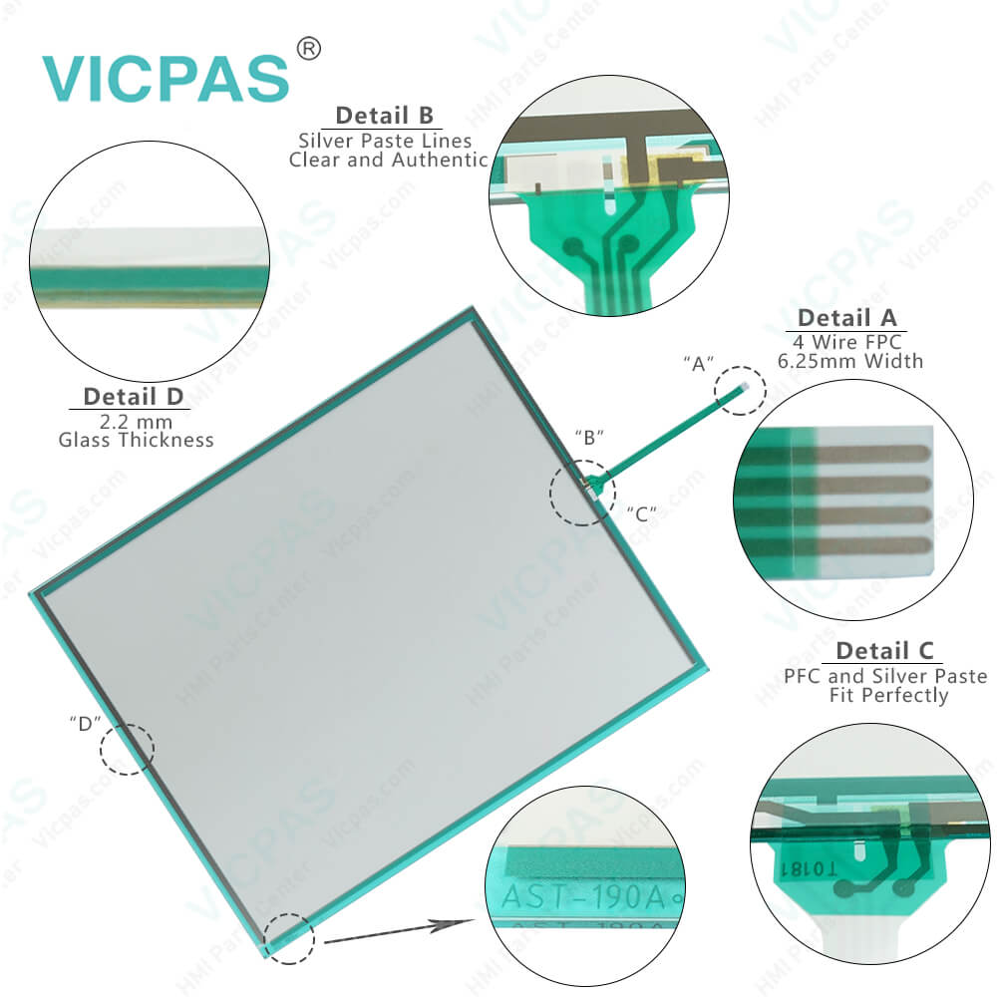

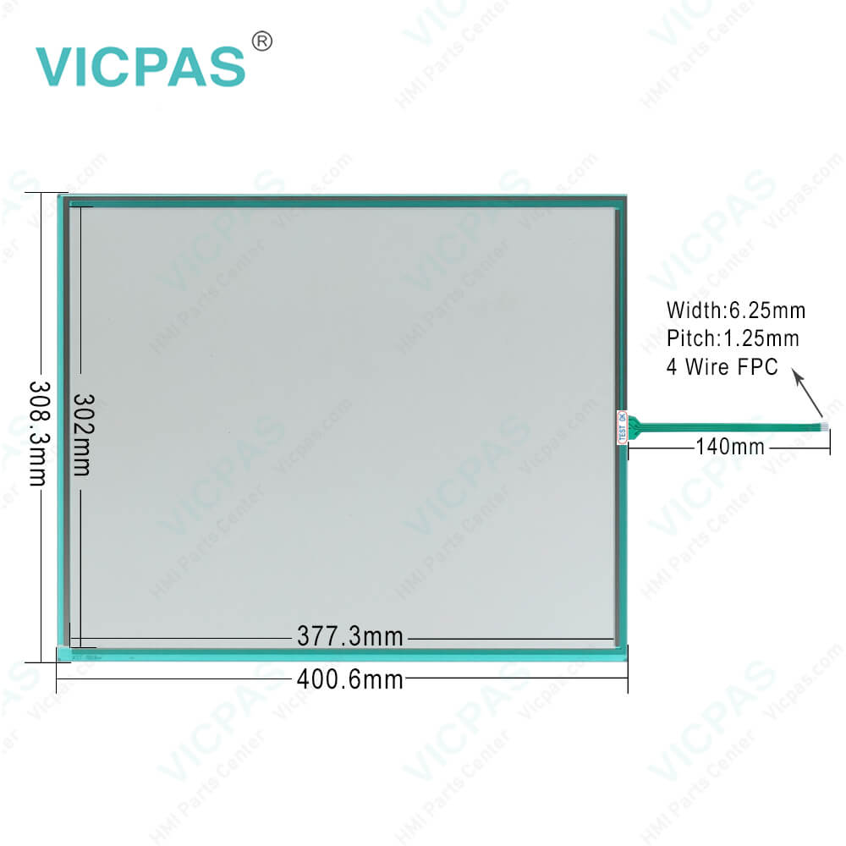
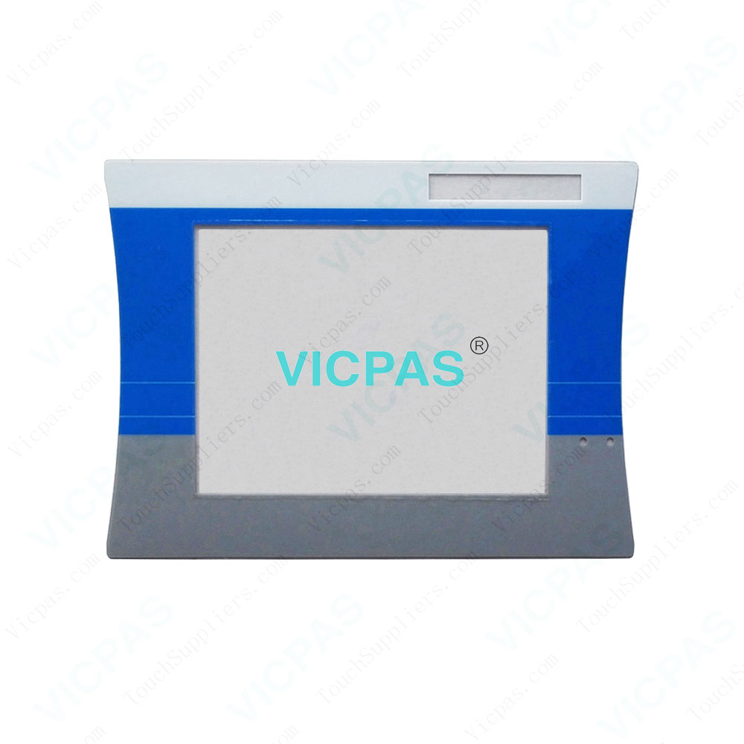

Condition:
All product are new, working in perfect condition,Meet bad environment,No need change any
shell and add any auxiliary to the HMI machine.

If you need more product detail, please contact us immediately. We will provide you with the best solution.

Company Profile:

Guangzhou Vicpas Touch Technology Co.,Ltd using only the best materials and exacting standards of quality assurance, is committed to customer satisfaction in the Highest Quality Material, Large size, High light transmittance, Free of Maintaining, Complete Reliability, Superior Product Durability, Design Flexibility, World-Class Service and Support:
*The ITO film imported from Japan, with long life cycle-more than 1 million touches in one location without failure;
*Drift free, Deviation of Error below 1.5%, suitable for the operation;

Our Advantages:
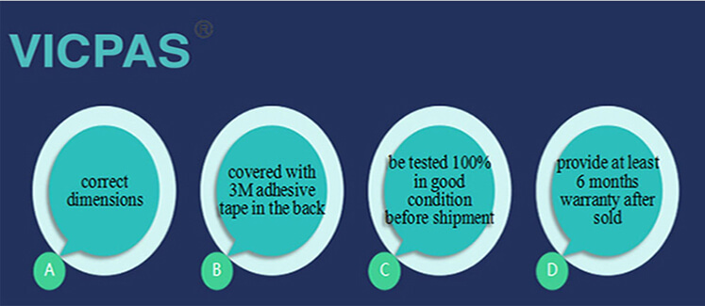
- Low cost
- Finger, gloved hand and stylus activation
- High accuracy and sensitivity
- High durability and reliability
- Contaminant proof and liquid resistance
- OEM is available.
To get more detail for OEM

Certifications:
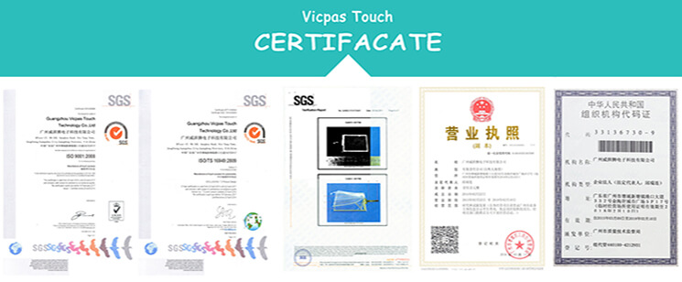

Packaging&Shopping:
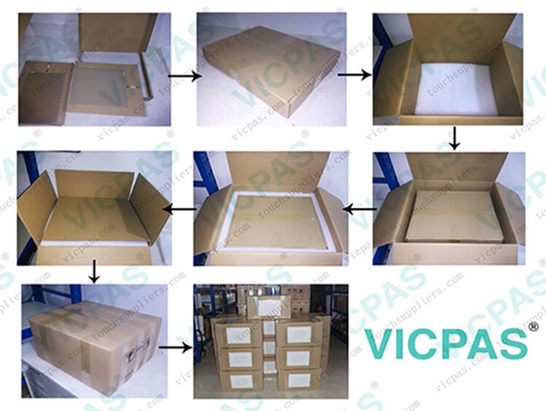
Packaging:
Outer packing is strong carton with Five corrugating medium, inner packing is foam which would protect the product in well condition.

Shipping:
We are shipping the goods to every country of the world!
Usually the goods will be sent at the next working day after payment, the shipping time depends on your country of residence, depending on your country's customs!
Our shipping method is Hong Kong DHL ,other shipping methods, such as Fedex is OK!
To get more detail for shipping
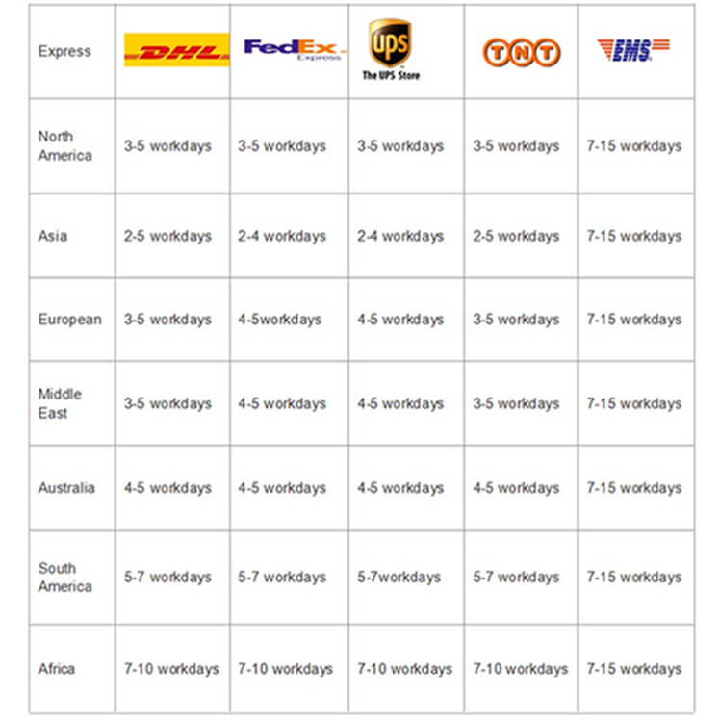

Our Services:
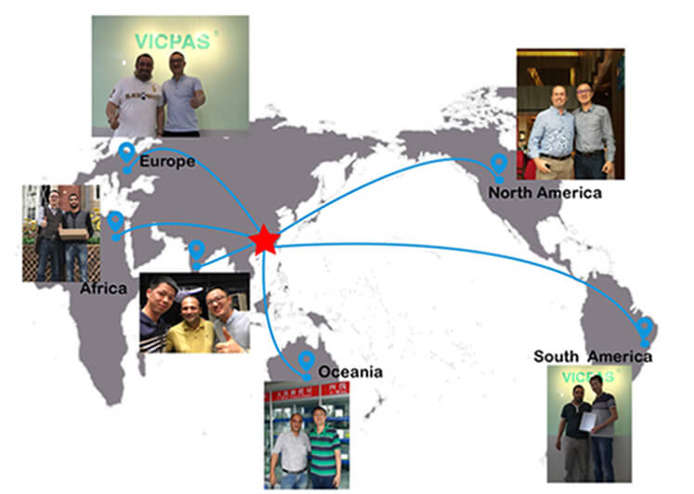
VICPAS has employed a variety of methods to improve the performance of the entire work force with a superior customer service strategy , aiming to provide excellent service and high quality products to meet or even exceed our customer`s expectations.
The key features of VICPAS customer service are as below:
1.Systematic management system to delivery right products to our customers.
2.Strictly quality control management system to maintain quality at sustainable level.
3.Honesty Culture makes sure to be your long term strategic partner in China
4.Unique and creative products and competitive price keep you in a competitive market position in harsh marketing environment.
5. VICPAS provide a 1 year warranty for all the touch screens and 6 months warranty for all the membrane keyboard.

FAQ:
Thank you very much for your interest in VICPAS products and VICPAS Company, below are few questions you may want answers.

1. What is the structure of a resistive single touch screen?
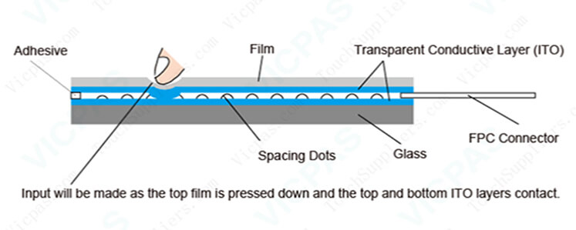
4wire and 5wire resistive touch screen is a two-layer structure, two materials (film or glass) with ITO are attached with a gap between them so that the ITO layers are facing each other. Touch input will be made as the top layer is pressed down and the two ITO layers contact. There are insulators called spacing dots between the top and bottom ITO layers. These spacing dots prevent unintended contacts (inputs) of the ITO layers when not pressed.

2. How to clean a touch screen?
Cleaning with a Microfiber Cloth
- Choose a microfiber cloth. This is ideal for cleaning a touchscreen. Some devices will have such a cloth included or perhaps you can borrow one you use on your sunglasses.
- Turn off the device before commencing to clean it. It is usually much easier to see where to clean when the device is switched off.
- Give the screen a once over by brushing it with the microfiber in small circles.This will remove the majority of simple imperfections.
- Only if truly needed, moisten a cotton cloth, even the corner of your cotton shirt, and repeat the small circular motions. It may actually be enough to just breathe over the screen and use that moisture to clean with.
- Brush again with the microfiber cloth to finish off. Don't over-rub though! And if there is any dampness left, just leave it to air dry.Do not put too much pressure on the screen when cleaning it.
- Wash the microfiber cloth.

3. Can I use a resistive single touch screen with mitten?
Of course, a resistive single touch screen can be used with mitten.

4. How long is the operation life of a resistive single touch screen from VICPAS?
12 million touches are guaranteed for a 4 wire touch screen.
37 million touches are guaranteed for a 5 wire touch screen.

5. If I need a resistive single touch screen whose specifications are tailored to my needs.
VICPAS can provide a resistive single touch screen customized to your requested specifications. Please contact us for more details.

6. How is your production management and quality control system?
VICPAS develops process - oriented QMS to identify and meet needs of customer requirement and expectation in an effective and efficient manner to achieve competitive advantage.
All our product process follows up ISO9001: income quality checking, in process quality checking, final product quality checking. The strict implementation of ISO9001 assures to provide error – free products to our customers.
We will show you these in our workshop during your visiting.
If you are interested in our products,please contact us for further information without hesitate.We will reply you as soon as we receive your inquiry.
VICPAS Looking forword to your cooperation.

