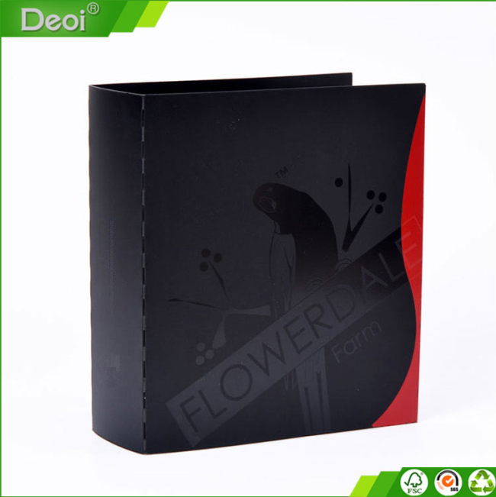 | Name | Australian stationery
 | Type | JY-L049
 | Material&Thickness
 | Size
 | Printing | cmyk+white UV printing
 | Packing
 | HS Code | 3926100000
 | Carton size/weight
 | Quantity | 5000/10000/50000
 | Unit price(USD)

