SHANGHAI JINYUAN PLASTIC PRODUCTS CO.,LTD

Product Description

1. File folder
E310 file folder
Product name： | E310 file folder/L shape file folder
Material： | Environmental mirror PP, Cape through
Product Specifications： | A4
Product Size（mm）：  Expand Size（mm）： | 310*220  460*640----2 piece
Material thickness（mm）： | 0.2
Product Weight（g）： | 22.5
printing art： | CMYK+white Offset printing ink in printing
Production Process： | Produced films - Printing - die - Ultrasound - Packaging

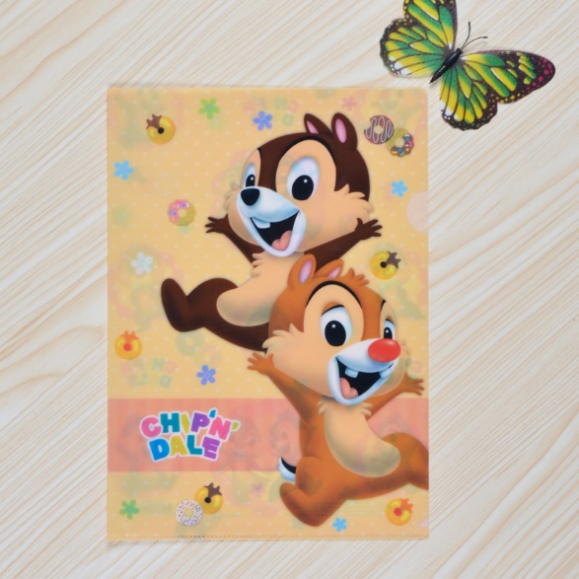

3 in file folder
Product name： | 3 in file folder
Material： | Environmental mirror PP, Cape through
Product Specifications： | A4
Product Size（mm）：  Expand Size（mm）： | 310*220  460*640----1 piece
Material thickness（mm）： | 0.2
Product Weight（g）： | 48.4
Printing art： | Cover and inside pages are  CMYK + white offset printing, ink is printed inside
Production Process： | Produced films - Printing - die - Ultrasound - Packaging
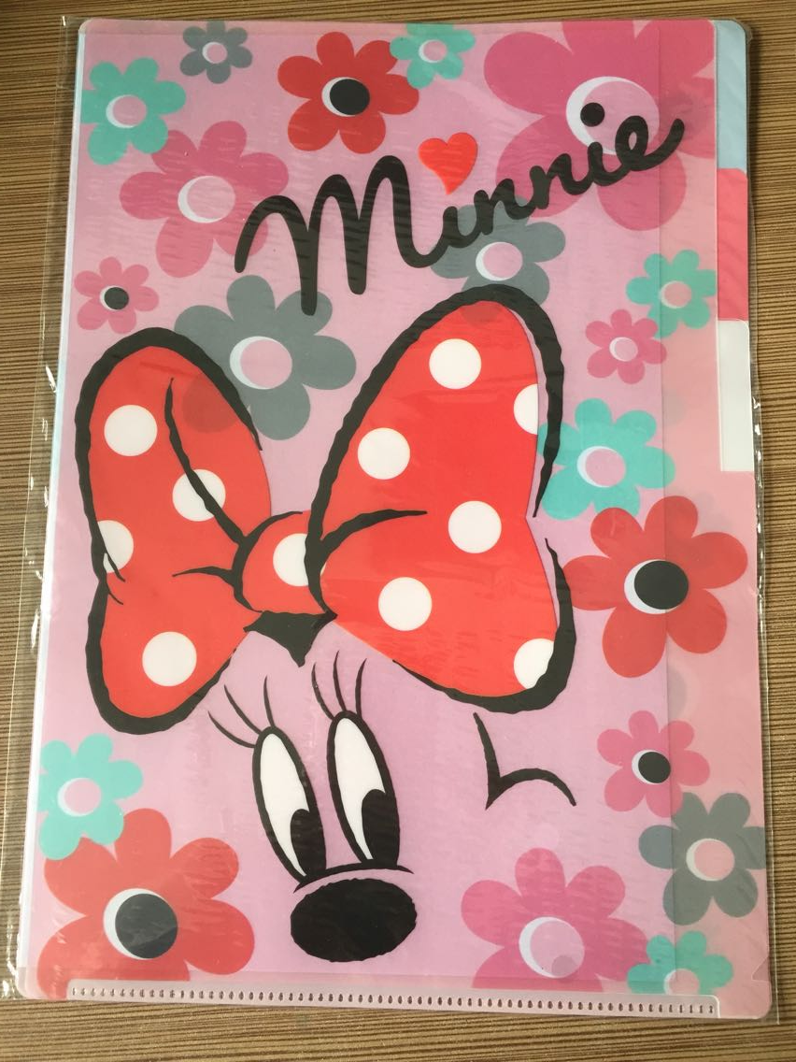

4 in file folder
Product name： | 4 in file folder
Material： | Environmental mirror PP, Cape through
Product Specifications： | A4
Product Size（mm）：  Expand Size（mm）： | 310*220  460*640--1piece，320*230---1 piece
Material thickness（mm）： | 0.2
Product Weight（g）： | 58.5
printing art： | Cover and inside pages are  CMYK + white offset printing, ink is printed inside
Production Process： | Produced films - Printing - die - Ultrasound - Packaging
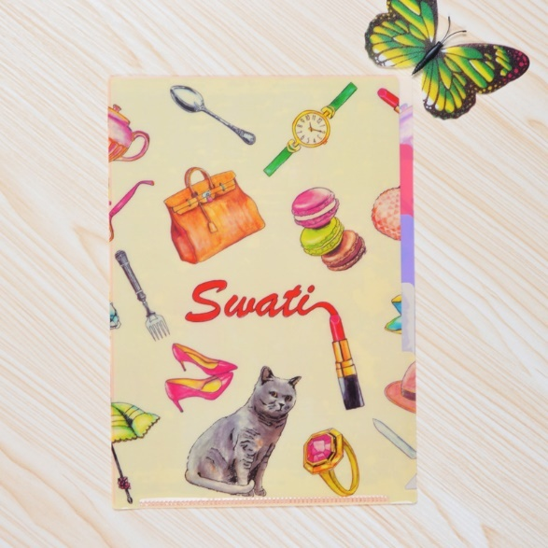

5 in file folder
Product name： | 5 in file folder
Material： | Environmental mirror PP, Cape through
Product Specifications： | A4
Product Size（mm）：  Expand Size（mm）： | 310*235  480*645-----2 piece
Material thickness（mm）： | 0.2
Product Weight（g）： | 74.8
printing art： | Front and back covers CMYK + white offset  Ink in print, in the page does not print
Production Process： | Produced films - Printing - die - Ultrasound - Packaging
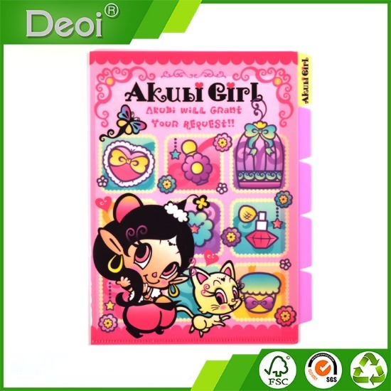

10 in file folder
Product name： | 10 in file folder
Material： | Environmental mirror PP, front and back covers of Cape transparent material, inside color material
Product Specifications： | A4
Product Size（mm）：  Expand Size（mm）： | 310*235  490*650------2 piece
Material thickness（mm）： | 0.2
Product Weight（g）： | 154
printing art： | Front and back covers CMYK + white offset  Ink in print, in the page does not print
Production Process： | Produced films - Printing - die - Ultrasound - Packaging
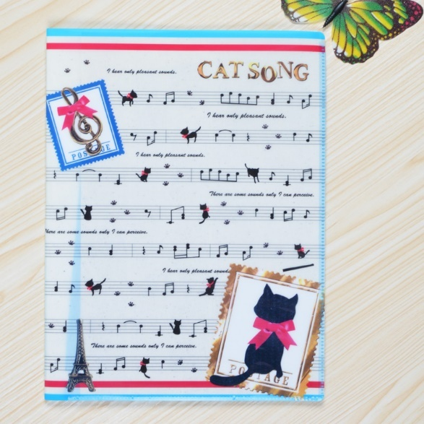

File folder with a zipper
Product name： | File folder with a zipper
Material： | Environmental mirror PP, front and back covers Cape thoroughly, inside color
Product Specifications： | A4
Product Size（mm）：  Expand Size（mm）： | 310*235  490*650------2 piece
Material thickness（mm）： | 0.2
Product Weight（g）： | 103.5
printing art： | Front and back covers CMYK + white offset  Ink in print, in the page does not print
Production Process： | Produced films - Printing - die - pressed zipper - hot - Ultrasound - Packaging
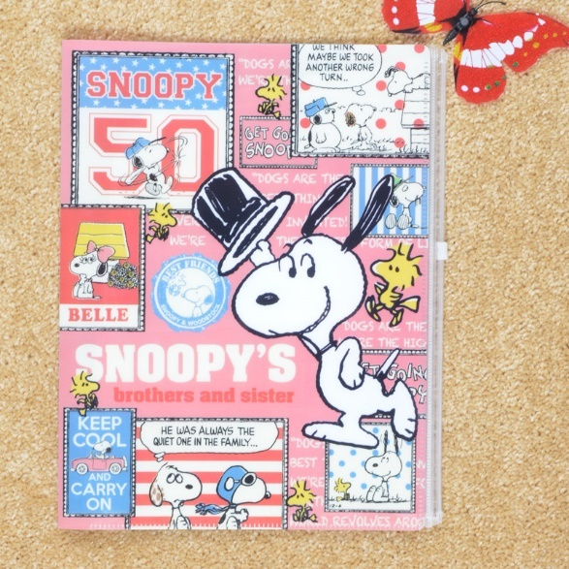

Open type 5 in folder
Product name： | Open type 5 in folder
Material： | Environmental protection PP mirror cover, transparent material, color pages
Product Specifications： | A4
Product Size（mm）：  Expand Size（mm）： | 310*240  920*650------2 piece
Material thickness（mm）： | 0.2
Product Weight（g）： | 103.5
printing art： | Front and back covers CMYK + white offset printing ink in printing, printing on the boot
Production Process： | Produced films - Printing - die - Ultrasound - Packaging
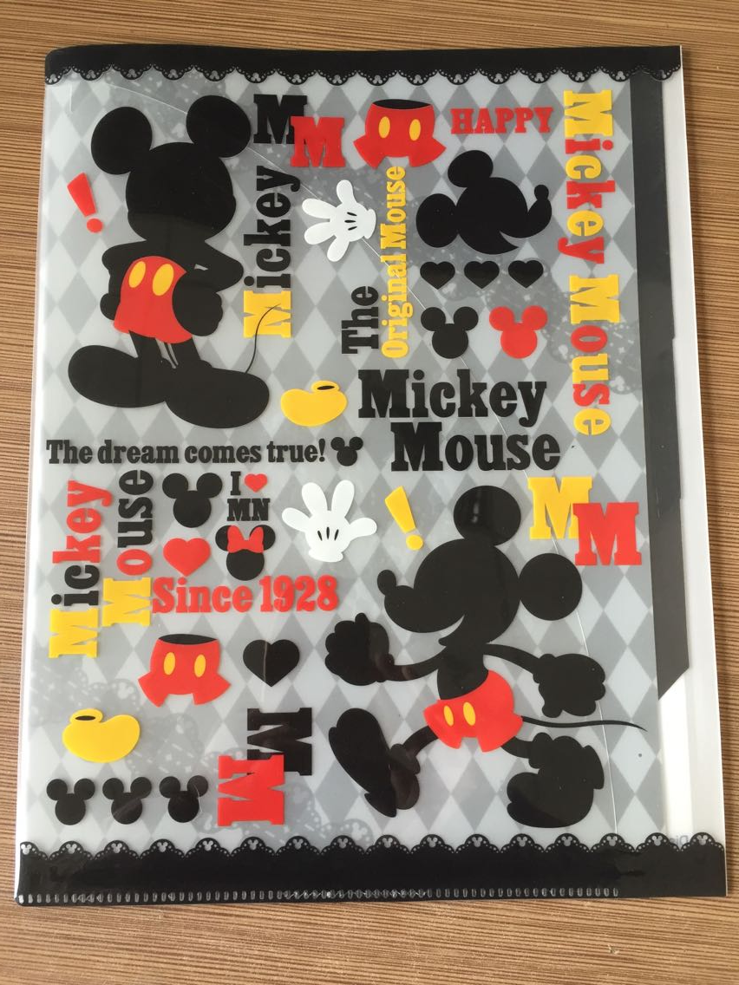

Powerful folder
Product name： | Powerful folder
Material： | Green frosted PP, material qualities
Product Specifications： | A4
Product Size（mm）：  Expand Size（mm）： | 310*240*20  520*640----2 piece
Material thickness（mm）： | 0.8
Product Weight（g）： | 140
printing art： | 1 color screen printing
Production Process： | Produced films - Printing - die - Nail jig - Packaging

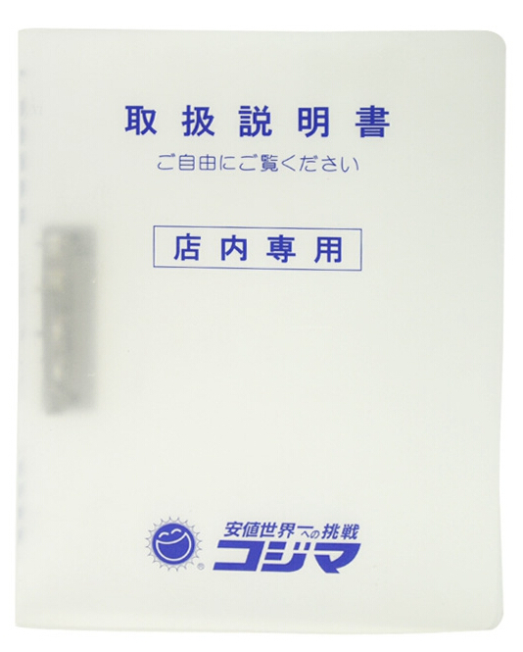

Loose-leaf binder

Product name： | Loose-leaf binder
Material： | Environmental protection double-sided matte PP, translucent green
Product Specifications： | A4
Product Size（mm）：  Expand Size（mm）： | 310*240*40  540*640----2 piece
Material thickness（mm）： | 0.92
Product Weight（g）： | 168.2
printing art： | gilding
Production Process： | Products - stamping die cutting nail fixture - pressure - packing strap
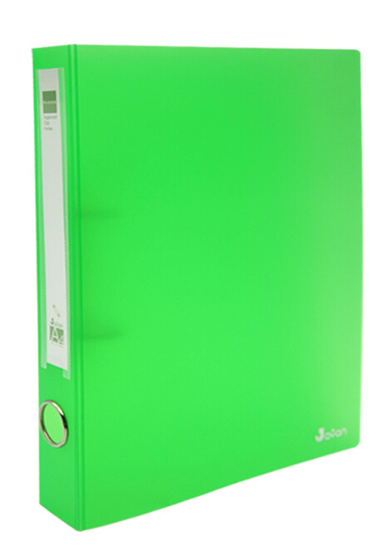

2. File package
Loose-leaf binder

Product name： | File package
Material： | Environmental protection double-sided matte PP (metal blue)
Product Specifications： | A4
Product Size（mm）：  Expand Size（mm）： | 318*238*40  420*720----1 piece
Material thickness（mm）： | 0.5
Product Weight（g）： | 89
printing art： | Bronzing LOGO
Production Process： | Produced films - stamping - die - stick Velcro - ultrasonic - Packaging
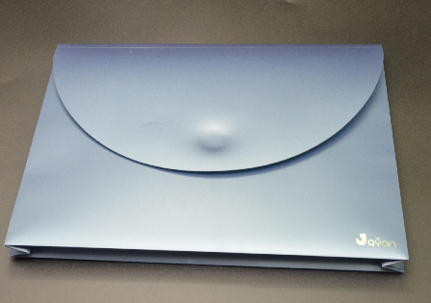

File package
Product name： | File package
Material： | Environmental sided matte PP, white
Product Specifications： | A4
Product Size（mm）：  Expand Size（mm）： | 323*240*40  680*420----1 piece
Material thickness（mm）： | 0.81
Product Weight（g）： | 187.4
printing art： | Offset CMYK + white, is printed
Production Process： | Produced films - Printing - die - clinch - Ultrasound - Packaging
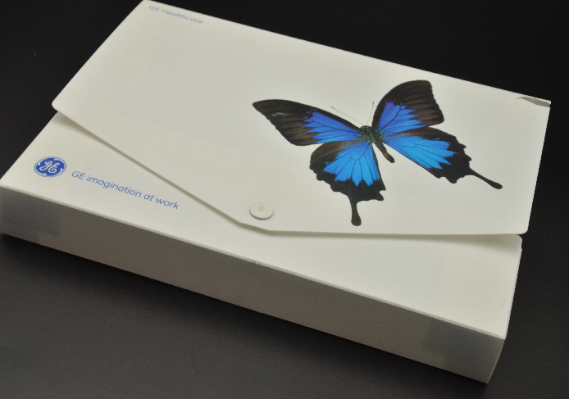

File package
Product name： | File package
Material： | Environmental sided matte PP, Cape transparent material
Product Specifications： | A4
Product Size（mm）：  Expand Size（mm）： | 310*245
Material thickness（mm）： | 0.46
Product Weight（g）： | 90
printing art： | CMYK + white offset printing ink in printing
Production Process： | Produced films - Printing - die - wear elastic band - Packaging
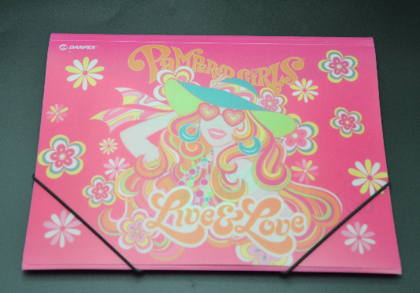

3. Material bag
Product name： | Material bag
Material： | Environmental mirror PP, Cape transparent material
Product Specifications： | A4
Product Size（mm）：  Expand Size（mm）： | 344*250*30
Material thickness（mm）： | 0.2
Product Weight（g）： | 37.8
printing art： | CMYK + white offset printing ink in printing
Production Process： | Produced films - Printing - die - pressed zipper - hot - Nail Corner - Packaging
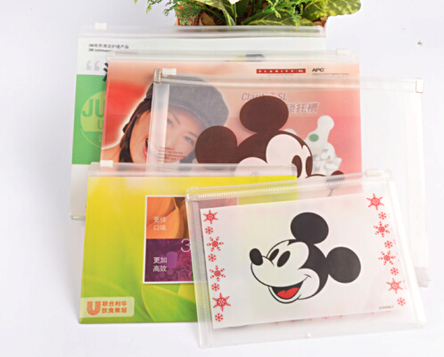

4.Information Booklet
Information Booklet
Product name： | Information Booklet
Material： | Environmental sided matte PP, white material
Product Specifications： | B5
Product Size（mm）：  In-page size（mm）：  Expand Size (mm): | 235*160*10  320*227mm  380*500*0.6-----2 piece
Material Thickness (mm):  Inside Thickness (mm): | 0.6  Single 0.4
Product Weight (g): | 64.4
printing art: | CMYK + white offset printing, ink is printed
Production process: | Produced films - Printing - die - Ultrasonic inside pages - Packaging
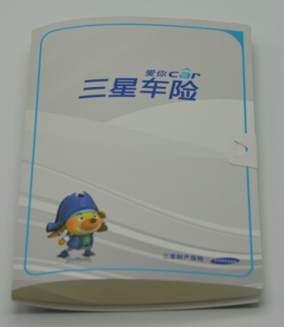

Information Booklet
Product name： | Information Booklet
Material： | Environmental sided matte PP, translucent blue
Product Size（mm）：  In-page size（mm）：  Expand Size (mm): | 315 * 235 * 16,  471 * 315 * 20  650 * 505 ---- 2 fight
Material Thickness (mm):  Inside Thickness (mm): | 0.65mm  Single 0.04mm
Product Weight (g): | 194.4
printing art: | CMYK + white offset printing ink in printing
Production process: | Produced films - Printing - die - Ultrasonic inside pages - Packaging

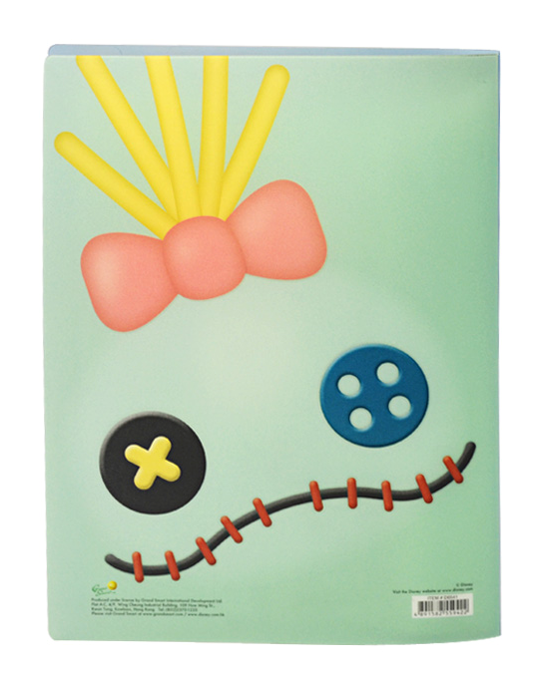

Information Booklet
Product name： | Information Booklet
Material： | Environmental sided matte PP, translucent blue
Product Size（mm）：  In-page size（mm）：  Expand Size (mm): | 319 * 235 * 15  505 * 670 ---- 2 fight  47.1 * 319 (20-page)
Material Thickness (mm):  Inside Thickness (mm): | 0.61  8 double wire
Product Weight (g): | 168.2
printing art: | No printing
Production process: | Produced films - Printing - die - Ultrasonic inside pages - Packaging
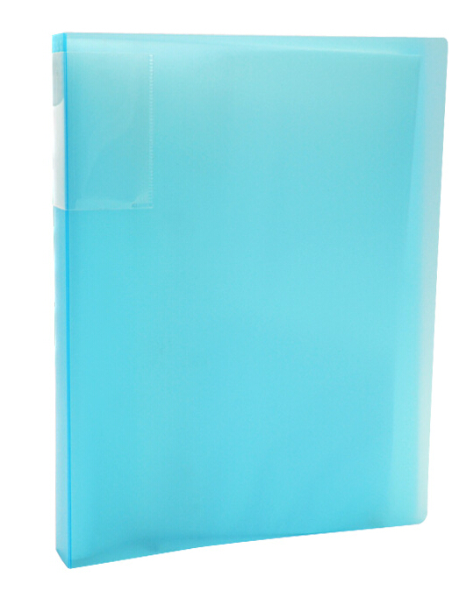

5.Slipcase

Product name： | Slipcase
Material： | Environmental mirror PP, Cape through
Product Specifications： | B5
Product Size（mm）：  Expand Size（mm）： | 220 * 155  490 * 690 ----- 3 fight
Material thickness（mm）： | 0.17
Product Weight（g）： | 16.4
printing art： | CMYK + white offset printing ink in printing
Production Process： | Produced films - Printing - die - Ultrasound - Packaging
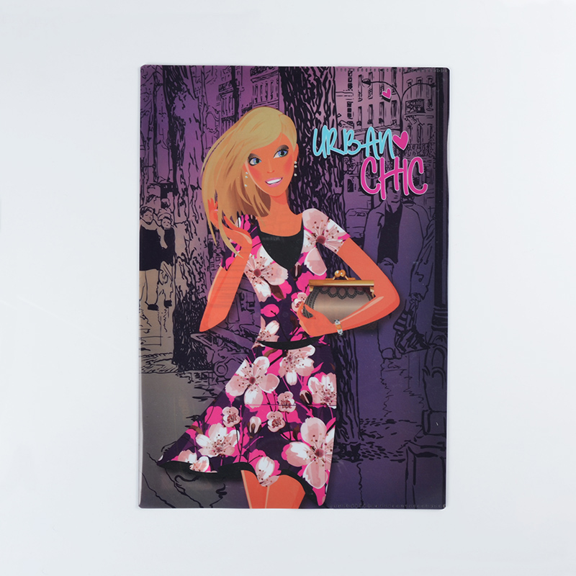

6.Expanding File

Product name： | Organ bags, Georgia 12PP
Material： | Green frosted PP, transparent
Product Specifications： | A4
Product Size（mm）：  Expand Size (mm): | 310*240*30  720*330---1 piece
Material Thickness (mm):  Inside Thickness (mm): | 0.6  0.2
Product Weight (g): | 288
Printing art: | CMYK + white offset printing ink in printing
Production Process | Produced films - Printing - die - a combination of internal pockets - hot - Ultrasound - clinch - wear elastic band - Packaging

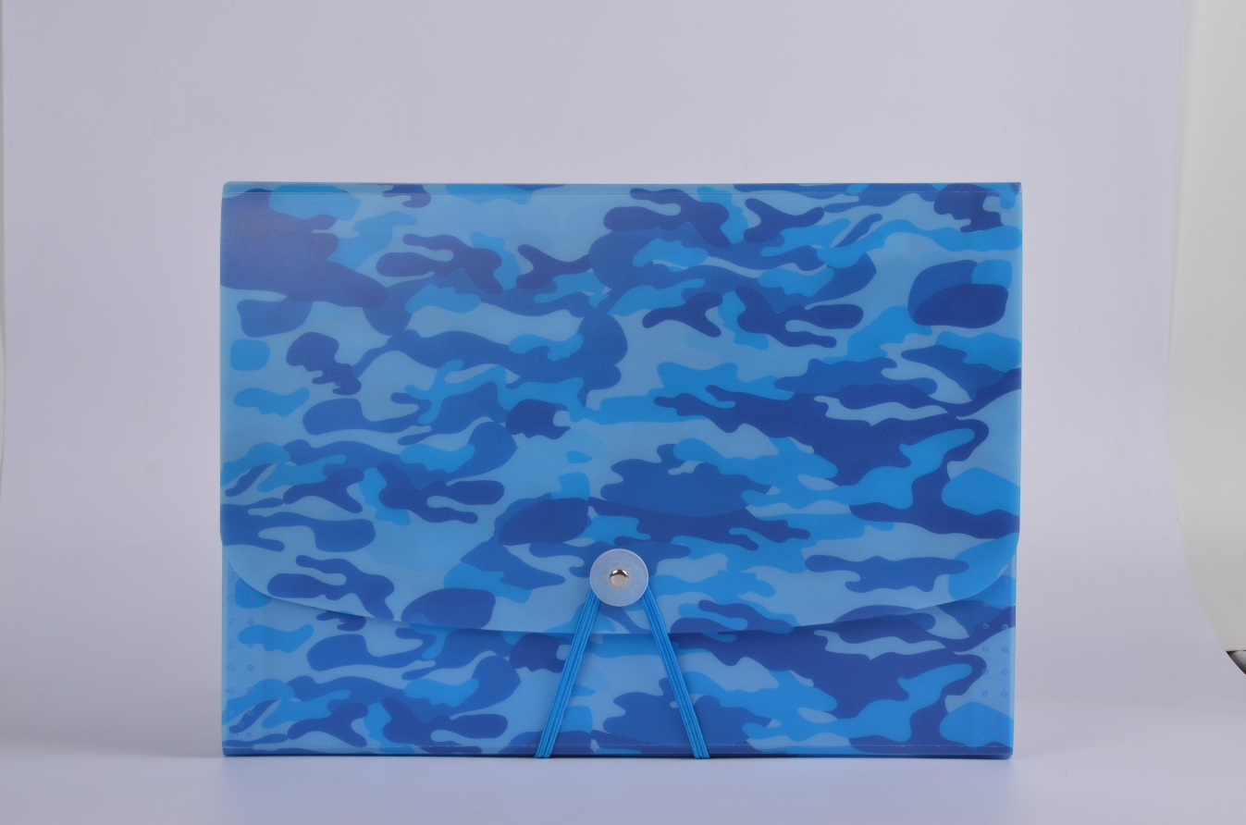

Suede organ package

Product name： | Suede organ package
Material： | Suede + cardboard + green PP
Product Specifications： | A4
Product Size（mm）： | 220 * 155
Material thickness（mm）： | 0.2
Product Weight（g）： | 603.6
printing art： | No
Production Process： | Produced films - die - a combination of inside pages - sewing - the buckle - Packaging
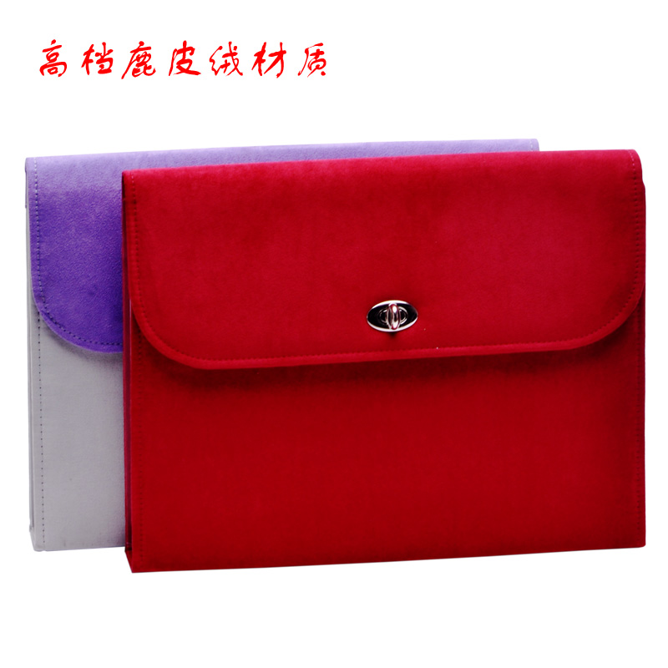

7. Plate

Product name： | PET Plate
Material： | Environmental protection mirror PET, transparent material
Product Specifications：
Product Size（mm）：  Expand Size (mm): | 250*180  390*530-----4 piece
Material thickness（mm）： | 0.55
Product Weight（g）： | 34
printing art： | CMYK+ white offset printing ink
Production Process： | Film production - Printing - die - cutting - packaging

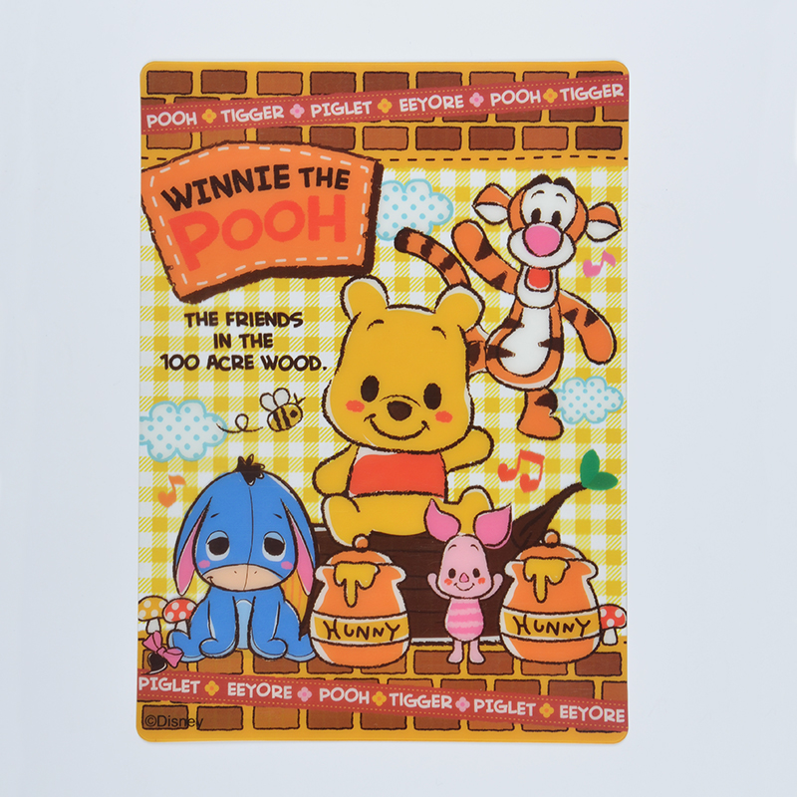

PET Plate

Product name： | PET Plate
Material： | Environmental protection PP, one side matte side light,  Transparent material
Product Specifications：
Product Size（mm）：  Expand Size (mm): | 290*180  610*390----4 piece
Material thickness（mm）： | 0.67
Product Weight（g）： | 30.2
printing art： | CMYK+ white offset printing ink
Production Process： | Film production - Printing - die - cutting - packaging

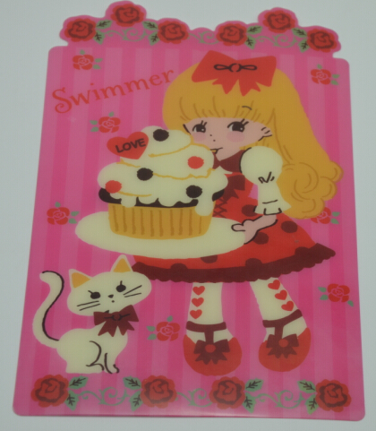

8.Mat

Product name： | Mat
Material： | Environmental protection double-sided matte PP, orange material
Product Specifications：
Product Size（mm）：  Expand Size (mm): | 388*292  410*615----2
Material thickness（mm）： | 0.7
Product Weight（g）： | 58.8
printing art： | 1 color screen printing
Production Process： | Film production - Printing - die - cutting - packaging
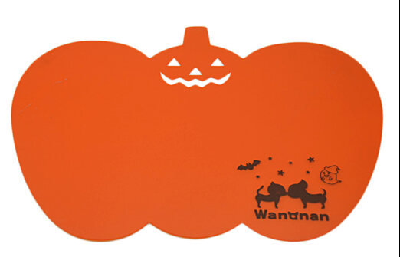

Mat

Product name： | Mat
Material： | Environmental sided matte PP, white material
Product Specifications：
Product Size（mm）：  Expand Size (mm): | 398*258  415*550---2
Material thickness（mm）： | 0.5
Product Weight（g）： | 45.8
printing art： | CMYK + white offset printing, ink is printed
Production Process： | Film production - Printing - die - cutting - packaging

Product name： | Mat
Material： | Environmental sided matte PP, white material
Product Specifications：
Product Size（mm）：  Expand Size (mm): | 285*427  600*450---2
Material thickness（mm）： | 0.56
Product Weight（g）： | 51
printing art： | CMYK + white offset printing, ink is printed
Production Process： | Film production - Printing - die - cutting - packaging

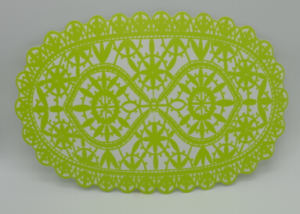

9. Advertising fan

Product name： | 7 folding
Material： | Environmental PP, side light side of the sand, Pu transparent material
Product Specifications：
Product Size（mm）：  Expand Size (mm): | 180 * 70 (folded size)
Material thickness（mm）： | 0.6
Product Weight（g）： | 28.8
printing art： | CMYK + white offset printing, ink is printed
Production Process： | Film production - Printing - die - cutting - packaging
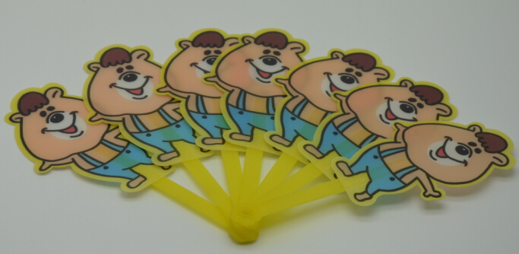

Product name： | Advertising fan
Material： | Green frosted PP, double-sided Matte, general permeable material
Product Specifications：
Product Size（mm）：  Expand Size (mm): | 265*165
Material thickness（mm）： | 0.67
Product Weight（g）： | 14.2
printing art： | CMYK + white offset printing, ink is printed
Production Process： | Film production - Printing - die - cutting - packaging

Product name： | Advertising fan
Material： | Green glossy PP, Cape through
Product Specifications：
Product Size（mm）：  Expand Size (mm): | 290*180
Material thickness（mm）： | 0.5
Product Weight（g）： | 22
printing art： | CMYK + white offset printing, ink is printed
Production Process： | Film production - Printing - die - cutting - packaging

10. Portable Notebook
Product name： | Portable Notebook
Material： | Environmental sided matte PP, white material
Product Specifications：
Product Size（mm）：  Expand Size (mm): | 305*175*6
Material thickness（mm）： | 0.4
Product Weight（g）： | 218
printing art： | CMYK + white offset printing, ink is printed
Production Process： | Produced films - Printing - die - Loading and coil - loaded handle - Packaging

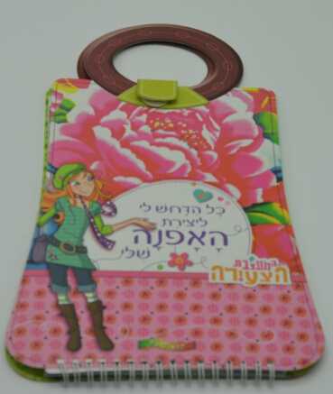

Product name： | Portable Notebook
Material： | Environmental sided matte PP, white material
Product Specifications：
Product Size（mm）：  Expand Size (mm): | 280*217*6
Material thickness（mm）： | 0.52
Product Weight（g）： | 240
printing art： | CMYK + white offset printing, ink is printed
Production Process： | Produced films - Printing - die - Loading and coil - loaded handle - Packaging
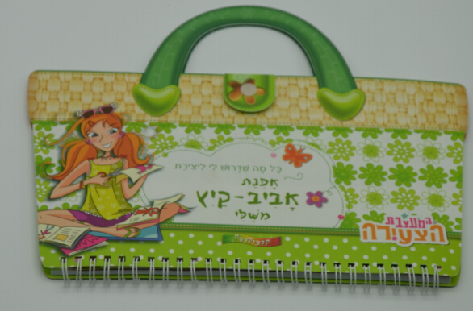

Golden Notebook
Product name： | Golden Notebook
Material： | Environmental sided matte PP, golden material
Product Specifications：
Product Size（mm）：  Expand Size (mm): | 170*190*35
Material thickness（mm）： | Notebook Cover 1.2  Envelope 0.7
Product Weight（g）： | 476.5
printing art： | No
Production Process： | Produced films - Printing - die - Loading and coil - loaded handle - Packaging
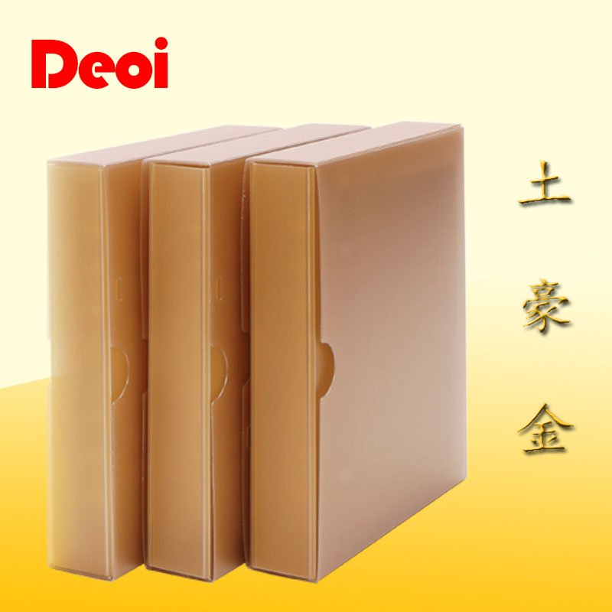

Pencil box
Product name： | Pencil box
Material： | Environmental protection double-sided matte PP
Product Specifications：
Product Size（mm）：  Expand Size (mm): | 200*80*28
Material thickness（mm）： | Carton: 0.47, inside the box: 0.6
Product Weight（g）： | 37.2
printing art： | Offset CMYK + White
Production Process： | Produced films - Printing - die - Ultrasound - clinch - Packaging
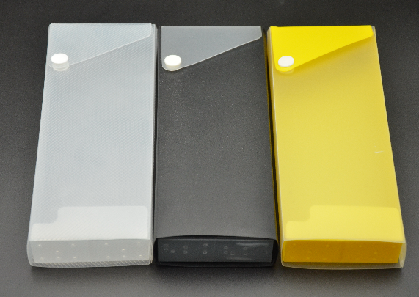

Ruler
Product name： | Ruler
Material： | White PVC
Product Specifications：
Product Size（mm）：  Expand Size (mm): | 160*40  250*350----10
Material thickness（mm）： | 0.6
Product Weight（g）： | 6
printing art： | CMYK + white offset printing, ink is printed
Production Process： | Produced films - Printing - die - Packaging

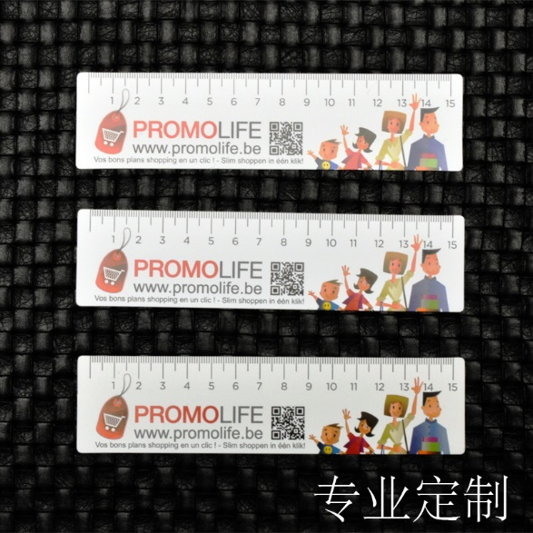

11. Hand bag
Product name： | Hand bag
Material： | Environmental protection rubber roller PP, semi transparent white
Product Specifications：
Product Size（mm）：  Expand Size（mm）： | 235*220*135  740*385----1
Thickness（mm）： | 0.2
Product Weight（g）： | 66.4
Printing art： | 2 color screen printing, ink, printing
Production Process： | Film production - Printing - die - cutting - hot pressing - nail pipe handle - packaging

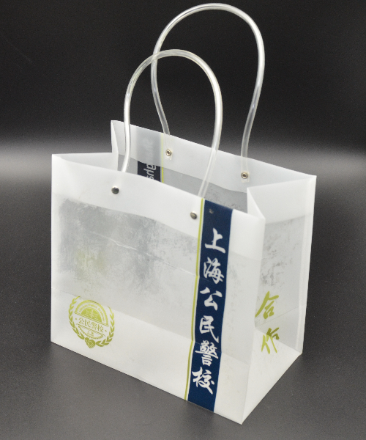

Hand bag
Product name： | Hand bag
Material： | Environmental protection mirror PP
Product Specifications：
Product Size（mm）：  Expand Size（mm）： | 230*180*77  550*670----2
Thickness（mm）： | 0.15
Product Weight（g）： | 33.4
Printing art： | CMYK+ white offset printing ink
Production Process： | Film production - Printing - die - cutting - hot pressing - wear - rope - packaging
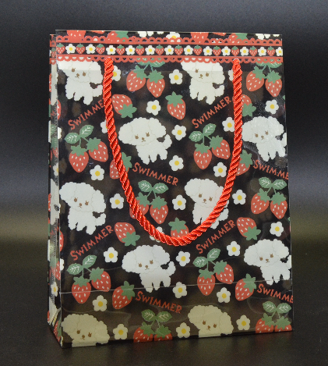

Product name： | Hand bag
Material： | Environmental protection mirror PP, ultra transparent material  (material imported from Japan)
Product Specifications：
Product Size（mm）：  Expand Size（mm）： | 160*200*90  530*320----1
Thickness（mm）： | 0.2
Product Weight（g）： | 40.5
Printing art： | Gilding
Production Process： | Film production - Printing - die - cutting - hot pressing - wear - rope - packaging
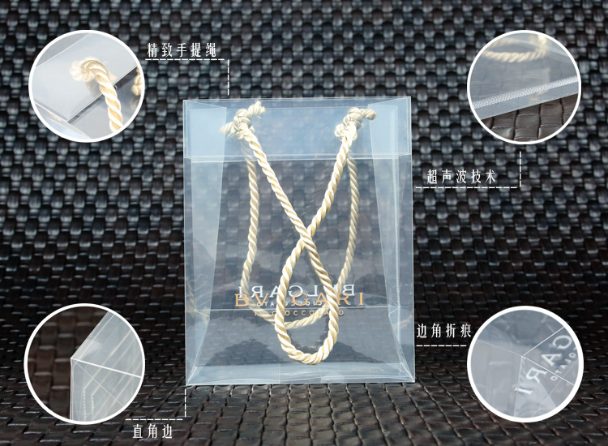

Product name： | Hand bag
Material： | Environmental protection mirror PP, PU material
Product Specifications：
Product Size（mm）：  Expand Size（mm）： | 165*105*85  330*410*0.2mm----1
Thickness（mm）： | 0.2
Product Weight（g）： | 41.4
Printing art： | CMYK+ white offset printing ink
Production Process： | Film - Printing - die - cutting - Ultrasonic - paste - paste - packaging

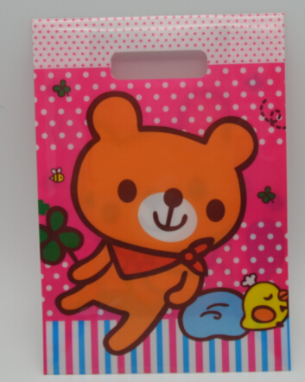

12. Lampshade
Product name： | Lampshade
Material： | Environmental protection matte PP, white material
Product Specifications：
Product Size（mm）：  Expand Size（mm）： | 300*160  350*630----4
Thickness（mm）： | 0.4
Product Weight（g）： | 16.5
Printing art： | CMYK+ offset printing, ink printing
Production Process： | Film production - Printing - die - cutting - packaging

