SHANGHAI JINYUAN PLASTIC PRODUCTS CO.,LTD

Product Description

The difference between the three materials，PP/PET/PVC

PP：（Our factory production）
化学名称：聚丙烯，英文:Polypropylene（简称PP）
材质性能：环保、无毒 、无味、耐高温、耐腐蚀、不易撕裂、韧性好，透明度比PVC和PET低，重量轻，PP比重0.91。
用途：适合做各式文件夹、手提袋、包装盒、垫板、笔记本封面等

PVC：（Divided into two，soft PVC and hard PVC）Materials purchased Chemical Name: PVC, English: Polyvinyl chloride (referred to as PVC)Material Properties: Rigid PVC is not environmental protection, transparency, high ratio of PP, hard material not easily deformed, has good tensile, flexural, compressive strength, specific gravity of 1.40.
Soft PVC can be divided Cape permeability, ultra-transparent, environmental protection and not environmentally friendly, soft and strong, specific gravity of 1.40.
Uses: hard material suitable for packaging, cards, and other OEM.
Soft material suitable slipcase, zipper bags, card sets, book bags, all kinds of leather bags and so on.

PET：Materials purchased Chemical name: polyethylene terephthalate English: Polythylene terephthalate (abbreviated PET)
Material properties: environmentally friendly, non-toxic, tasteless, good temperature, low temperature performance, impact strength is 3-5 times that of other materials, folding is good. Transparent, hard material not easily deformed, specific gravity 1.40
Uses: suitable for pallets, bottles, lunch boxes, high-end cosmetics packaging, etc.
Cost Structure

Customers asked us a product, the six points we need to know:
1. What kind of material and thickness
2. Printing colors
3. The process, after
4. Packing
5. The number of
6. quotations (RMB, US gold / FOB / CIF / CNF, etc.)

The basic structure of costs: printing materials + + + package, after + accessories + shipping
Materials: Expand the area + 1cm bleed.
Printing: CMYK or spot color printing (less than the price of 3,000 large sheet of printing costs are the same)
After said: die cutting, pressing, ultrasonic, nail Sihetun deduction, nail clips, etc.
Accessories: Commonly used materials with instructions, labels, OPP bags
package:
Freight:

1. File folder
E310 file folder
Product name： | E310 file folder/L shape file folder
Material： | Environmental mirror PP, Cape through
Product Specifications： | A4
Product Size（mm）：  Expand Size（mm）： | 310*220  460*640----2 piece
Material thickness（mm）： | 0.2
Product Weight（g）： | 22.5
printing art： | CMYK+white Offset printing ink in printing
Production Process： | Produced films - Printing - die - Ultrasound - Packaging

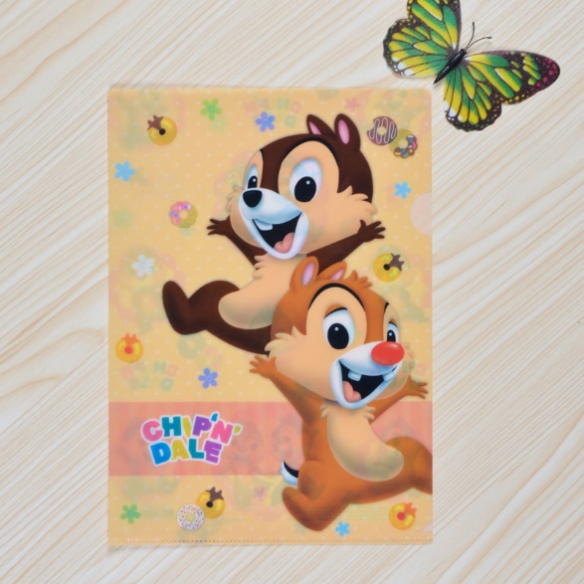

3 in file folder
Product name： | 3 in file folder
Material： | Environmental mirror PP, Cape through
Product Specifications： | A4
Product Size（mm）：  Expand Size（mm）： | 310*220  460*640----1 piece
Material thickness（mm）： | 0.2
Product Weight（g）： | 48.4
Printing art： | Cover and inside pages are  CMYK + white offset printing, ink is printed inside
Production Process： | Produced films - Printing - die - Ultrasound - Packaging
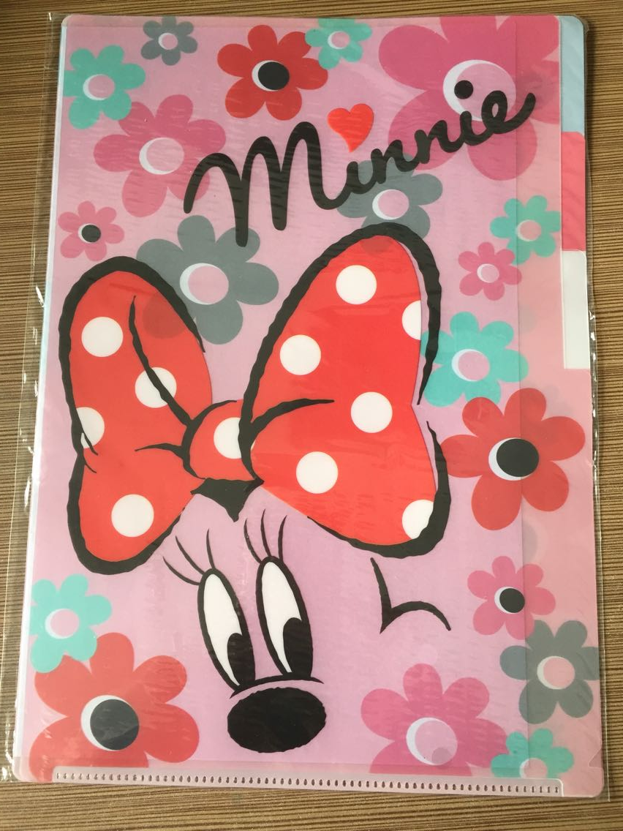

4 in file folder
Product name： | 4 in file folder
Material： | Environmental mirror PP, Cape through
Product Specifications： | A4
Product Size（mm）：  Expand Size（mm）： | 310*220  460*640--1piece，320*230---1 piece
Material thickness（mm）： | 0.2
Product Weight（g）： | 58.5
printing art： | Cover and inside pages are  CMYK + white offset printing, ink is printed inside
Production Process： | Produced films - Printing - die - Ultrasound - Packaging
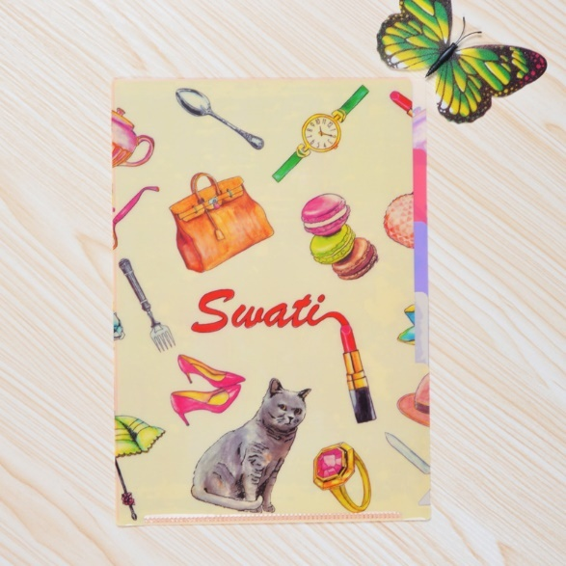

5 in file folder
Product name： | 5 in file folder
Material： | Environmental mirror PP, Cape through
Product Specifications： | A4
Product Size（mm）：  Expand Size（mm）： | 310*235  480*645-----2 piece
Material thickness（mm）： | 0.2
Product Weight（g）： | 74.8
printing art： | Front and back covers CMYK + white offset  Ink in print, in the page does not print
Production Process： | Produced films - Printing - die - Ultrasound - Packaging
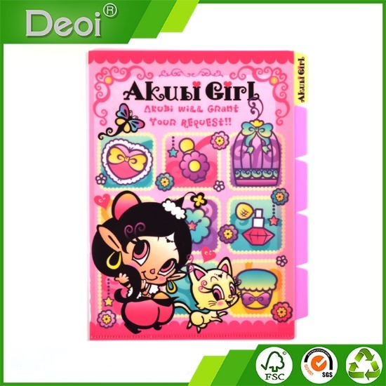

10 in file folder
Product name： | 10 in file folder
Material： | Environmental mirror PP, front and back covers of Cape transparent material, inside color material
Product Specifications： | A4
Product Size（mm）：  Expand Size（mm）： | 310*235  490*650------2 piece
Material thickness（mm）： | 0.2
Product Weight（g）： | 154
printing art： | Front and back covers CMYK + white offset  Ink in print, in the page does not print
Production Process： | Produced films - Printing - die - Ultrasound - Packaging
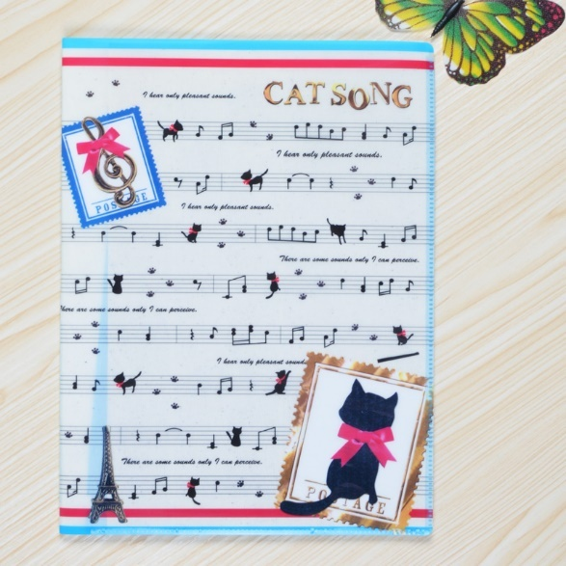

File folder with a zipper
Product name： | File folder with a zipper
Material： | Environmental mirror PP, front and back covers Cape thoroughly, inside color
Product Specifications： | A4
Product Size（mm）：  Expand Size（mm）： | 310*235  490*650------2 piece
Material thickness（mm）： | 0.2
Product Weight（g）： | 103.5
printing art： | Front and back covers CMYK + white offset  Ink in print, in the page does not print
Production Process： | Produced films - Printing - die - pressed zipper - hot - Ultrasound - Packaging
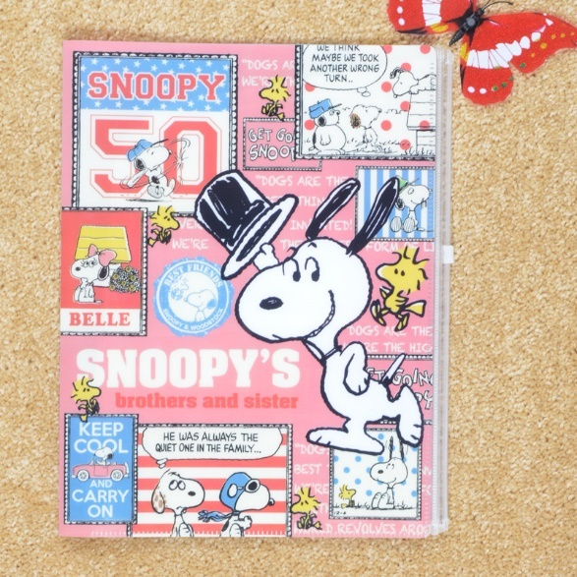

Open type 5 in folder
Product name： | Open type 5 in folder
Material： | Environmental protection PP mirror cover, transparent material, color pages
Product Specifications： | A4
Product Size（mm）：  Expand Size（mm）： | 310*240  920*650------2 piece
Material thickness（mm）： | 0.2
Product Weight（g）： | 103.5
printing art： | Front and back covers CMYK + white offset printing ink in printing, printing on the boot
Production Process： | Produced films - Printing - die - Ultrasound - Packaging
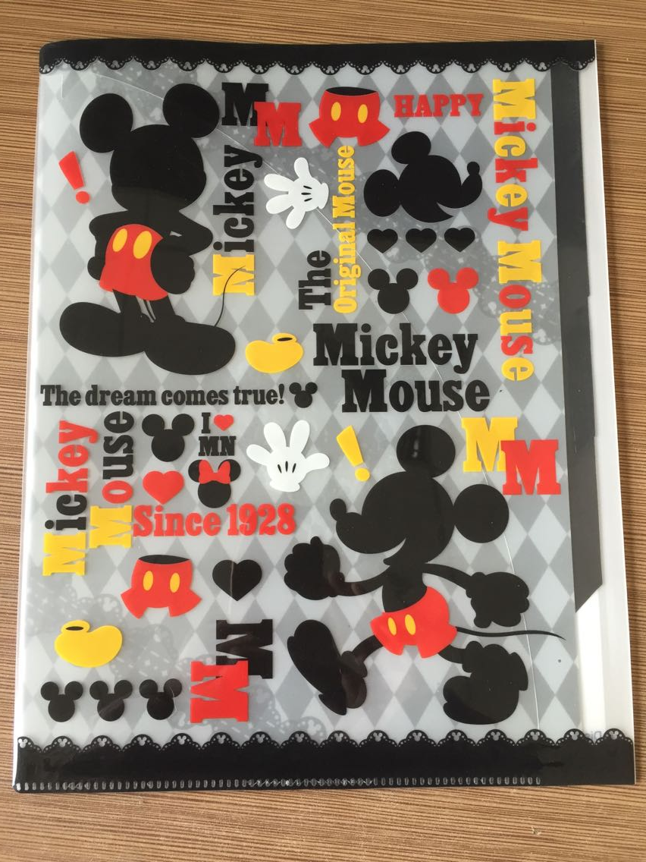

Powerful folder
Product name： | Powerful folder
Material： | Green frosted PP, material qualities
Product Specifications： | A4
Product Size（mm）：  Expand Size（mm）： | 310*240*20  520*640----2 piece
Material thickness（mm）： | 0.8
Product Weight（g）： | 140
printing art： | 1 color screen printing
Production Process： | Produced films - Printing - die - Nail jig - Packaging

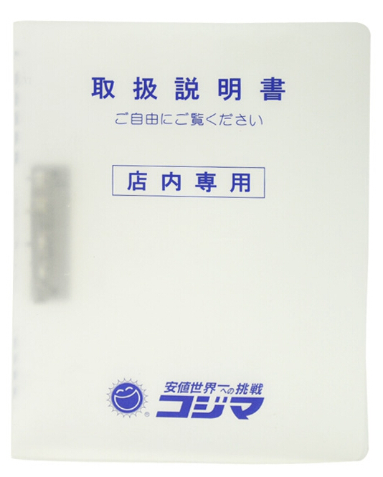

Loose-leaf binder

Product name： | Loose-leaf binder
Material： | Environmental protection double-sided matte PP, translucent green
Product Specifications： | A4
Product Size（mm）：  Expand Size（mm）： | 310*240*40  540*640----2 piece
Material thickness（mm）： | 0.92
Product Weight（g）： | 168.2
printing art： | gilding
Production Process： | Products - stamping die cutting nail fixture - pressure - packing strap
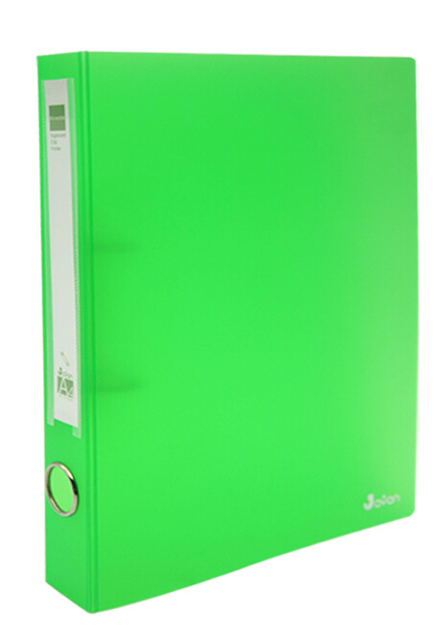

2. File package
Loose-leaf binder

Product name： | File package
Material： | Environmental protection double-sided matte PP (metal blue)
Product Specifications： | A4
Product Size（mm）：  Expand Size（mm）： | 318*238*40  420*720----1 piece
Material thickness（mm）： | 0.5
Product Weight（g）： | 89
printing art： | Bronzing LOGO
Production Process： | Produced films - stamping - die - stick Velcro - ultrasonic - Packaging
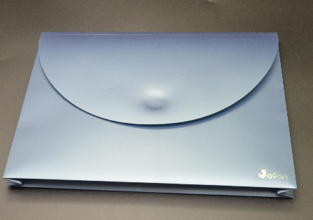

File package
Product name： | File package
Material： | Environmental sided matte PP, white
Product Specifications： | A4
Product Size（mm）：  Expand Size（mm）： | 323*240*40  680*420----1 piece
Material thickness（mm）： | 0.81
Product Weight（g）： | 187.4
printing art： | Offset CMYK + white, is printed
Production Process： | Produced films - Printing - die - clinch - Ultrasound - Packaging
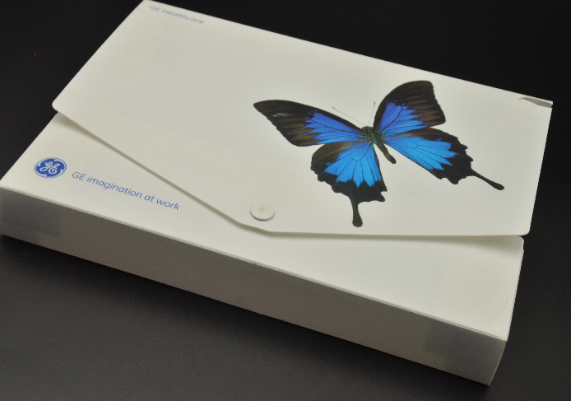

File package
Product name： | File package
Material： | Environmental sided matte PP, Cape transparent material
Product Specifications： | A4
Product Size（mm）：  Expand Size（mm）： | 310*245
Material thickness（mm）： | 0.46
Product Weight（g）： | 90
printing art： | CMYK + white offset printing ink in printing
Production Process： | Produced films - Printing - die - wear elastic band - Packaging
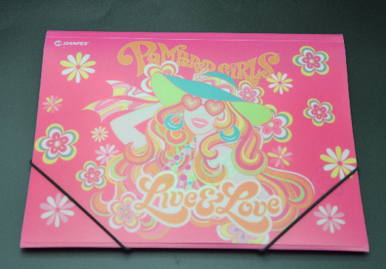

3. Material bag
Product name： | Material bag
Material： | Environmental mirror PP, Cape transparent material
Product Specifications： | A4
Product Size（mm）：  Expand Size（mm）： | 344*250*30
Material thickness（mm）： | 0.2
Product Weight（g）： | 37.8
printing art： | CMYK + white offset printing ink in printing
Production Process： | Produced films - Printing - die - pressed zipper - hot - Nail Corner - Packaging
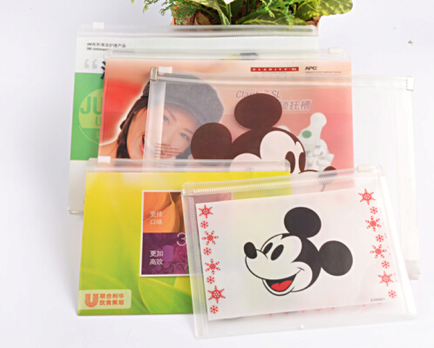

4.Information Booklet
Information Booklet
Product name： | Information Booklet
Material： | Environmental sided matte PP, white material
Product Specifications： | B5
Product Size（mm）：  In-page size（mm）：  Expand Size (mm): | 235*160*10  320*227mm  380*500*0.6-----2 piece
Material Thickness (mm):  Inside Thickness (mm): | 0.6  Single 0.4
Product Weight (g): | 64.4
printing art: | CMYK + white offset printing, ink is printed
Production process: | Produced films - Printing - die - Ultrasonic inside pages - Packaging
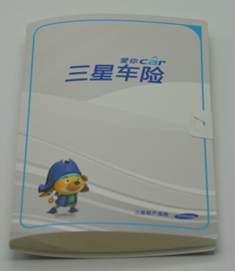

Information Booklet
Product name： | Information Booklet
Material： | Environmental sided matte PP, translucent blue
Product Size（mm）：  In-page size（mm）：  Expand Size (mm): | 315 * 235 * 16,  471 * 315 * 20  650 * 505 ---- 2 fight
Material Thickness (mm):  Inside Thickness (mm): | 0.65mm  Single 0.04mm
Product Weight (g): | 194.4
printing art: | CMYK + white offset printing ink in printing
Production process: | Produced films - Printing - die - Ultrasonic inside pages - Packaging

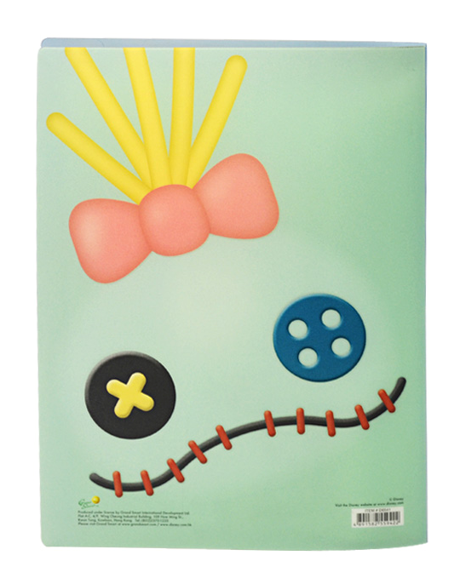

Information Booklet
Product name： | Information Booklet
Material： | Environmental sided matte PP, translucent blue
Product Size（mm）：  In-page size（mm）：  Expand Size (mm): | 319 * 235 * 15  505 * 670 ---- 2 fight  47.1 * 319 (20-page)
Material Thickness (mm):  Inside Thickness (mm): | 0.61  8 double wire
Product Weight (g): | 168.2
printing art: | No printing
Production process: | Produced films - Printing - die - Ultrasonic inside pages - Packaging
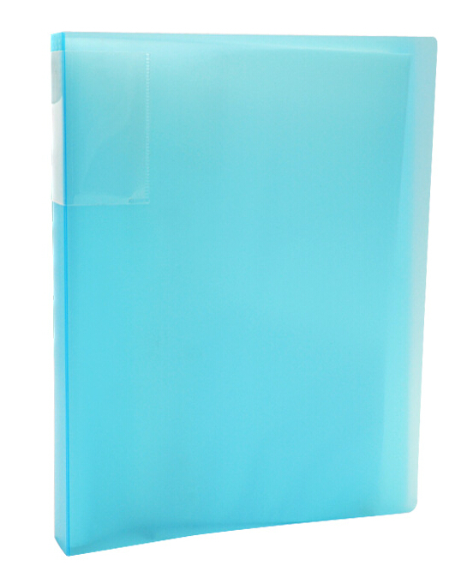

5.Slipcase

Product name： | Slipcase
Material： | Environmental mirror PP, Cape through
Product Specifications： | B5
Product Size（mm）：  Expand Size（mm）： | 220 * 155  490 * 690 ----- 3 fight
Material thickness（mm）： | 0.17
Product Weight（g）： | 16.4
printing art： | CMYK + white offset printing ink in printing
Production Process： | Produced films - Printing - die - Ultrasound - Packaging
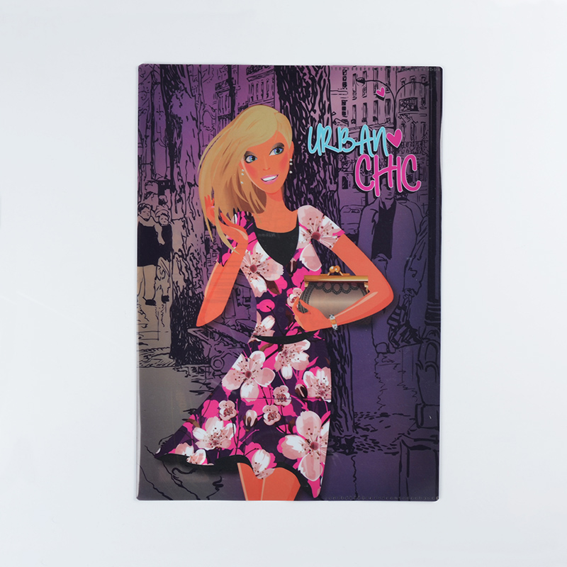

6.Expanding File

Product name： | Organ bags, Georgia 12PP
Material： | Green frosted PP, transparent
Product Specifications： | A4
Product Size（mm）：  Expand Size (mm): | 310*240*30  720*330---1 piece
Material Thickness (mm):  Inside Thickness (mm): | 0.6  0.2
Product Weight (g): | 288
Printing art: | CMYK + white offset printing ink in printing
Production Process | Produced films - Printing - die - a combination of internal pockets - hot - Ultrasound - clinch - wear elastic band - Packaging

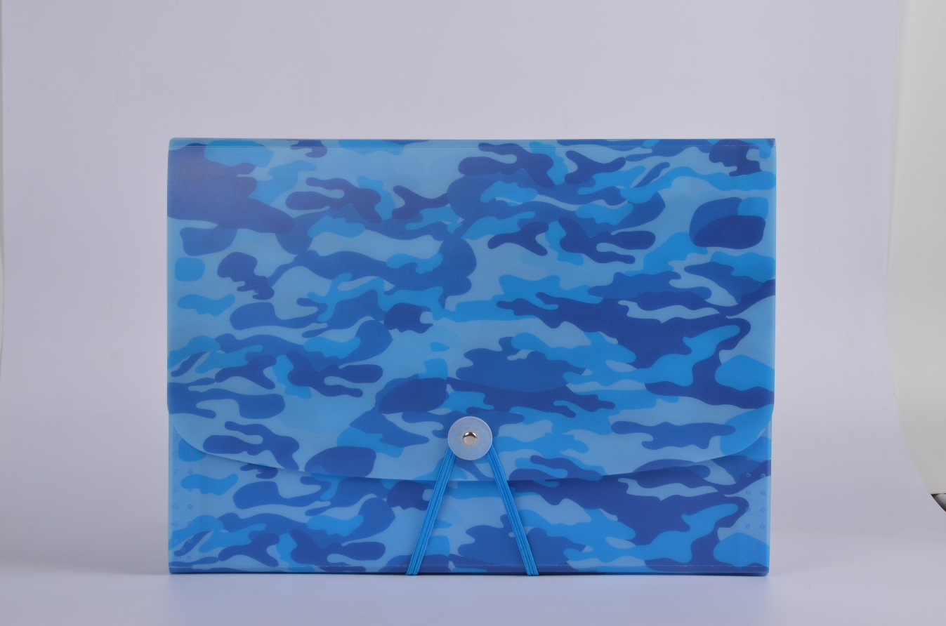

Suede organ package

Product name： | Suede organ package
Material： | Suede + cardboard + green PP
Product Specifications： | A4
Product Size（mm）： | 220 * 155
Material thickness（mm）： | 0.2
Product Weight（g）： | 603.6
printing art： | No
Production Process： | Produced films - die - a combination of inside pages - sewing - the buckle - Packaging
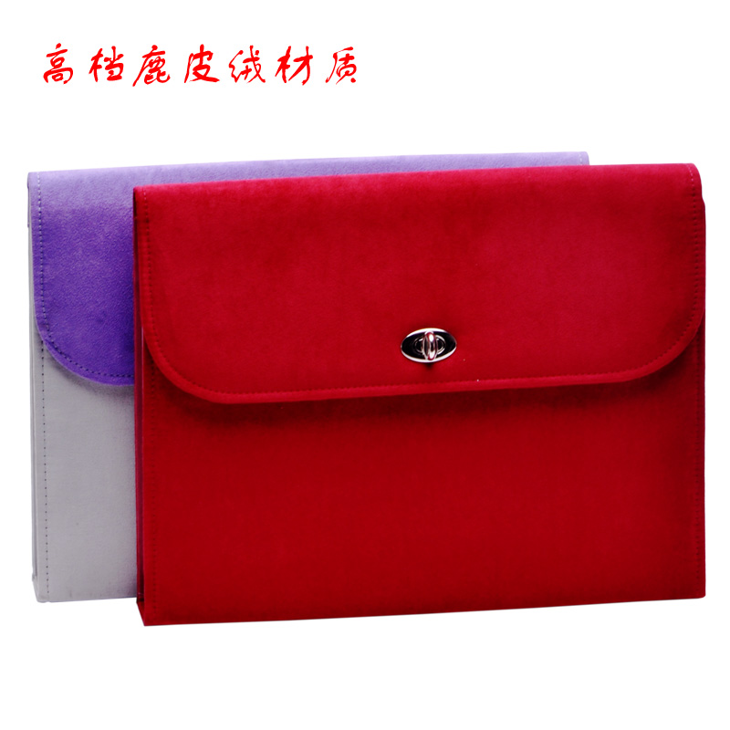

7.Tag

Product name： | Tag
Material： | White PVC
Product Specifications：
Product Size（mm）：  Expand Size (mm): | 200*110  430*250---4
Material thickness（mm）： | 1.17
Product Weight（g）： | 44.8
printing art： | 4 color screen printing (two sided printing)
Production Process： | Film production - Printing - die - cutting - packaging
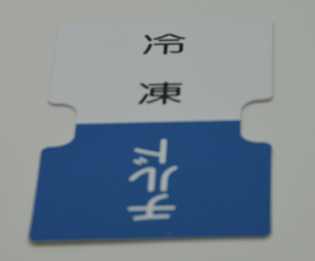

Tag

Product name： | Tag
Material： | Green black matte PP
Product Specifications：
Product Size（mm）：  Expand Size (mm): | 200*110  510*230---4
Material thickness（mm）： | 0.75
Product Weight（g）： | 14.2
printing art： | 1 color screen printing
Production Process： | Film production - Printing - die - cutting - packaging

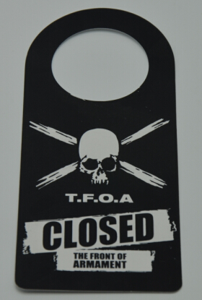

Tag

Product name： | Tag
Material： | Environmental protection double-sided matte PP (a variety of colors)
Product Specifications：
Product Size（mm）：  Expand Size (mm): | 400*90  420*400---4
Material thickness（mm）： | 1.2
Product Weight（g）： | 36.8
printing art： | 1 color screen printing
Production Process： | Film production - Printing - die - cutting - packaging
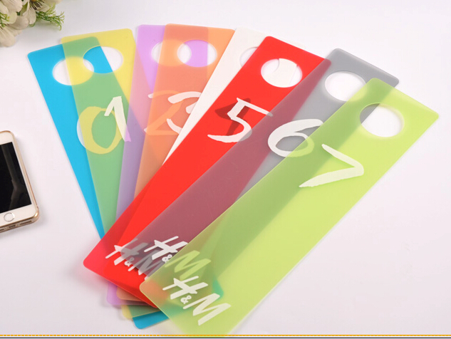

8. Name-card album
Product name： | Name-card album
Material： | Environmental sided matte PU, white material
Product Specifications：
Product Size（mm）：  Expand Size (mm): | 214*108*20  500*460----4
Material Thickness (mm):  Inside Thickness (mm): | 0.68  Double 10 wire * 8
Product Weight (g): | 71.4
Printing art: | CMYK + white offset printing ink in printing
Production Process | Produced films - Printing - die - Ultrasound - Packaging
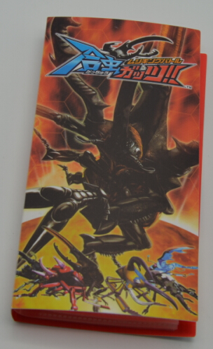

9. Portable Notebook
Product name： | Portable Notebook
Material： | Environmental sided matte PP, white material
Product Specifications：
Product Size（mm）：  Expand Size (mm): | 305*175*6
Material thickness（mm）： | 0.4
Product Weight（g）： | 218
printing art： | CMYK + white offset printing, ink is printed
Production Process： | Produced films - Printing - die - Loading and coil - loaded handle - Packaging

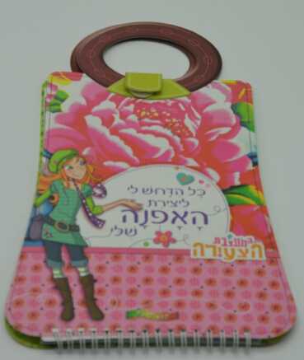

Product name： | Portable Notebook
Material： | Environmental sided matte PP, white material
Product Specifications：
Product Size（mm）：  Expand Size (mm): | 280*217*6
Material thickness（mm）： | 0.52
Product Weight（g）： | 240
printing art： | CMYK + white offset printing, ink is printed
Production Process： | Produced films - Printing - die - Loading and coil - loaded handle - Packaging
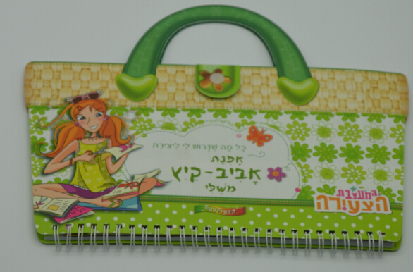

Golden Notebook
Product name： | Golden Notebook
Material： | Environmental sided matte PP, golden material
Product Specifications：
Product Size（mm）：  Expand Size (mm): | 170*190*35
Material thickness（mm）： | Notebook Cover 1.2  Envelope 0.7
Product Weight（g）： | 476.5
printing art： | No
Production Process： | Produced films - Printing - die - Loading and coil - loaded handle - Packaging
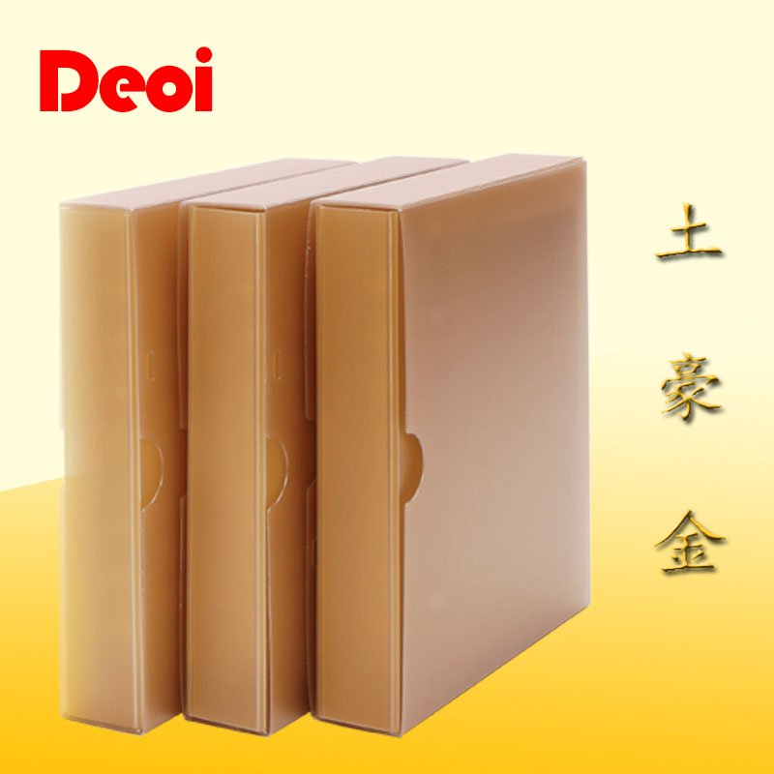

Pencil box
Product name： | Pencil box
Material： | Environmental protection double-sided matte PP
Product Specifications：
Product Size（mm）：  Expand Size (mm): | 200*80*28
Material thickness（mm）： | Carton: 0.47, inside the box: 0.6
Product Weight（g）： | 37.2
printing art： | Offset CMYK + White
Production Process： | Produced films - Printing - die - Ultrasound - clinch - Packaging
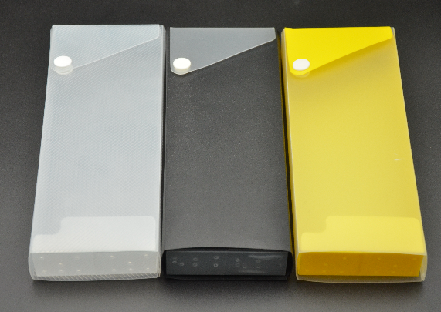

Ruler
Product name： | Ruler
Material： | White PVC
Product Specifications：
Product Size（mm）：  Expand Size (mm): | 160*40  250*350----10
Material thickness（mm）： | 0.6
Product Weight（g）： | 6
printing art： | CMYK + white offset printing, ink is printed
Production Process： | Produced films - Printing - die - Packaging

