TIANJIN OCEAN BICYCLE INDUSTRY GROUP LIMITED
ADD: NO.88 HEYUAN ROAD,CHINA BICYCLE INDUSTRY ZONE TIANJIN CHINA
TEL:86 22 22144951 FAX:86-22-22144959 CONTACT PERSON: Dorothy Niu
WEBSITE: www.oceanbicycle.com E-MAIL:oceanbicycle@oceanbicycle.com.cn

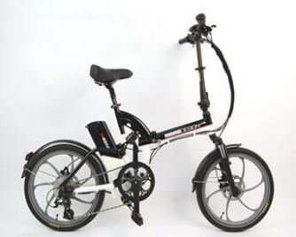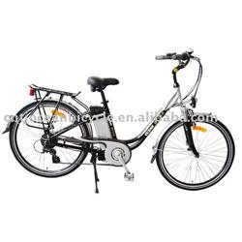
OC-EB20005 OC-EB26007
ALLOY FRAME AND FORK ALLOY FRAME
SHIMANO 7 SPEED SHIMANO 6S
DOUBLE WALLOY ALLOY RIM 24V 180W BRUSHLESS
KENDA TYRE AND TUBE DOUBLE WALL ALLOY RIM
UNI-WHEEL 36V TORQUE SENSOR

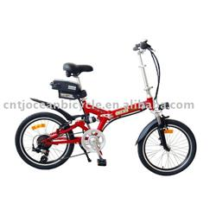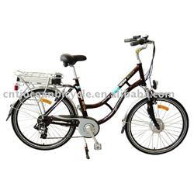
OC-EB20002 OC-EB26006
ALLUMINUM ALLOY 20" FOLDABLE ALLOY FRAME AND SUSPENSION FORK
SHIMANO 6S SHIMANO 6S
MOTOR: 24V 180W BRUSHLESS 24V Lithium Battery
ALLOY DOUBLE WALL BLACK
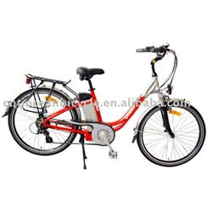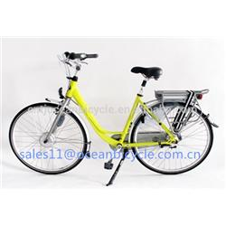
OC-EB24005 OC-E700C-002
ALLOY FRAME ALLOY FRAME
SHIMANO 6S 24V Lithium Battery
24V Lithium Battery Brushless, 700C*36V*250W

