TIANJIN OCEAN BICYCLE INDUSTRY GROUP LIMITED

ADD: NO.88 HEYUAN ROAD,CHINA BICYCLE INDUSTRY ZONE TIANJIN CHINA
TEL:86 22 22144951 FAX:86-22-22144959 CONTACT PERSON: Dorothy Niu
WEBSITE: www.oceanbicycle.com E-MAIL:oceanbicycle@oceanbicycle.com.cn

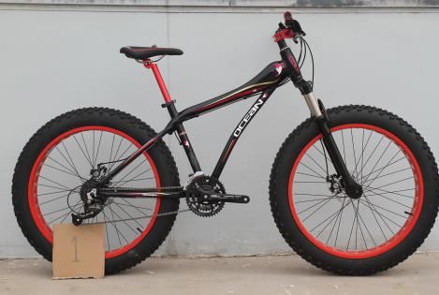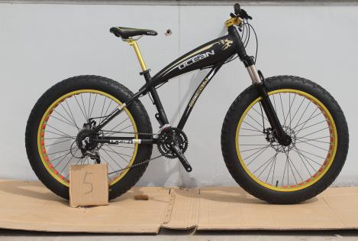
OC-26"*4.0-67DA OC-26"4.0-70DA
OC-26"*4.0-67DA ALLOY FRAME AND FORK
SHIMANO 27S SHIMANO 27 SPEED
HOLLOW ALLOY RIM HOLLOW ANODIZED ALLOY RIM
INNOVA 26"4.0 TYRE INNOVA 26"4.0 TYRE
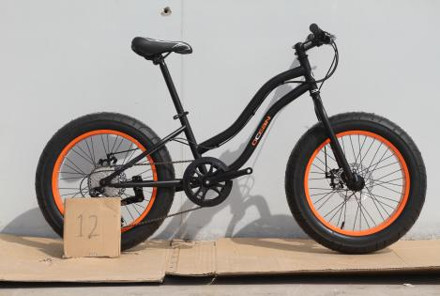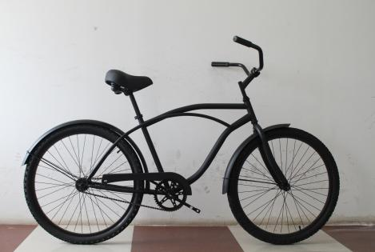
OC-20"4-1/4"-75DS OC-26103S
HI-TEN STEEL FRAME AND FORK HIGH-TEN STEEL FRAME AND FORK
SHIMANO 8 SPEED KT COASTER HUB
COLOR ALLOY RIM
INNOVA TYRE SET

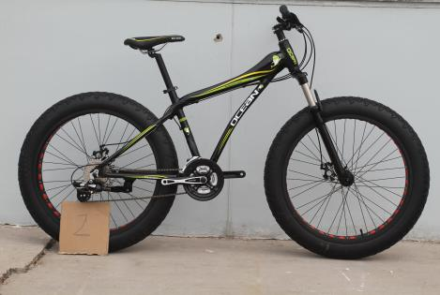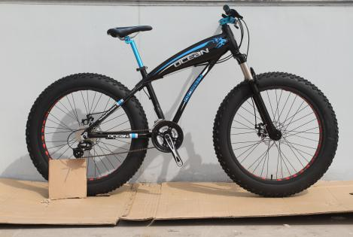
OC-26"*4.0-68DA OC-26"*4.0-72DA
ALLOY FRAME AND FORK ALLOY FRAME AND FORK
SHIMANO 24 SPEED SHIMANO 24 SPEED
HOLLOW ALLOY RIM HOLLOW ALLOY RIM
INNOVA 26"4.0 TYRE INNOVA TYRE SET

