Sheep Temperature Telemetry System
International patent : PCT/CN20171083945
一Overview
STTS sheep temperature telemetry system consist of disposable protective earmuffs, intelligent telemetry ear tag, sheep ear tag lock, special-designed sheep ear tag clamp, ear tag automatic installation equipment, Router, Internet, JZsoft system installation software, compatible to NB -IOT , OceanConnectIoT platform, Cloud application software. STTS can continuously measure the sheep body's temperature (ie, basal body temperature) in sheep's free, awake, unbound state, and recording the individual identity and growth information of the sheep.
It is mainly used in the prevention and control of diseases, breeding, and precision feeding of sheep. It can greatly improve the disease prevention and control ability and breeding efficiency of sheep, and will become a new generation of AI intelligent equipment for livestock breeding.
—System schematic
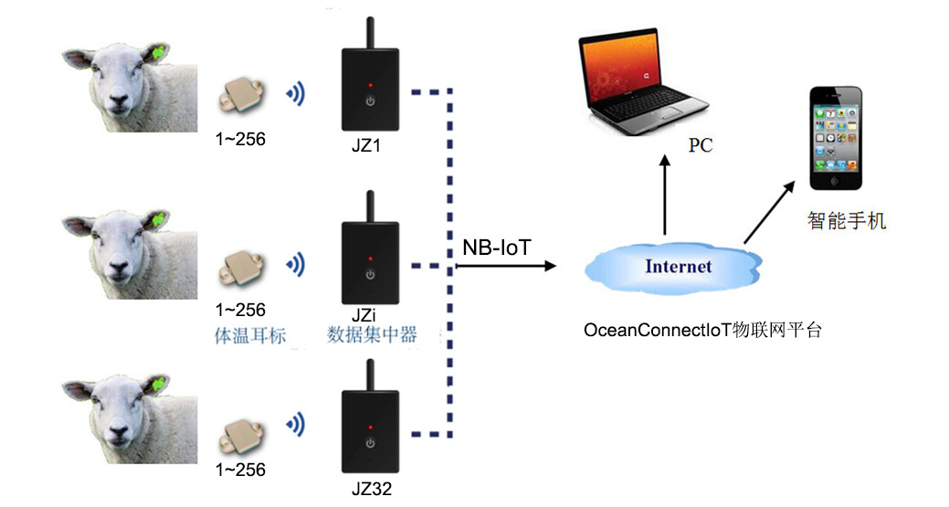
—Functional characteristics
· Sheep body temperature measurement range: 32 ° C ~ 43 ° C, ± 0.2 ° C
· Environmental temperature and humidity measurement: -40 ~ 70 ° C, ± 1 ° C
· Environmental humidity measurement range: 0 ~ 100% RH, ± 5%
· Intelligent telemetry ear tag and Router wireless transmission distance: >60 meters
· Router supports NB-IoT 700/850/900Mhz data transmission
· Router and NB-IoT base station wireless transmission distance 10kM
· Telemetry ear tag weight 9g, battery life 2 years, waterproof class IPX4
· Remote RFID input/output ear tag information
· Working environment: -30 ° C ~ 60 ° C
· Steps counting, GPS positioning, automatic weighing function (future development)
· Maximum topology of LAN: 32 routers, 256 ear tags for each router wireless link
· The master station downloads/stores/analyzes the temperature data of each collector node of the Router.
· Real-time display of the body temperature curve and breeding status of the sheep (disease, estrus, pregnancy, birth).
—Application case
Infrared Temperature of Incubator
Temperature Measurement of Pig
Temperature Measurement of Rabit

Shenzhen Flamingo Technology Co.,Ltd
Address: 5/F, Beikechuangye Building, No.1077 NanhaiBoulevard, Nanshan, Shenzhen, China. Tel：13602571660， Email：zf@fmg-tech.com
www.fmg-tech.com

