Cow Temperature Telemetry System（CTTS）
International patent : PCT/CN20171083945
一Overview
Cow temperature telemetry system consist of disposable protective earmuffs, intelligent telemetry ear tag, cow ear tag lock, special-designed ear tag clamp, ear tag automatic installation equipment, Router, Internet, JZsoft system installation software, compatible to NB -IOT , OceanConnectIoT platform, Cloud application software. CTTS can continuously measure the cow body's temperature (ie, basal body temperature) in cow's free, awake, unbound state, and recording the individual identity and growth information of the cow.
It is mainly used in the prevention and control of diseases, breeding, and precision feeding of cow. It can greatly improve the disease prevention and control ability and breeding efficiency of cow, and will become a new generation of AI intelligent equipment for cow breeding.
—System schematic
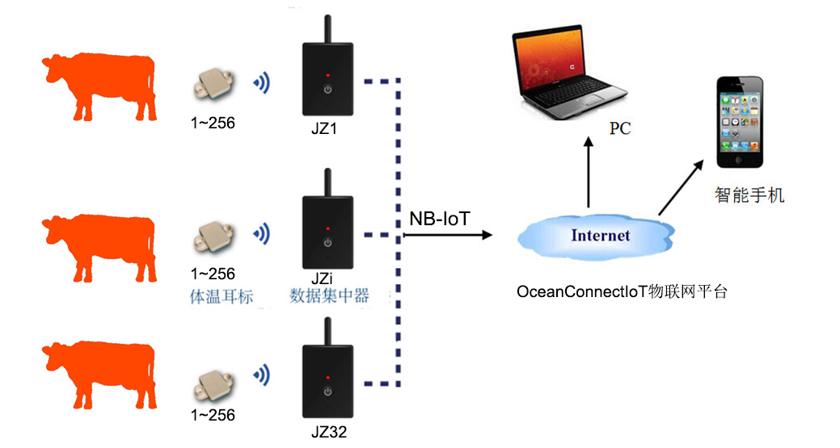
—Functional characteristics
· Cow body temperature measurement range: 32 ° C ~ 43 ° C, ± 0.2 ° C
· Environmental temperature and humidity measurement: -40 ~ 70 ° C, ± 1 ° C
· Environmental humidity measurement range: 0 ~ 100% RH, ± 5%
· Intelligent telemetry ear tag and Router wireless transmission distance: >60 meters
· Router supports NB-IoT 700/850/900Mhz data transmission
· Router and NB-IoT base station wireless transmission distance 10kM
· Telemetry ear tag weight 9g, battery life 2 years, waterproof class IPX4
· Remote RFID input/output ear tag information
· Working environment: -30 ° C ~ 60 ° C
· Steps counting, GPS positioning, automatic weighing function (future development)
· Maximum topology of LAN: 32 routers, 256 ear tags for each router wireless link
· The master station downloads/stores/analyzes the temperature data of each
collector node of the Router.
· Real-time display of the body temperature curve and breeding status of the cow
(disease, estrus, pregnancy, birth).
—Application case
Infrared Temperature of Incubator
Temperature Measurement of Pig
Temperature Measurement of Rabit

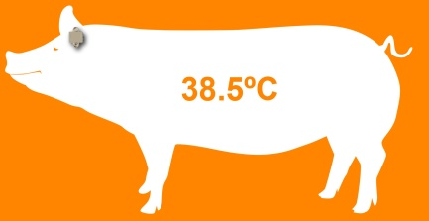

Shenzhen Flamingo Technology Co.,Ltd
Address: 5/F, Beikechuangye Building, No.1077 NanhaiBoulevard, Nanshan, Shenzhen, China. Tel：13602571660， Email：zf@fmg-tech.com
www.fmg-tech.com

