羊体温遥测系统STTS
Sheep Temperature Telemetry System
International patent : PCT/CN20171083945
一Overview
STTS sheep temperature telemetry system consist of disposable protective earmuffs, intelligent telemetry ear tag, sheep ear tag lock, special-design sheep ear tag clamp, ear tag automatic installation equipment, data concentrator, LAN master station, JZsoft system installation software, NB -IoT base station, OceanConnectIoT platform, cloud application software. It can continuously measure the body's nuclear temperature (ie, basal body temperature) in sheep's free, awake, unbound state, and carry the individual identity and growth information of the sheep.
It is mainly used in the prevention and control of diseases, breeding and breeding, and precision breeding of sheep. It can greatly improve the disease prevention and control ability and breeding efficiency of sheep, and will become a new generation of AI intelligent equipment for livestock breeding.
—System schematic
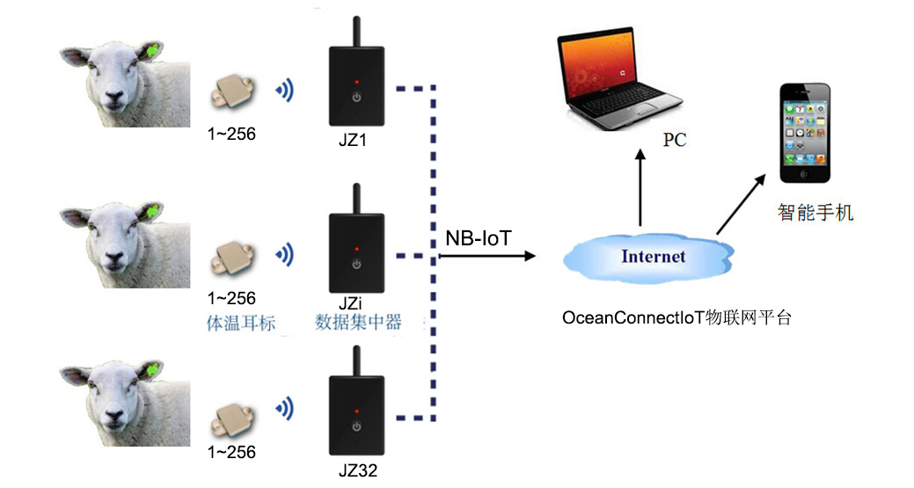
—Functional characteristics
· Sheep body temperature measurement range: 32 ° C ~ 43 ° C, ± 0.2 ° C
· Ambient temperature and humidity measurement: -40 ~ 70 ° C, ± 1 ° C
· Ambient humidity measurement range: 0 ~ 100% RH, ± 5%
· Intelligent telemetry ear tag and concentrator wireless transmission distance: >60 meters
· Concentrator supports NB-IoT 700M data transmission
· Concentrator and NB-IoT base station wireless transmission distance 10kM
· Telemetry ear tag weight 9g, battery life 2 years, waterproof class IPX4
· Remote RFID read and write ear tag information function
· Working environment: -30 ° C ~ 60 ° C
· Step counting, GPS positioning, automatic weighing function (future expansion)
· Maximum topology of LAN: 32 concentrators, 256 collectors for each concentrator wireless link
· The master station downloads/stores/analyzes the temperature data of each collector node of the concentrator.
· Real-time display of the body temperature curve and breeding status of the sheep (blight, estrus, pregnancy, birth).
—Application case
Infrared Temperature of Incubator
Temperature Measurement of Pig
Temperature Measurement of Rabit

Shenzhen Flamingo Technology Co.,Ltd
Address: 5/F, Beikechuangye Building, No.1077 NanhaiBoulevard, Nanshan, Shenzhen, China. Tel：13602571660， Email：zf@fmg-tech.com
www.fmg-tech.com

