Wireless Bluetooth Temperature Recorder

Model SH216

User's Manual
1. Overview
SH216 Wireless Bluetooth Temperature Recorder is composed of a monitor and multiple remote temperature sensors. It has a thermometer and a mobile phone operation mode. One monitor can monitor the measurement data of eight remote sensors. It uses the most advanced dual-frequency and dual-mode wireless transmission technology. It may be the wireless thermometer with the longest transmission distance and best value for money in the world. The user can preset the alarm value and sound and light alarm when the temperature is abnormal. The monitor communicates with the mobile phone Bluetooth, and the user runs the App software TempView+. It is convenient to download and view the water temperature measurement data with the mobile phone.
It use for monitoring environmental temperature in factories, agriculture, transportation, medicine and food, laboratories, computer rooms and other places.

2, Functional and specification

2.1 Remote sensor
- Measuring range: -40℃ ~ 100 ℃
- Accuracy: ±1℃
- Radio f requency: 433Mhz
- Transmission distance > 100 meters
- Transmission interval: 15 minutes
- Memory capacity: 4096B
- Mobile phone downloads memory data
- LCD display temperature data and clock
- Inside or outside sensor
- Use rechargeable battery with USB port
- Product size: 44x41x10mm
- Product weight: 18g

2.2 Monitor
- Indoor temperature measurement: 0°C～50°C
- Temperature measurement accuracy: ±1 °C
- Humidity measurement: 10% to 95% RH
- Humidity measurement accuracy: ± 5%
- Wireless 433Mhz and Bluetooth BLE4.0 dual-band communication
- Monitor can receive and display the data of eight remote sensors
- Display clock, collector temperature, indoor temperature and humidity
- Preset temperature alarm threshold, sound and light alarm
- Transmission distance: >100M (433Mhz), >30M (Bluetooth)
- App software is compatible with Android and iOS operating systems
- Use two 1.5Vdc AAA alkaline batteries
- Dimensions: 108×90×22mm

3. Product topology

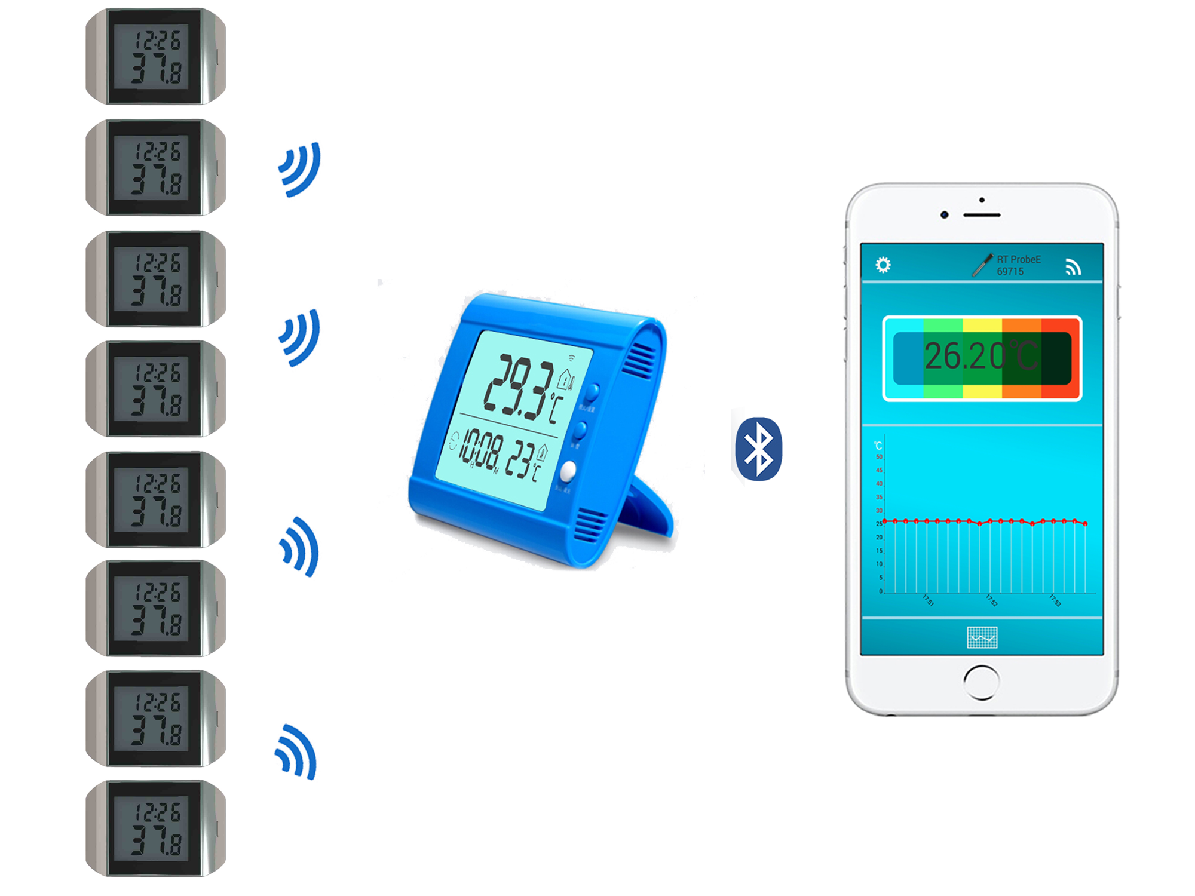

4, operation instructions
4.1. Operation of remote temperature sensor
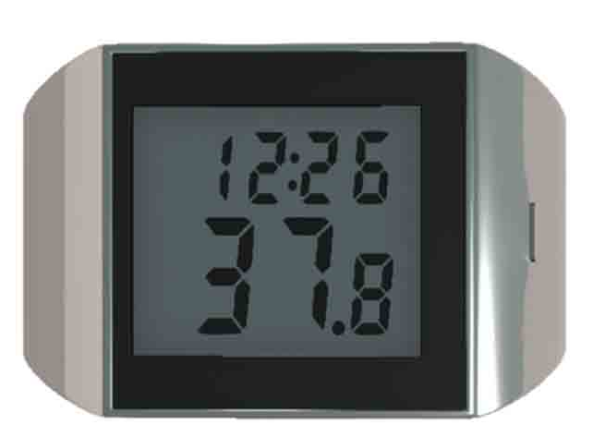
S Key

- Battery charging and switching
When remote temperature sensor is used for the first time or the battery is low, please connect to the USB charging line for 2 hours. Press the S button for 3 seconds to turn on or turn off and clear memory.

- Remoter sensor registration
Before using remote sensor, the registration operation is as follows: Press the monitor C/F key for 3 seconds, the house icon on the upper left of the monitor flickers Press the S key for 3 seconds, remote sensor sends the registration request After the monitor receives, set the serial number and clock of remote sensor. When the house icon on the monitor stops flickering. The serial number appears to indicate that the registration is successful, and remote sensor and monitor are in the state of wireless communication. If the registration is not successful, repeat the above steps.

- Placing remote sensor
After the registering , remote sensor is placed within 100 meters of the monitor, and the LCD of remote sensor alternately displays the temperature and serial number.

- Temperature measurement and transmission
Remote sensor stores and transmits the measurement data once every 15 minutes, and you can queries the maximum and minimum values and past hourly temperature measurement data by pressing S key.

Download storage data
The mobile phone download the storing data to the remote sensor through the monitor by App TempView+. After the data upload is successful, the memory of the remote sensor is cleared.

- Temperature unit conversation
Press S key for 3 seconds and converse temperature unit by connecting USB port with external power.

4.2. Monitor operation

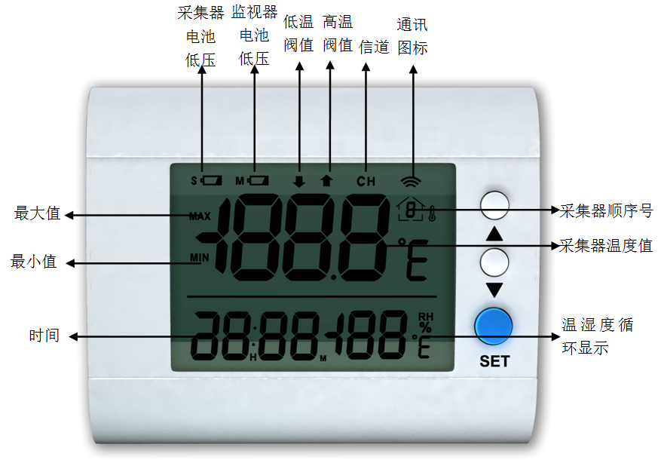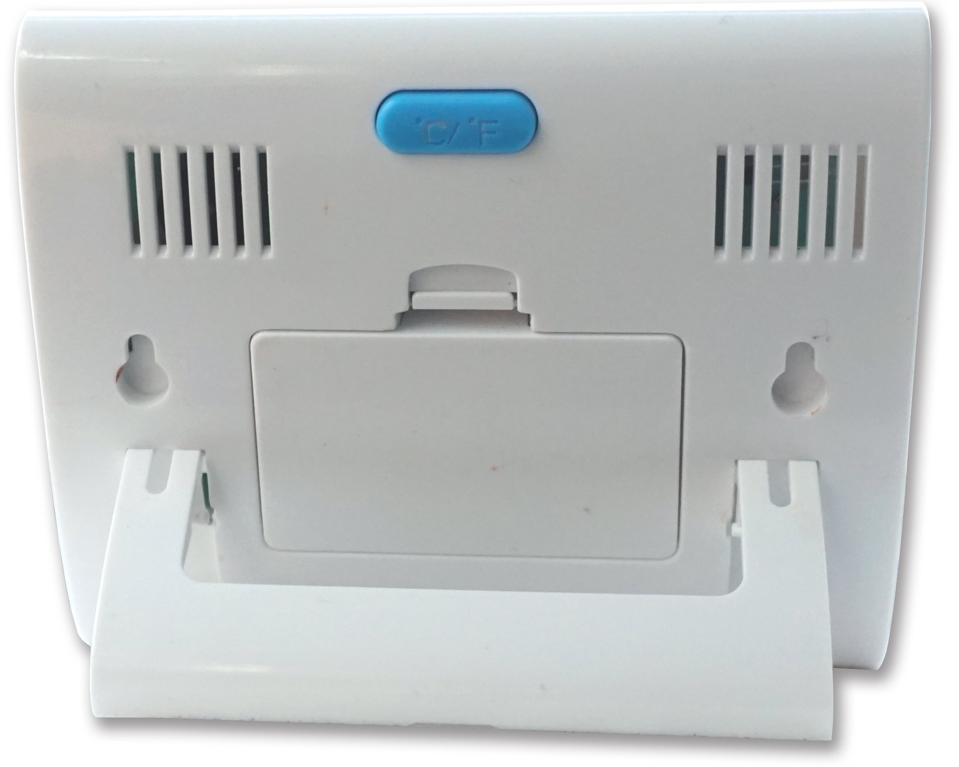
℃/F

- Install batteries.
Open the battery cover and load batteries. Press the C/F key on the rear of the monitor and select the unit of temperature.

- Remote Sensor Registration
See the previous description

- Setting parameters
Press and hold "SET" key for 3 seconds → the screen upper digit flash and appears "↑" the high temperature threshold setting icon → press▲or▼_key to set high temperature threshold ,and then press S key to confirm → display low temperature threshold setting "↓" icon → press▲or_▼key to set low temperature threshold and then press SET key to confirm → the hour number "12" flickers at the bottom left of the screen, enters the time setting → press▲or_▼key to adjust hours and then press SET key to confirm → minute number "00" flickers, press▲or_▼key to adjust minutes and then press SET key to confirm → the house icon at the top left of the screen flicker, press▲or▼key to deleted the serial number of remote sensor (serial number 0 means no deletion) → press SET key to confirm and then return to the original state.

Monitor display
The house icon on the screen shows the serial number of remote sensors, the upper row of screen circulates to display the measured value of remote sensors, and the lower row alternately displays the indoor temperature, humidity and time.

- Inquire the measured value of remote sensors
Press▲key to query the temperature values of remote sensors; Press▼key to query the maximum and minimum temperature values; Press and hold ▼key for three 3senconds to clear the maximum and minimum values.

- High and low temperature alarm
When the temperature exceeds the threshold temperature, the monitor sends out acousto-optic alarm and presses any key to interrupt.

Battery low indication
When the M or S icon appears in the upper right corner of the display screen, it indicates that the battery of the monitor or remote sensor.

4.3. Mobile App operation
-Download App software
Please download and install App application TempView+ at Apple Store or Google Play Store.

-APP main interface

Data download prompt

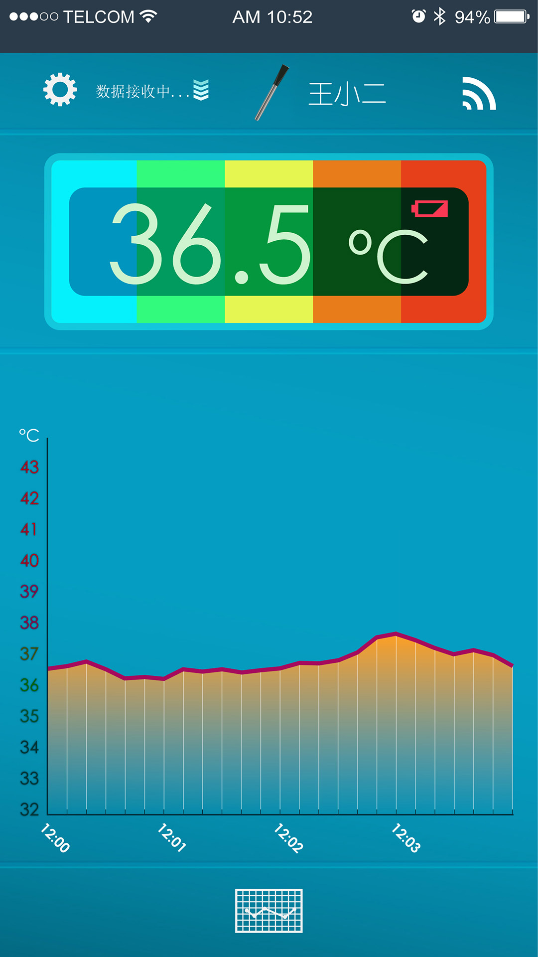
Current temperature value
Device connection status
Historical data query
Temperature curve
Device name
Low battery
System settings
—Bluetooth Connection
Press and hold the △ button for 3 seconds to link bluetooth communication between the monitor and the mobile phone. The icon in the upper left corner of the monitor screen flashes;. You need to repeat the above steps for Bluetooth connection. if the pairing is unsuccessful within 60 seconds and then the icon stops flashing

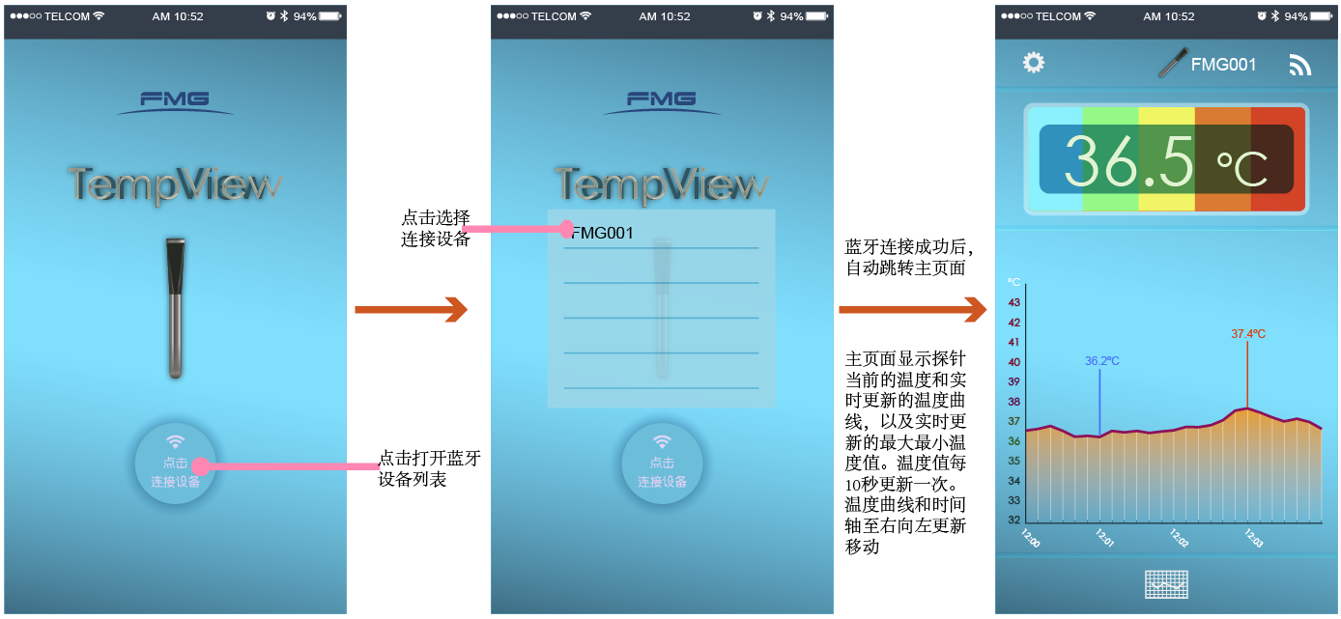

-parameter settings
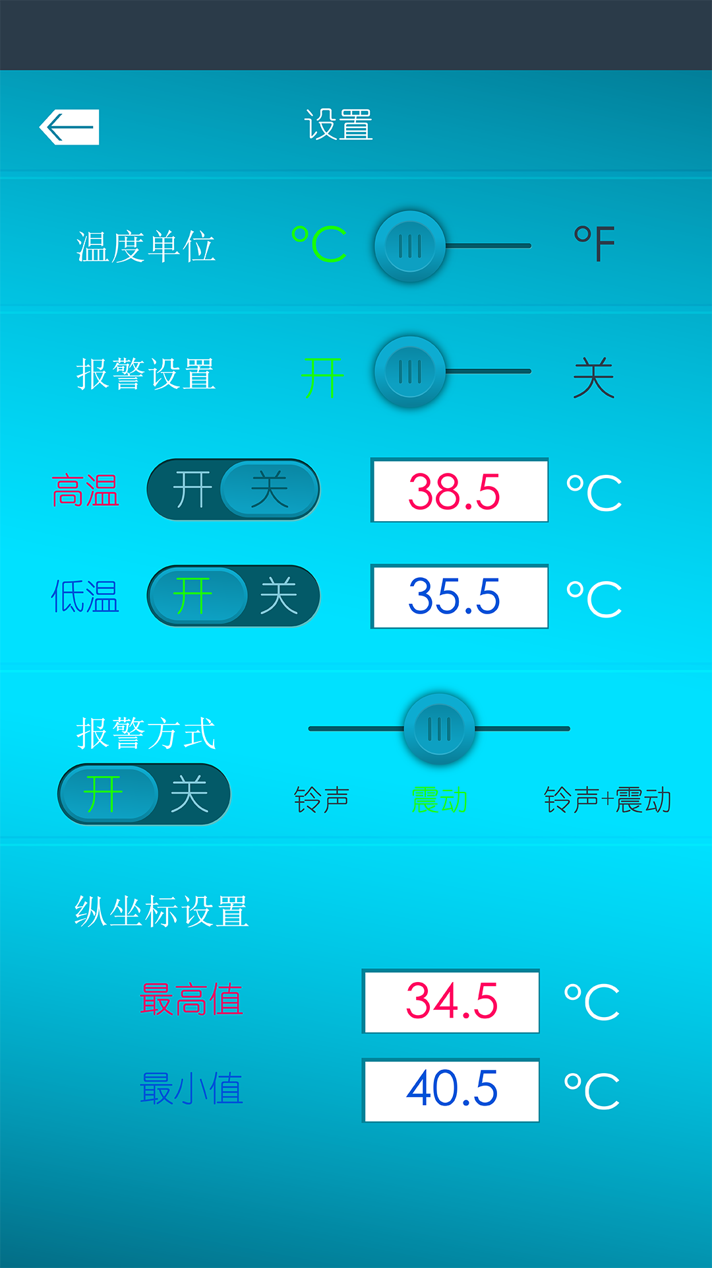
Click  Set temperature unit, alarm switch, high temperature threshold, low temperature threshold, alarm mode, ordinate.
Temperature unit: Celsius °C and Fahrenheit F
Alarm setting: set high and low temperature alarm threshold, select ringing, vibration, ringing alarm mode;
Vertical coordinate setting: Set the maximum and minimum ordinate.

--Data download
After the monitor is connected to the Bluetooth of the smart phone, the mobile phone sends upload command to the remote floating sensor through monitor and the remote floating sensor upload the logging data to smart phone

- History query
Click the “ ” icon on the homepage to enter the historical data query interface, as shown below:
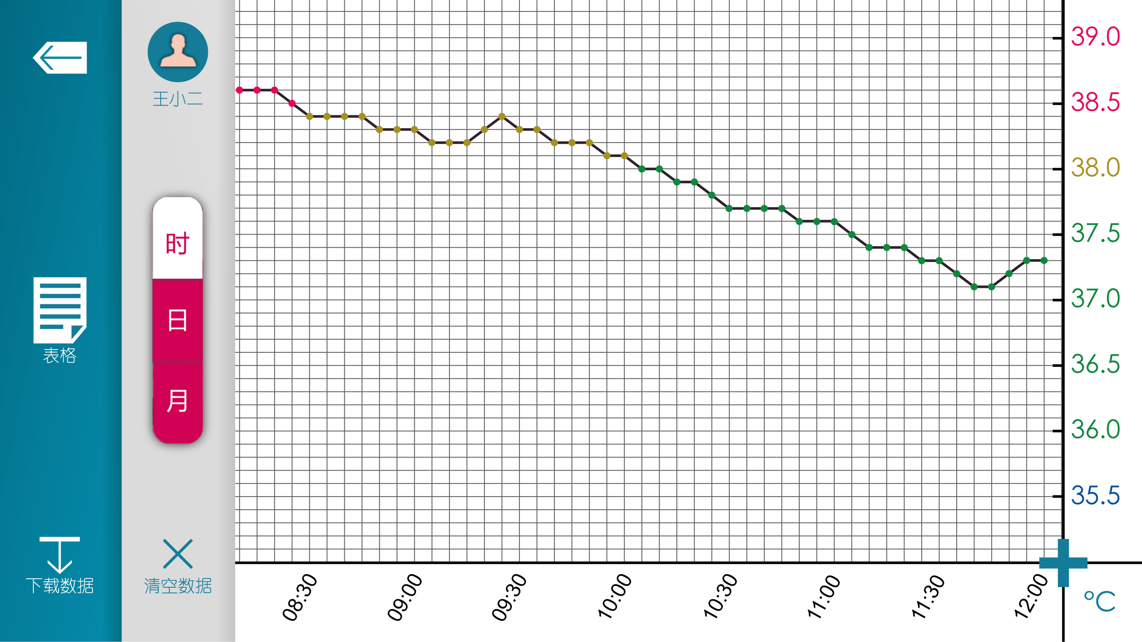

Click  to view the collector list and select the collector to be queried.
Click  to view the temperature data table of the collector.
Click  Data Export: Export the data table by email.
Click “Time, Day, Month”: corresponding to view the corresponding interface.
Click to delete the history of the current collector.

5, FAQ

The monitor cannot receive the temperature data of the collector. Please place the monitor near the collector.

Mobile phone cannot view temperature data, cause: monitor and mobile phone Bluetooth communication interruption.

6, packing list

SH210M monitor 1 pc
SH216S Remote Sensor 1 pcs (multiple options)
AAA alkaline batteries 2pcs
USB charging line 1pc
SH216 user manual 1pc

7. About FMG
Browse www.fmg-tech.com for more products. If you have any questions, please contact: sale@fmg-tech.com.

8. Recommend related products

SH218 Bluetooth temperature recording probe SH216C mini cold chain thermometer SH104M dial temperature recorder


