Wireless Bluetooth Pool Thermometer

Model SH210

User manual

1. Overview

The SH210 wireless Bluetooth pool thermometer consists of a monitor and multiple remote floating sensors . It uses advanced dual-band dual-mode wireless transmission technology, which may be the wireless bluetooth pool thermometer with the longest transmission distance and best value for money in the world. It can simultaneously monitor and record the measurement data of eight remote floating sensors. The user runs the App application software TempView+, which can conveniently download and view the water temperature measurement data with the mobile phone. It is widely used in the measurement and recording of water temperature in baths, pools, swimming pools, spas, bathing centers and other places.

2. Function and Specification

— Remote floating sensor
- Measurement range: 0°C～70°C
- Accuracy: ±1 °C
- Radio frequency: 433Mhz
- Transmission distance >100 meters
- Memory capacity: 4096B
- Product size: D85×H47mm

— Monitor
- Indoor temperature measurement: 0°C～50°C
- Temperature measurement accuracy: ±1 °C
- Humidity measurement: 10% to 95% RH
- Humidity measurement accuracy: ± 5%
- Wireless 433Mhz and Bluetooth BLE4.0 dual-band communication
- Monitor can receive and display the data of eight remote floating sensors
- Display clock, collector temperature, indoor temperature and humidity
- Preset temperature alarm threshold, sound and light alarm
- Transmission distance: >100M (433Mhz), >30M (Bluetooth)
- App software is compatible with Android and iOS operating systems
- Use two 1.5Vdc AAA alkaline batteries
- Dimensions: 108×90×22mm

3. Product Descriptions
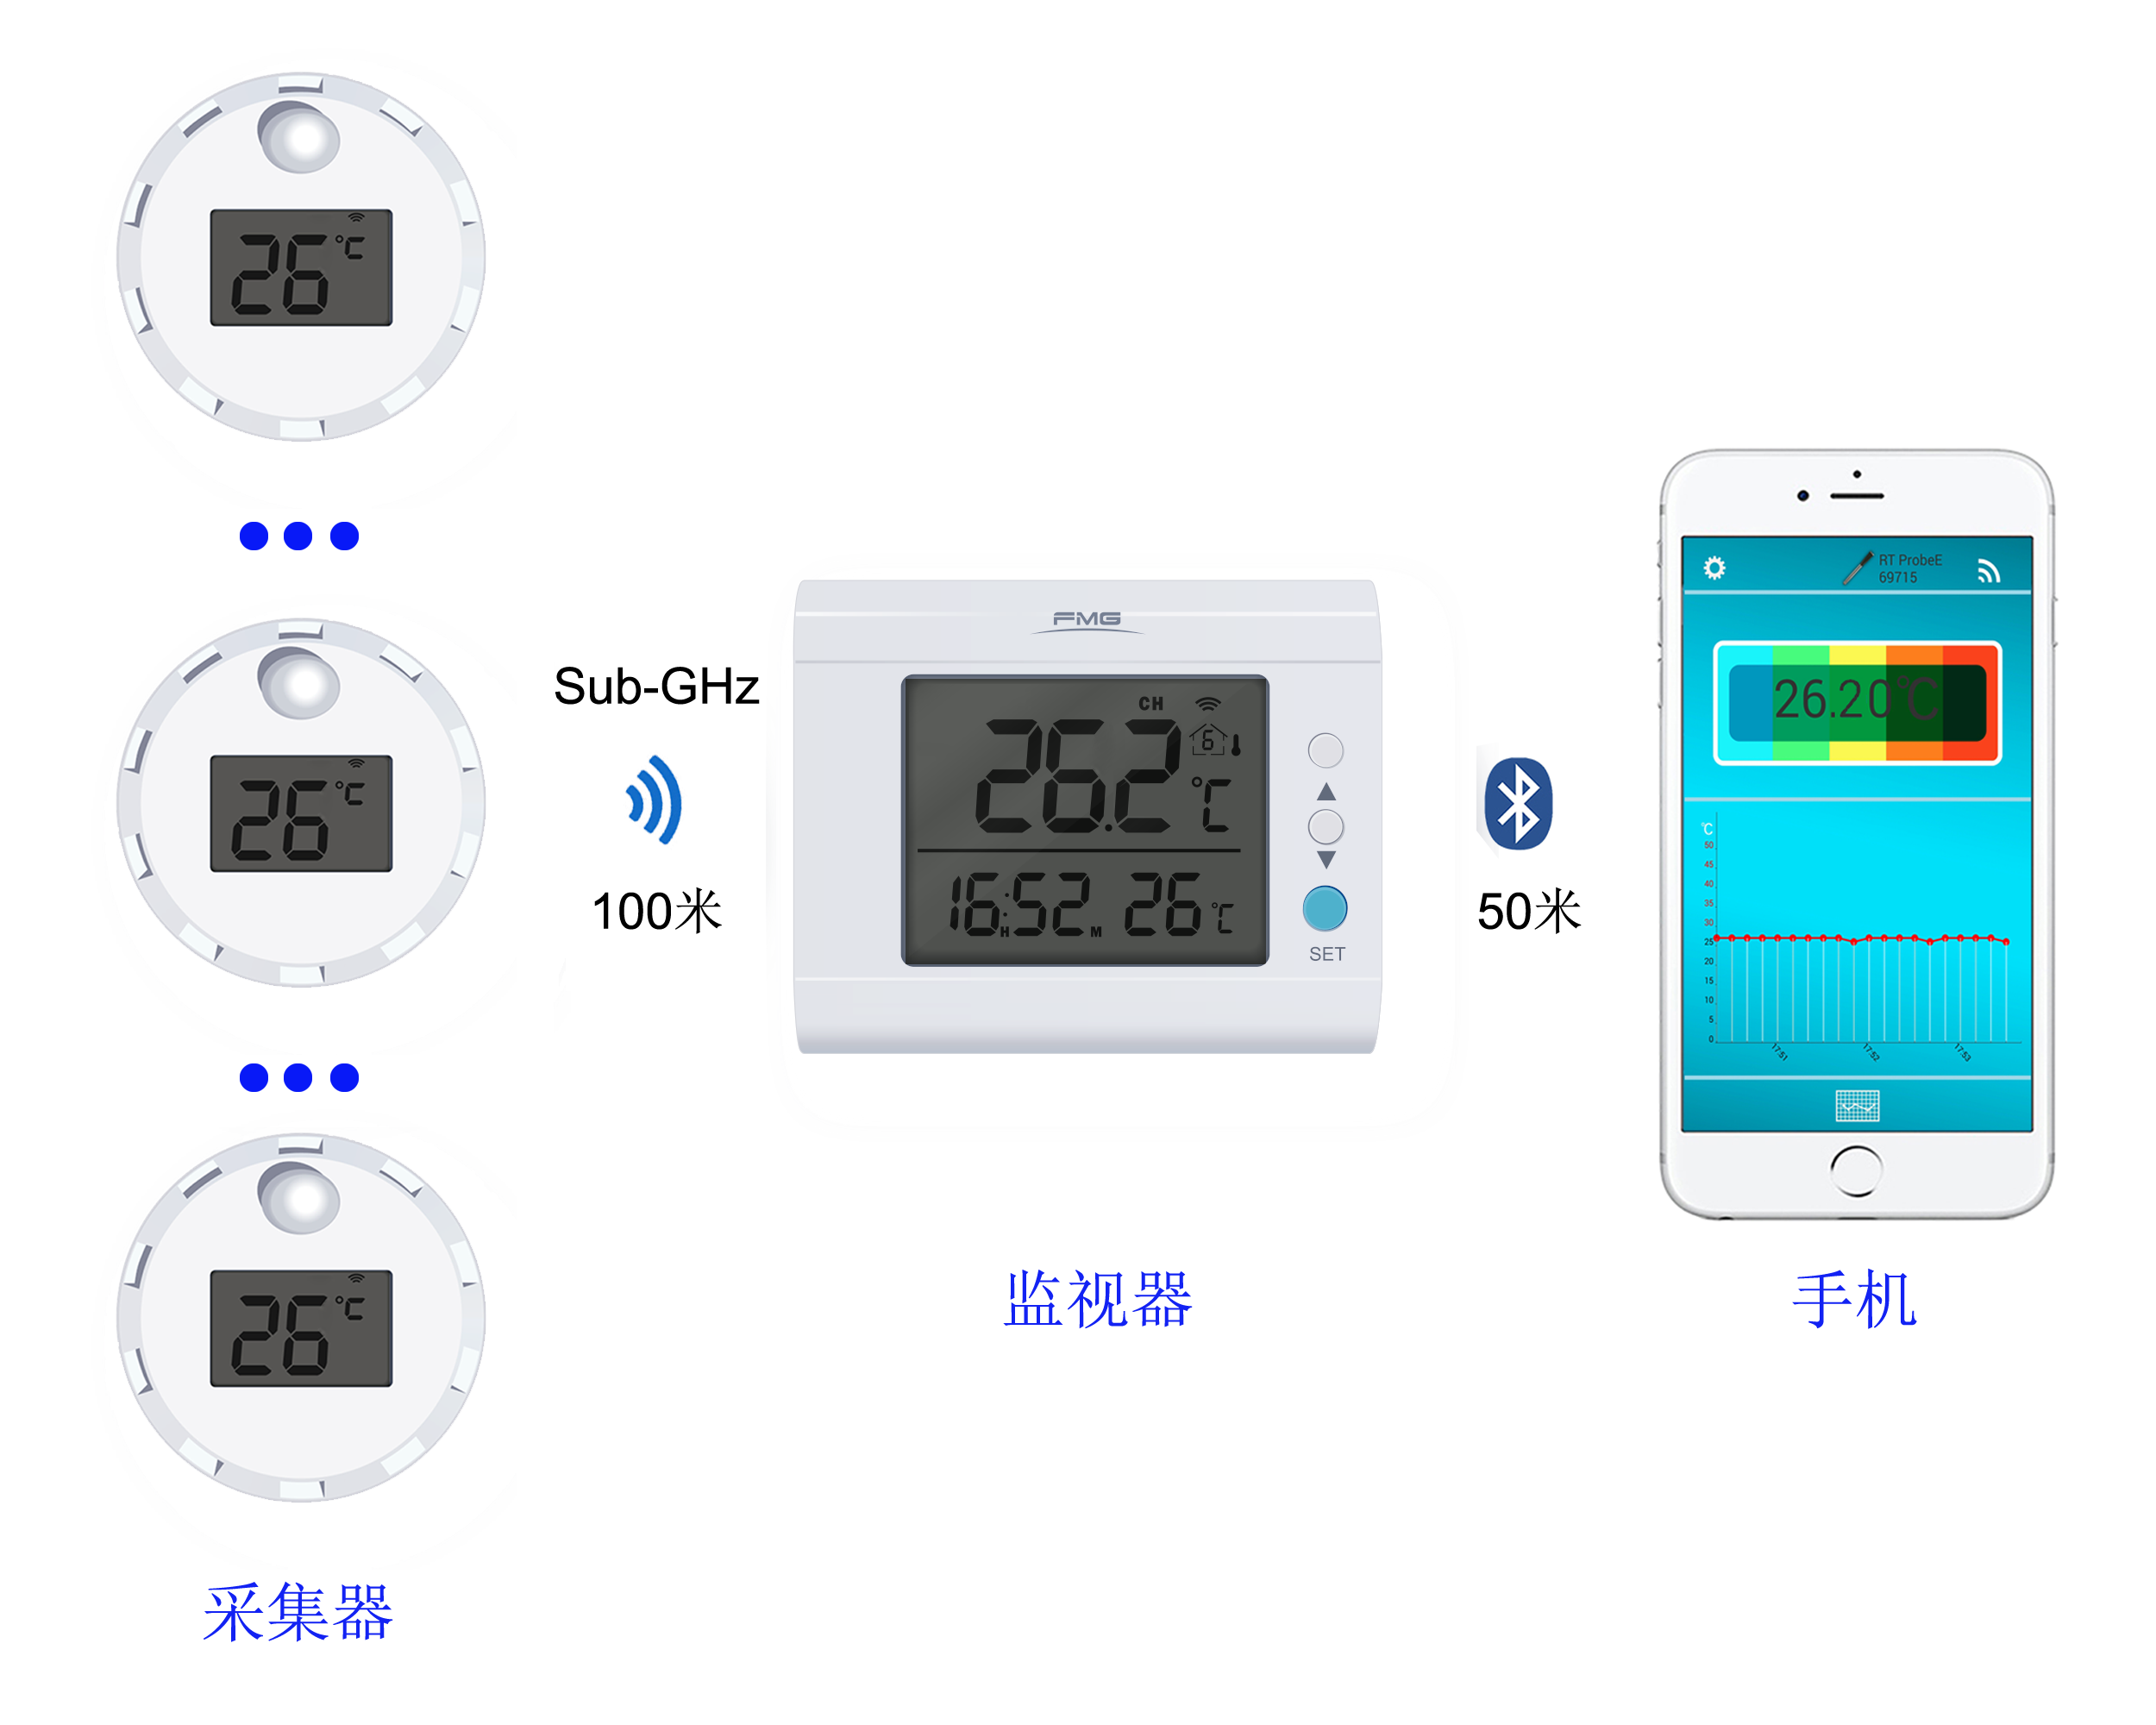

4. Operating Instructions
4.1. water temperature collector
-Install the battery
Unscrew the thermometer cover counterclockwise, remove the battery insulation strip or reload the CR2032 coin cell battery. Press the S key on the board to converse temperature display unit. Press and hold the S button to switch on or off .
- Remote floating sensor registration
Remote floating sensor needs to be registered before use. The registration operation is as follows: press and hold the C/F button of monitor for three seconds → the house icon on the upper left of the monitor screen flashes → in remote floating sensor closed state, press and hold S button three seconds, remote floating sensor sends a registration request → when the house icon on the monitor display stops flashing and the serial number is displayed, indicating that the registration is successful. If the registration is unsuccessful within 10 seconds, the icon disappears, and you need to re-register.
- Place remote floating sensor
Close the cover of the remote floating sensor which is put into the water far away 100 meters from the monitor. To measure the temperature of the bath or pool, tight the rope through the small hole in the cover so that the remote floating sensor does not drift far away . When measuring the water temperature of the fish tank, remote floating sensor is attached to the inner wall of the fish tank by using a plastic suction cup .
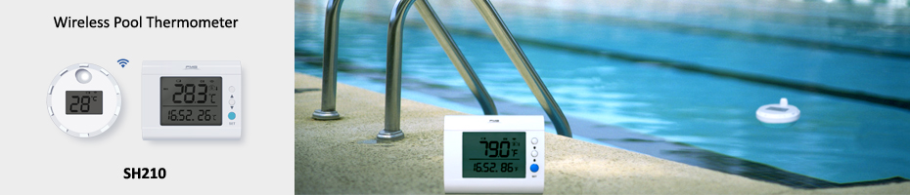
- Upload the logging data in remote floating sensor
The mobile phone sends an upload instruction to remote floating sensor and receive the stored data in the remote floating sensor through the monitor and App software . After the data is successfully uploaded, the memory is cleared.

4.2. Monitor

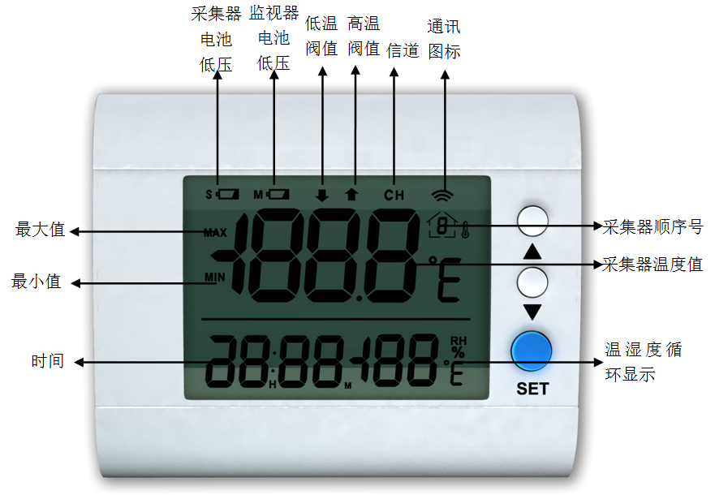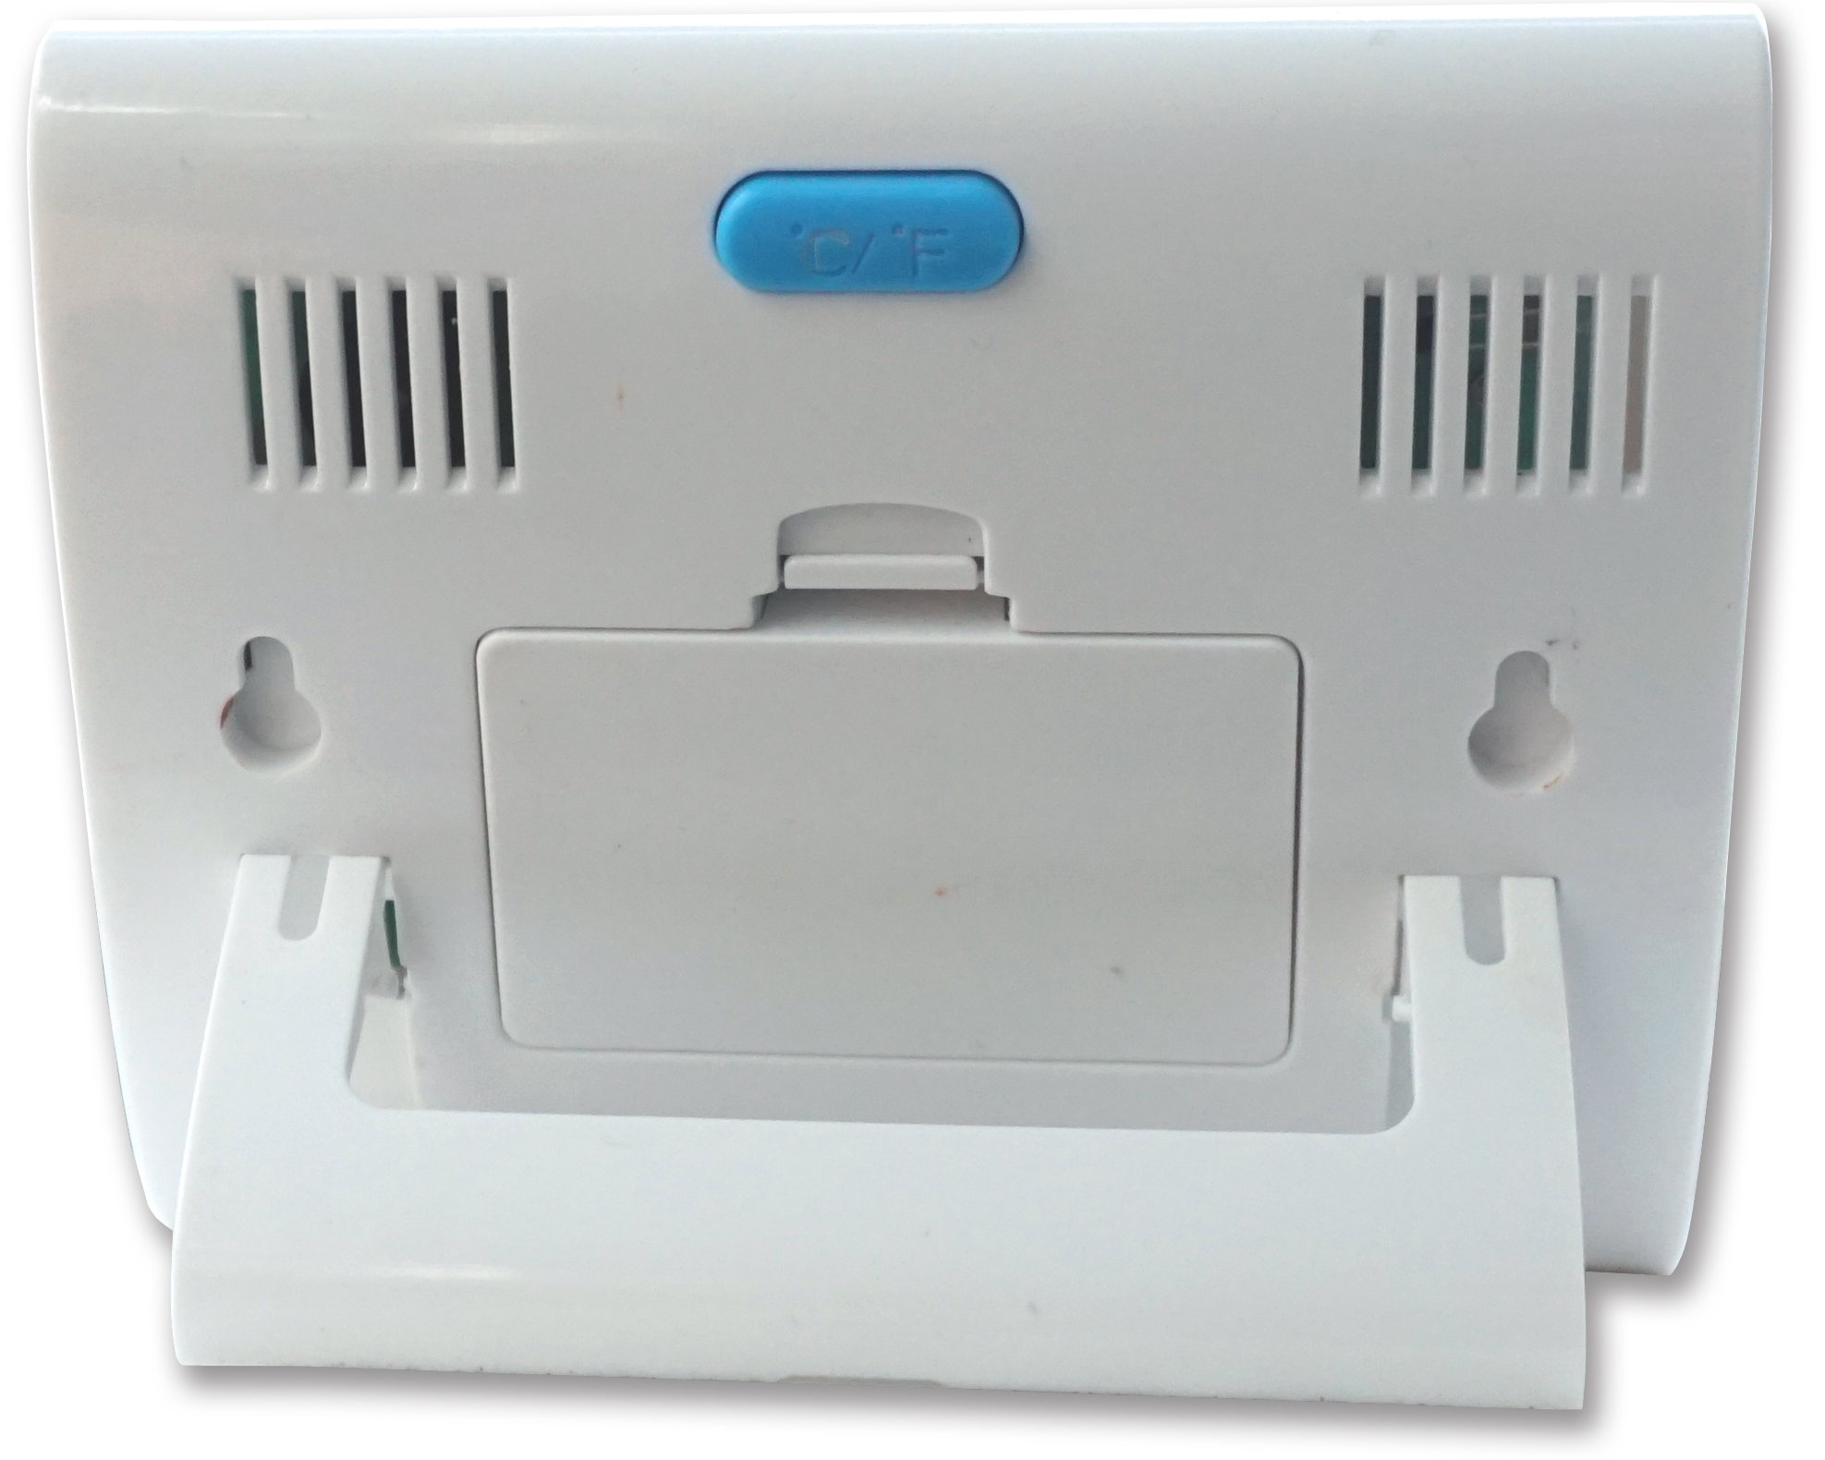
℃/F键

- Install the battery
Open the battery cover and load two AAA batteries.

- set the temperature unit
Press the C/F button on the back cover of the monitor to select the temperature unit.

- Setting parameters
Press and hold "SET" key for 3 seconds → the screen upper digit flash and appears "↑" the high temperature threshold setting icon → press▲or▼_key to set high temperature threshold ,and then press S key to confirm → display low temperature threshold setting "↓" icon → press▲or_▼key to set low temperature threshold and then press SET key to confirm → the hour number "12" flickers at the bottom left of the screen, enters the time setting → press▲or_▼key to adjust hours and then press SET key to confirm → minute number "00" flickers, press▲or_▼key to adjust minutes and then press SET key to confirm → the house icon at the top left of the screen flicker, press▲or▼key to deleted the serial number of remote sensor (serial number 0 means no deletion) → press SET key to confirm and then return to the original state
—Bluetooth link
Run the App TempView+ on the mobile phone, press and hold the monitor △ button for 3 seconds to link bluetooth communication between monitor and smartphone. The icon in the upper left corner of the monitor screen will flashes. If the icon stops flashing after 60 seconds, the Bluetooth link fails. Please repeat the above steps.

- Monitor Display
The number in the upper left corner of the monitor indicates the serial number of the collector. The upper row of the screen cyclically displays the measured water temperature of the remote floating sensors, and the lower row alternates between the indoor temperature and humidity and time.

- Query Maximum and Minimum Record
Press the monitor ▼ button to query the maximum and minimum water temperature values ​​of each remote floating sensor. Press and hold the button for 3 seconds to clear the maximum and minimum values.

- Query the data of remote floating sensors
Press the monitor ▲ button to query the water temperature value of each remote floating sensor.

- High and Low Temperature Alarm
When the water temperature exceeds the threshold temperature, the monitor emits an audible and visual alarm, and any button is pressed to interrupt the alarm.

- battery low voltage display
When the M or S icon appears in the upper right corner of the display, it indicates that the monitor or remote floating sensor battery is low voltage and the battery needs to be replaced.

4.4. Mobile phone App operation
- Download App Software
Please download and install the App TempView+ in the Apple Store or Google Play Store

--APP
Data download prompt

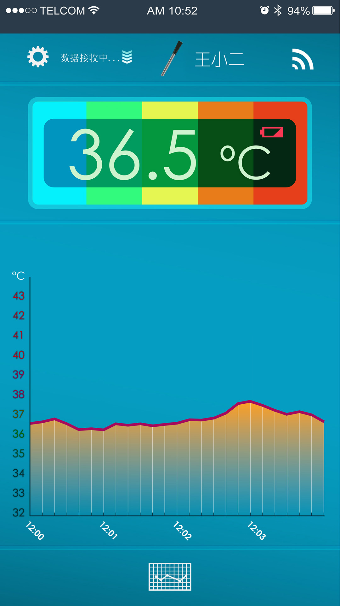
Current temperature value
Device connection status
Historical data query
Temperature curve
Device name
Low battery
System settings

—Bluetooth Connection
Press and hold the △ button for 3 seconds to link bluetooth communication between the monitor and the mobile phone. The icon in the upper left corner of the monitor screen flashes;. You need to repeat the above steps for Bluetooth connection. if the pairing is unsuccessful within 60 seconds and then the icon stops flashing

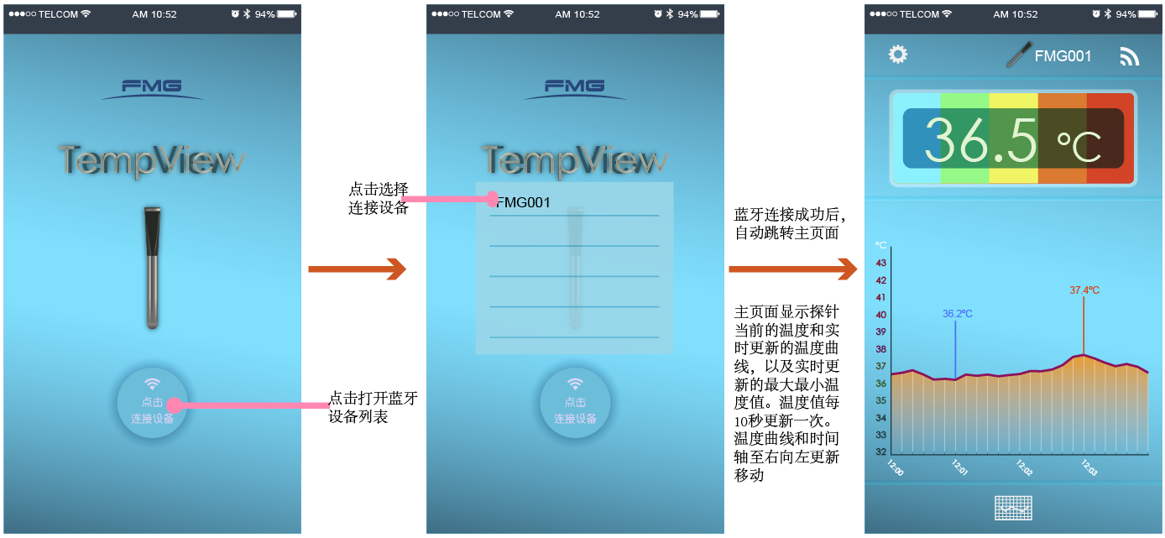

-parameter settings
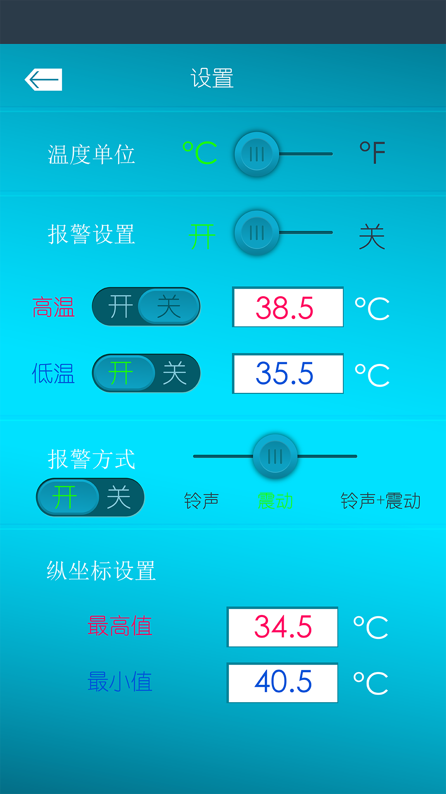
Click  Set temperature unit, alarm switch, high temperature threshold, low temperature threshold, alarm mode, ordinate.
Temperature unit: Celsius °C and Fahrenheit F
Alarm setting: set high and low temperature alarm threshold, select ringing, vibration, ringing alarm mode;
Vertical coordinate setting: Set the maximum and minimum ordinate.

--Data download
After the monitor is connected to the Bluetooth of the smart phone, the mobile phone sends upload command to the remote floating sensor through monitor and the remote floating sensor upload the logging data to smart phone

- History query
Click the “ ” icon on the homepage to enter the historical data query interface, as shown below:
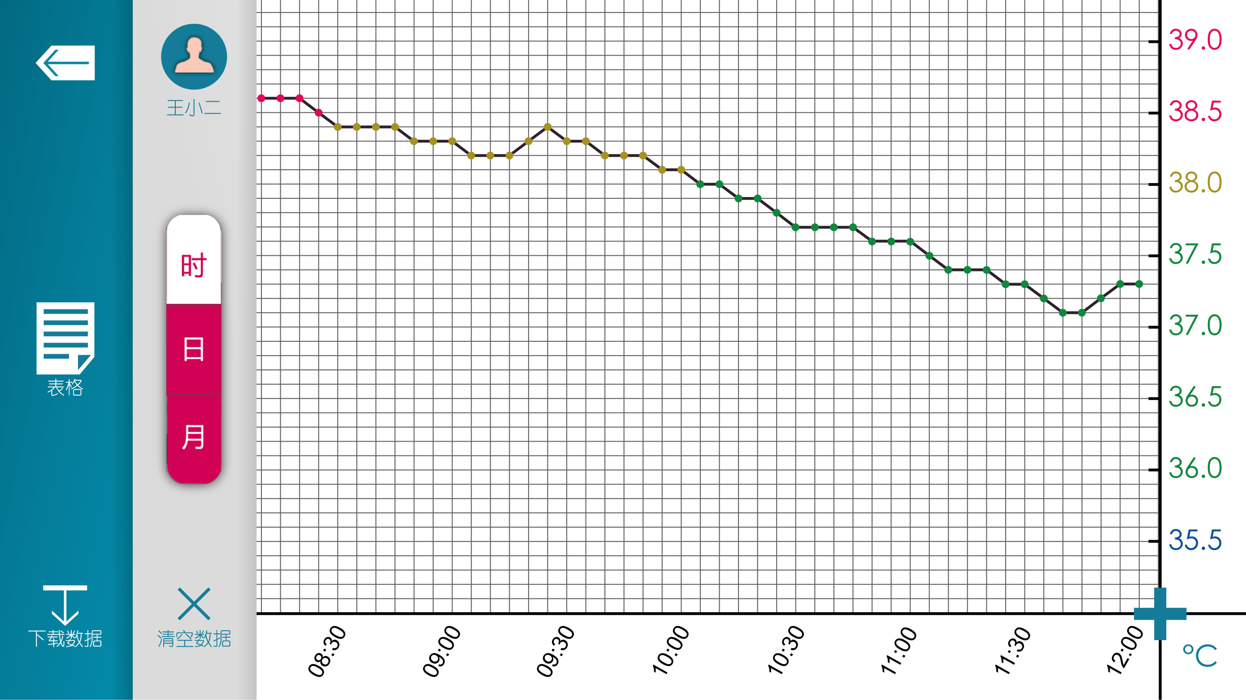

Click  to view the collector list and select the collector to be queried.
Click  to view the temperature data table of the collector.
Click  Data Export: Export the data table by email.
Click “Time, Day, Month”: corresponding to view the corresponding interface.
Click to delete the history of the current collector.

5. Packing List
SH210M monitor 1 pc
SH210S Remote floating Sensor 1 pc (multiple options)
Rope 1pc
CR2032 cell 1pc
SH210 User Manual 1pc
6. About FMG
Visit www.fmg-tech.com for more products. If you have any questions, please contact: sale@fmg-tech.com.

