Introduction
The LX3V-4PG four channels pulse generator unit, each channel performs simple positioning of an independent axis by supplying a prescribed quantity of pulses (200 kHz maximum) to drive amplifiers for servo or stepper motors.
The LX3V-4PG is attached as an extension to the LX3V series programmable logic controller (hereinafter referred to as “PLC”), which transfers data with the PLC using the FROM/TO instructions.
There are two types, one is LX3V-4PGA (Enhanced), and the other is LX3V-4PGB (Basic).
Warnings：
Cut off the electricity before installation/disassembly of the unit or connection of wires onto the unit, to prevent electric shock or product damage.

Dimensions
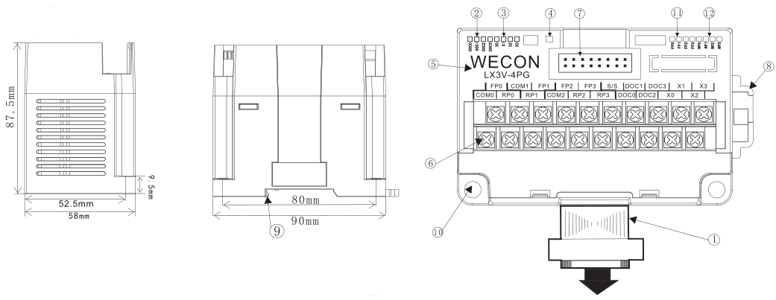
Weight: Approx. 0.3 kg (0.661bs)
Unit: mm
Note:
① Extension cable and connector
② Com LED: It keeps on communicating is OK.
③ Power LED: It keeps on when it supplied by 24v DC outside.
④ State LED: It keeps on when it works properly
⑤ Module name
⑥ Analog signal output terminal
⑦ Extension module interface
⑧ DIN rail mounting slot
⑨ DIN rail hook
⑩ Mounting holes (φ4.5)

Crimp terminations

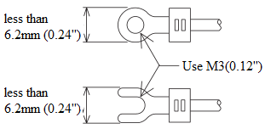
- Please use crimp terminals as indicated on the graph.
- The tightening torque should be applied 5 to 8 Kg.cm.
- Other terminals should be empty but only wiring terminals mention in this manual.

Terminal Definition
Terminal | Instruction | Terminal | Instruction | Terminal | Instruction
COM 0 | Common terminal for channel 1 | FP 2 | Channel 3 outputs pulses | S/S | Common terminal for X and DOG, it supports NPN/PNP type.
FP 0 | Channel 1 outputs pulses | RP 2 | Channel 3 outputs direction
RP 0 | Channel 1 outputs direction | FP 3 | Channel 4 outputs pulses | DOG 3 | Original point signal input 4
COM 1 | Common terminal for channel 2 | RP 3 | Channel 4 outputs direction | X 0 | Terminal for STOP input 1
FP 1 | Channel 2 outputs pulses | DOG 0 | Original point signal input 1 | X 1 | Terminal for STOP input 2
RP 1 | Channel 2 outputs direction | DOG 1 | Original point signal input 2 | X 2 | Terminal for STOP input 3
COM 2 | Common terminal for channel 3 and 4 | DOG 2 | Original point signal input 3 | X 3 | Terminal for STOP input 4

Input and output Specification

Input specification
LX3V-4PG input specification
Input terminal: X0-X3, DOG0-DOG3
This is NPN type, if you want to
PNP type, please connect S/S to
24V negative electrode, and X
connects to positive electrode.
X input and DOG input
Input signal voltage | DC V 24 ±10% | Input signal type | Contact input, NPN and PNP
Input signal current | 5 mA /DC24V | Circuit insulation | Optocouples insulation
Input ON current | 3.5 mA / DC24 V | Input action | LED turns on, when input ON
Input OFF current | Less than 1.5 mA

Output specification
Output circuit
Output:
FP0-3: High-speed pulse output;
Electrical parameters: Same as PLC high speed output (Y0-Y1);
PR0-3: Normal output direction;
Electrical parameters: Same as PLC normal output ( from Y4);
Items |  | Transistor output
Models |  | LX3V series mode
External power supply |  | DC 5~30V
Circuit insulation |  | Photocoupler insulation
Action |  | LED turns on when optocoupler working.
Maximum  load | Resistance | 0.5A/ each point, 0.8A/ four points (0.3A/each point in FP terminal)
 | Inductance | 12W/DC24V (7.2W/DC24V in FP terminal)
 | Lamp | 0.9W/DC24V (0.9W/DC24V in FP terminal)
Leakage current |  | 0.1mA/DC30V
Minimum load |  | DC5V2mA
Response time | Input current (ON) | 5us less than 0.2ms (FP terminal)
 | Input current (OFF) | 5us less than 0.2ms (FP terminal)
Output type |  | NPN signal

Function description

BFM list
BFM number |  |  |  |  |  |  |  | Power-off save | Operation | Name | b15 | b14 | b13 | b12 |  | b11 |  | b10 | Default value | Range
CH1 |  | CH2 |  | CH3 |  | CH4
H16 | L16 | H16 | L16 | H16 | L16 | H16 | L16
0 |  | 40 |  | 80 |  | 120 |  | X | R/W | Pulse rate | Unit : PLUSE/REV [1] |  |  |  |  |  |  |  | 2000 | 1-32,767
2 | 1 | 42 | 41 | 82 | 81 | 122 | 121 | X | R/W | Feed rate | Unit: it set by b2-b0 of BFM#3 [1] |  |  |  |  |  |  |  | 1000 | 1-999999
3 |  | 43 |  | 83 |  | 123 |  | X | R/W | Parameters | -- |  |  | DOG input polarity |  |  | S-type acceleration and deceleration [3] | Home position return direction | 0 | 0-5
5 | 4 | 45 | 44 | 85 | 84 | 125 | 124 | X | R/W | Maximum speed | The unit value is depending on the system of units set in the BFM #3 b1 and b0 |  |  |  |  |  |  |  | 100KHz | 10Hz-200,000Hz
6 |  | 46 |  | 86 |  | 126 |  | X | R/W | Bias speed | The unit value is depending on the system of units set in the BFM #3 b1 and b0 |  |  |  |  |  |  |  | 0Hz | 0Hz-10,000Hz
8 | 7 | 48 | 47 | 88 | 87 | 128 | 127 | X | R/W | JOG speed | The unit value is depending on the system of units set in the BFM #3 b1 and b0 |  |  |  |  |  |  |  | 10KHz | 10Hz-100,000Hz
10 | 9 | 50 | 49 | 90 | 89 | 130 | 129 | X | R/W | Home position return speed (high speed) | The unit value is depending on the system of units set in the BFM #3 b1 and b0 |  |  |  |  |  |  |  | 50KHz | 1Hz-100,000Hz
11 |  | 51 |  | 91 |  | 131 |  | X | R/W | Home position return speed (creep speed) | The unit value is depending on the system of units set in the BFM #3 b1 and b0 |  |  |  |  |  |  |  | 1KHz | 0Hz-10,000Hz
12 |  | 52 |  | 92 |  | 132 |  | X | R/W | Reserved | -- |  |  |  |  |  |  |  | -- | --
14 | 13 | 54 | 53 | 94 | 93 | 134 | 133 | O | R/W | Home position | The unit value is depending on the system of units set in the BFM #3 b1 and b0 |  |  |  |  |  |  |  | 0 | -999,999-999,999
15 |  | 55 |  | 95 |  | 135 |  | X | R/W | Acceleration time | Acceleration time from the bias speed to the maximum speed. |  |  |  |  |  |  |  | 100ms | 20-32000ms
16 |  | 56 |  | 96 |  | 136 |  | X | R/W | deceleration time | Deceleration time from the maximum speed to the bias speed. |  |  |  |  |  |  |  | 100ms | 20-32000ms
18 | 17 | 58 | 57 | 98 | 97 | 138 | 137 | X | R/W | Set position (I) | The unit value is depending on the system of units set in the BFM #3 b1 and b0 |  |  |  |  |  |  |  | 0 | -999,999-999,999
20 | 19 | 60 | 59 | 100 | 99 | 140 | 139 | X | R/W | Operating speed (I) | The unit value is depending on the system of units set in the BFM #3 b1 and b0 |  |  |  |  |  |  |  | 10Hz | 10Hz-200,000Hz
22 | 21 | 62 | 61 | 102 | 101 | 142 | 141 | X | R/W | Set position (II) | The unit value is depending on the system of units set in the BFM #3 b1 and b0 |  |  |  |  |  |  |  | 0 | -999,999-999,999
24 | 23 | 64 | 63 | 104 | 103 | 144 | 143 | X | R/W | Operating speed (II) | The unit value is depending on the system of units set in the BFM #3 b1 and b0 |  |  |  |  |  |  |  | 10Hz | 10Hz-200,000Hz
25 |  | 65 |  | 105 |  | 145 |  | X | R/W | Operating mode | -- |  |  |  | Start shift operation |  | -- | Start two-Speed Positioning | -- | --
27 | 26 | 67 | 66 | 107 | 106 | 147 | 146 | O | R/W | Current position | The unit value is depending on the system of units set in the BFM #3 b1 and b0 |  |  |  |  |  |  |  |  | -2147483648-2147483647
28 |  | 68 |  | 108 |  | 148 |  | X | R/W | Status flag | -- |  |  |  |  |  |  | Interrupt signal | -- | --
29 |  | 69 |  | 109 |  | 149 |  | X | R | Error code | -- |  |  |  |  |  |  |  | -- | --
30 |  | 70 |  | 110 |  | 150 |  | X | R | Model code | Basic: 5110;  Enhanced: 5120; [5] |  |  |  |  |  |  |  | K5110 | --
31 |  | 71 |  | 111 |  | 151 |  | X | R | Version code |  |  |  |  |  |  |  |  | K13301 | --
32 |  | 72 |  | 112 |  | 152 |  | X | R | Reserved | -- |  |  |  |  |  |  |  | -- | --
33 |  | 73 |  | 113 |  | 153 |  | X | R | Reserved
34 |  | 74 |  | 114 |  | 154 |  | X | R | Reserved
35 |  | 75 |  | 115 |  | 155 |  | X | R | Reserved
36 |  | 76 |  | 116 |  | 156 |  | X | R | Reserved
37 |  | 77 |  | 117 |  | 157 |  | X | R | Reserved
38 |  | 78 |  | 118 |  | 158 |  | X | R | Reserved
39 |  | 79 |  | 119 |  | 159 |  | X | R | Reserved

BFM list |  |  |  | Device name | b9 | b8 | b7 | b6 | b5 | b4 | b3 | b2 | b1 | b0
CH1 | CH2 | CH3 | CH4
3 | 43 | 83 | 123 | Parameters | Rotation direction | -- | -- | Interrupt signal input polarity[3] | Positioning data multiple 10⁰~10³ |  |  |  | System units: motor systems, mechanical systems, combined systems.
25 | 65 | 105 | 145 | Operating mode | Interrupt  single speed positioning start[3] | Single  speed | Relative /  absolute  position start | Home  position  return start | JOC- | JOC+ | Forward  pulse stop | Reverse  pulse stop | STOP | Error reset
28 | 68 | 108 | 148 | Flags | CLR signal | Positioning  completed  flag | Error flag | Current  position  value  overflow | -- | DOG signal | Stop signal | Home  position  return  completed | Reverse  rotation/  Forward  rotation | Ready/Busy
Note:
Symbol Description: O means power-off save type; X means power-off non-save type; R means read only; W means read and write.
[1]: Unit is um/R, mdeg/R or 10⁻⁴ inch/R.
[2]: Unit is PLS, um/R, mdeg/R or 10⁻⁴ inch depending on the system of units set in the BFM #3 b1 and b0.
[3]: S-type acceleration and deceleration interrupt single speed positioning and two-speed positioning are available in enhanced version.
[4]: When there are more than one bits set on in BFM #25 b6~b4, b12~b8, the operation will not be executed.
[5]: “5110” (basic): it has JOG, single speed positioning, home position return and speed change; “5120” (enhanced): it has all functions.

BFM instruction

System of Units and Parameter Setting
[BFM #0] Pulse rate
This is the number of input pulses required by the amplifier to rotate the motor by 1 revolution. It is not the number of encoder pulses per revolution of the motor. (The pulse rate becomes a different value in accordance with the electronic gear ratio.) The BFM #0 is not required to be set when the motor system of units is selected.

[BFMs #2 and #1] Feed rate
B1 (distance specification) = 1 to 999,999 um/R
B2 (angle specification) = 1 to 999,999 mdeg/R
B3 (distance specification) = 1 to 999,999x10⁻⁴ inch/R
This is the machine travel while the motor rotates by 1 revolution. Set either one among B1, B2 and B3 in accordance with the unit among um/R, mdeg/R and 10⁻⁴ inch/R suitable to the application. The BFMs #2 and #1 are not required to be set when the motor system of units described later is selected.

[BFM #3] Parameters (b0 to b15)
- System of units (b1, b0)
b1 | b0 | System of units | Remarks
0 | 0 | Motor system | Units based on pulses
0 | 1 | Machine system | Units based on lengths and angles
1 | 0 | Combined system | Units based on lengths and angles for position units based on HZ for speed
1 | 1

The table below shows the units for position and speed in accordance with the setting of the BFMs #2 and #1
 | Selection of feed rate | Motor system | Combined system | Machine system
Position data*1 | Unit 1 | PLS | um
 | Unit 2 | PLS | mdeg
 | Unit 3 | PLS | 10⁻⁴ inch
Speed data*2 | Unit 1 | Hz |  | cm / min
 | Unit 2 | Hz |  | 10 deg /min
 | Unit 3 | Hz |  | inch / min
*1 position data: HP, P(I), P(II), CP.
*2 speed data: Vmax, Vbia, Vjog, Vrt, V(I), V(II).

- Multiplication of position data (b5, b4)
b5 | b6 | Multiplication  The position data HP, P (I), P (II) and CP will be multiplied by the value shown in the table on the left.
0 | 0 | 10⁰
0 | 1 | 10¹
1 | 0 | 10²
1 | 1 | 10³
Example: When the value of the set position P(I) is 123 and the BFM #3 (b5, b4) is (1, 1), the actual position (or travel) becomes as follows:
Motor system of units | 123 * 10³=123,000 (pulses)
Machine system of units | 123*10³=123,000 (um, mdeg, 10⁻⁴inch)  =123 (mm,deg, 10⁻¹inch)
Combined system of units

- Rotation direction (b9)
When b9 = 0: The current position (CP) value increases with a forward pulse (FP).
When b9 = 1: The current position (CP) value decreases with a forward pulse (FP).
This bit is used for the initial setting. The change of rotation direction will not work in actual operation process.

- Home position return direction (b10)
When b10 = 0: The current position (CP) value decreases during return to the home position.
When b10 = 1: The current position (CP) value increases during return to the home position.

- S-type acceleration and deceleration(b11)
When b11=0, the acceleration is constant during acceleration and deceleration process for positioning operation, the curve of speed is trapezoidal.
When b11=1, the curve of speed is S-type during acceleration and deceleration process for positioning operation.
- DOG input polarity (b12)
When b12 = 0: The DOG (near point signal) input is turned on when the workpiece is coming near the home position.
When b12 = 1: The DOG (near point signal) input is turned off when the workpiece is coming near the home position.

Speed Data and Position Data
[BFMs #5 and #4] Maximum speed V_{max}
Motor system and combined system: 1 to 200,000 Hz
This is the maximum speed. Make sure that the bias speed (BFM #6), the JOG speed (BFMs #7 and #8), the home position return speed (BFMs #9 and #10), the creep speed (BFM #11), the operating speed (I) (BFMs #19 and #20) and the operating speed (II) (BFMs #23 and #24) are set respectively to a value equivalent to or less than the maximum speed. The degree of acceleration/deceleration is determined by this maximum speed, the bias speed (BFM #6), the acceleration time (BFM #15) and the deceleration time (BFM#16).

[BFM #6] Bias speed V_{bia}
The range is 0 to 10,000Hz
This is the bias speed at time of start. When the LX3V-4PG and the stepper motor are used together, set a value while taking the resonance area and the self-start frequency of the stepper motor into account.

[BFMs #8 and #7] JOG speed VJOG
The range is 1 to 100,000Hz
This is the speed for manual forward/reverse (JOG+/JOG-). Set a value between the bias speed V_{bia} and the maximum speed V_{max}

[BFMs #10 and #9] Home position return speed (high speed) V_{RT}
The range is 10 to 100,000Hz
This is the speed (high speed) for returning to the machine home position. Set a value between the bias speed V_{bia} and the maximum speed V_{max}.

[BFM #11] Home position return speed (creep) V_{CR}
This is the speed (extremely slow speed) after the ear point signal (DOG) for returning to the machine home position. It is the speed immediately before stopping in the machine home position. It is recommended to set it as slow as possible so that the precision of the home position becomes better.

[BFMs#14 and #13] Home position HP
Motor system: 0 to ±999,999 PLS. Machine system and combined system: 0 to ±999,999
This is the home position used for returning to the machine home position. When the home position return operation is completed, the value set here is written to the current position (BFMs #26 and #27).

[BFM #15] Acceleration time Ta
The range is 20 to 32,000 ms
This is the time between the bias speed (BFM #6) and the maximum speed (BFMs #5 and #4).

[BFM #16] Deceleration time Td
The range is 20 to 32,000 ms
This is the time between the bias speed (BFM#6) and the maximum speed (BFMs #5 and #4).
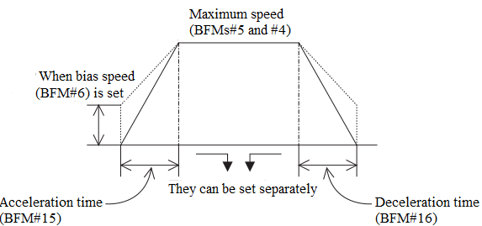

[BFMs#18 and #17] Set position (I) P (I)
Motor system: 0 to ±999,999 PLS. Machine system and combined system: 0 to ±999,999
This is the target position or the travel distance for operation. When the absolute position is used, the rotation direction is determined in accordance with the absolute value of the set position based on the current position (BFMs #26 and #27). When the relative position is used, the rotation direction is determined by the sign of the set position.

[BFMs #20 and #19] Operating speed (I) V (I)
The range is 10 to 100,000 Hz.
This is the actual operating speed within the range between the bias speed V_{bia} and the maximum speed V_{max}. In variable speed operation and external command positioning operation, forward rotation or reverse rotation is performed in accordance with the sign (positive or negative) of this set speed.

[BFMs #22 and #21] Set position (II) P (II)
Motor system: 0 to ±999,999 PLS. Machine system and combined system: 0 to ±999,999
This is the set position for the second speed in two-speed positioning operation.

[BFMs #24 and #23] Operating speed (II) V (II)
The range is 1 to 200,000Hz
This is the second operating speed in two-speed positioning operation.

[BFMs #27 and #26] Current position CP
Motor system: -2,147,483,648 to +2,147,483,647 Hz. Machine system and combined system: -2,147,483,648 to +2,147,483,647
The current position data is automatically written here.

Position Data, Home Position and Current Position
The position data includes the following: HP: Home position, P (I): Set position (I), P(II): Set position (II) and CP: Current position.
When the operation of returning to the machine home position is completed, the home position HP (BFMs #14 and #13) value is automatically written to the current position CP (BFMs #27 and #26).
The set positions P(I) and P(II) can be treated as absolute positions (distance from the current position CP = 0) or relative positions (travel from the current stop position) as described later.

Operation Command
[BFM #25] Operation command (b0 to b11, b12)
After data is written to the BFMs #0 to #24, write the BFM #25 (b0 to b12) as follows.
[b0] When b0 = 1: The error flag (BFM #28 b7) is reset.
[b1] When b1 = 0→1: Stop, if this bit is changed from 0 to 1 in positioning mode, the machine is decelerated and stopped.
[b2] When b2 = 1: Forward pulse stop, the forward pulse is immediate stopped in the forward limit position.
[b3] When b3 = 1: Reverse pulse stop, the reverse pulse is immediate stopped in the reverse limit position.
[b4] When b4 = 1: JOG+ operation, when b4 continues to be 1 for less than 300ms, one forward pulse is generated. When b4 continues to be 1 for 300 ms or more, continuous forward pulses are generated.
[b5] When b5 = 1: JOG- operation, when b5 continues to be 1 for less than 300ms, one reverse pulse is generated. When b5 continues to be 1 for 300 ms or more, continuous reverse pulses are generated.
[b6] When b6 = 0→1: Home position return start, the machine starts to return to the home position, and is stopped at the machine home position when the DOG input (near point signal) is given.
[b7] When b7 = 0: Absolute position. When b7 = 1: Relative position. The relative or absolute position is specified in accordance with the b7 status (1 or 0). (This bit is valid while operation is performed using b8, b9 or b10.)
[b8] When b8 = 0→1: Single-speed positioning operation is performed.
[b9] When b9 = 0→1: Interrupt single-speed positioning operation is performed.
[b10] When b10 = 0→1: Two-speed positioning operation is performed.
[b11] Reserved
[b12] When b12 = 1: Variable speed operation is performed.
Operation command data transfer method
- Error can be reset by forcedly turning on/off the peripheral unit. The input X000 does not have to be used. When the data on absence/presence of error and the error code should be saved even after power interrupt, use power down save register.
- In operation which does not require returning to the home position such as inching operation with a constant feed rate, the input X006 is not required.
- In the program below, the start bit for the operation mode cannot be set to OFF inside the PGU, so operation from the second time and later cannot be performed. Correct it as shown in the right.
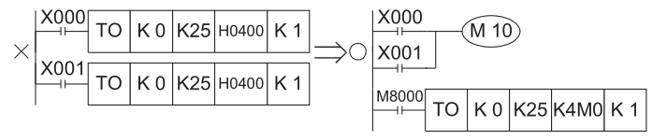

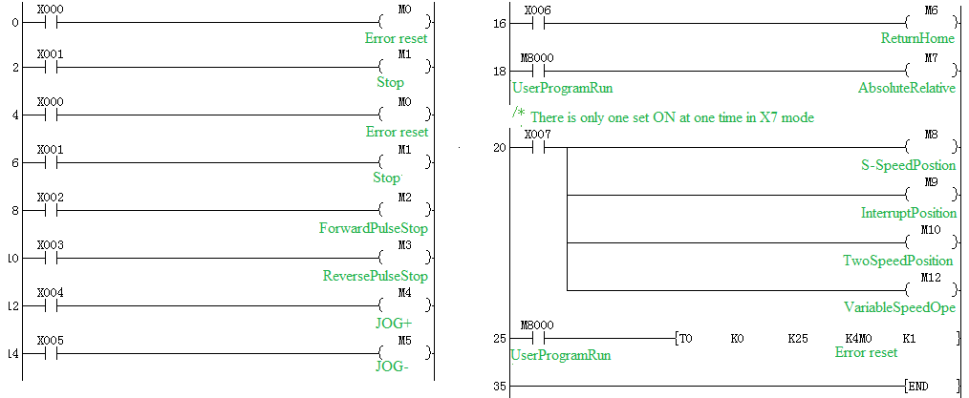

Status and Error Codes
[BFM #28] Status information (b0 to b8)
The status information to notify the PC of the PGU status is automatically saved in the BFM #28. Read it into the PC using the FROM instruction.
[b0] When b0 = 0: BUSY. When b0 = 1: READY. This bit is set to BUSY while the PGU is generating pulses.
[b1] When b1 = 0: Reverse rotation. When b1 = 1: Forward rotation. This bit is set to 1 when operation is started with forward pulse.
[b2] When b2 = 0: Home position return unexecuted. When b2 = 1: Home position return completed. When returning to the home position is completed, b2 is set to 1, and continues to be 1 until the power is turned off. To reset b2, use the program.
[b3] When b3 = 0: STOP input OFF. When b3 = 1: STOP input ON.
[b4] When b4 = 0: DOG input OFF. When b4 = 1: DOG input ON.
[b5] Reserved
[b6] When b6 = 1: Current position value overflow. The 32-bit data saved in the BFMs (#27 and#26) has overflown. This bit is reset when returning to the home position is completed or the power is turned off.
[b7] When b7 = 1: Error flag, b7 becomes 1 when an error has occurred in the PGU, and the contents of the error are saved in the BFM #29. This error flag is reset when the BFM #25 b0 becomes 1 or the power is turned off.
[b8] When b8 = 0: Positioning started. When b8 = 1: Positioning completed b8 is cleared when positioning is started home position return start, or error reset, and set when positioning is completed. b8 is also set when returning to the home position is completed.
[b9] CLR signal, when returning to the home position is completed, CLR signal is output, the duration is XXX ms.
[b10] When b10=0: interrupt input OFF. When b10 = 1: interrupt input ON.
- Various start commands are accepted exclusively while the BFM #28 b0 is set to 1 (READY).
- Various data is also accepted exclusively while the BFM #28 b0 is set to 1 (READY). However, the BFM #25 b1 (stop command), the BFM #25 b2 (forward pulse stop) and the BFM #25 b3 (reverse pulse stop) are accepted even while the BFM #28 b0 is set to 0 (BUSY)
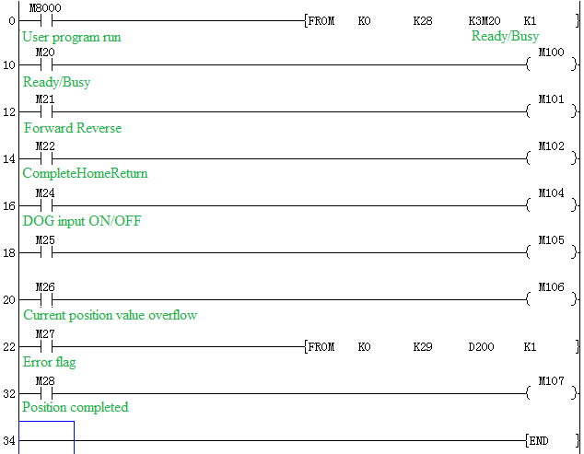

[BFM #29] Error code number
The following error codes Nos. are saved in the BFM#29. Read and check it when the BFM #28 b7 is set to 1 (Error present).
001: Large/small relationship is incorrect. (V max <V_{bia} or V RT < V CR);
002: Setting is not performed yet. (V (I), P (I), V (II) or P (II));
003: Setting range is incorrect;
00 indicates the corresponding BFM No. For example, “172" indicates that the BFMs #18 and #17 are set to 0. “043" indicates that the BFMs #5 and #4 are set to a value outside the range.
When a speed command specifies a value equivalent to or more than V max or a value equivalent to or less than V_{bia}, error does not occur. V max or V_{bia} is used for operation. Though the ready status can be specified even while an error is present, the start command is not accepted.

Function description
Seven operation modes are available in the PG in accordance with the start command type. The data on speed and position should be transferred preliminarily from the PC to the buffer memories (BFMs) of the PG.

JOG operation
While the forward or reverse button is pressed and held, the motor is driven forward or in reverse.
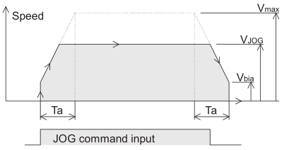
Any value between the bias speed V_{bia} (BFM #6) and the maximum speed Vmax (BFMs #5 and #4) is valid as the command speed V_{JOG} (BFMs #8 and #7). When JOG signal continues to be 1 for less than 300ms, one reverse pulse is generated. When JOG signal continues to be 1 for 300 ms or more, continuous reverse pulses are generated.

Machine home position return operation
When the home position start command is received, the motor makes the machine return to the home position. When returning to the home position is completed, the home position HP (BFMs #14 and #13) value is written to the current position CP (BFMs #27 and #26).
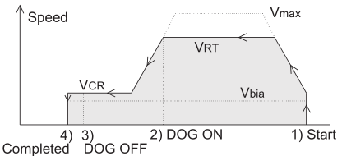
- When the home position return start command is changed from OFF to ON, the home position return operation is started at the speed V RT (BFMs #10 and #9).
- When the near point signal DOG input is turned on, the motor decelerates to the creep speed V CR (BFM #11).
- When the near point signal DOG input is changed from ON to OFF, the motor is immediately stopped in the position 4).
For the details, refer to “DOG Switch” and “Home Position Return Operation”

DOG Switch
DOG switch for returning to home position
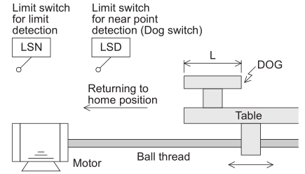
- A dog whose length is L is fixed to a table driven in the left and right direction by a servo motor via a ball thread.
- When the table moves in the home position return direction, the dog is in contact with the limit switch (LSD) for near point detection, and the LSD is actuated.
- The LSD is turned ON from OFF when the BFM #3 b12 is set to 0, and turned OFF from ON when the BFM #3 b12 is set to 1.
- The home position return direction is determined by the BFM #3 b9 (rotation direction) and b10 (home position return direction).
- The limit switch LSD is often referred to as dog switch. The actuation point of the dog switch is rather dispersed.

Home Position Return Operation
The home position return operation varies depending on the start position.
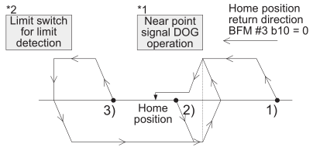
- The near point signal is turned off (before the DOG passes).
- The near point signal is turned on.
- The near point signal is turned off (after the DOG has passed).
For this operation, the limit switches for detecting the forward limit and the reverse limit should be provided on the PC.
When the limit switch for limit detection is actuated, the home position return operation is not performed even if the home position return operation is started. Move the dog by performing the JOG operation so that the limit switch for limit detection is not actuated, then start the home position returns operation.
*1. The example above shows the case where the BFM #3 b12 is set to 0 (DOG input polarity OFF→ON).
*2. When the limit switch for limit detection is turned on, the pulse output is immediately stopped (BFM #25 b3: ON). At this time, the clear signal is also output.

When the stepper motor is used
When the stepper motor is used, rigid attention should be paid to the following items.
- If the motor capacity is not sufficient compared with the load torque, the motor may stall. In such a case, even if the specified quantity of pulses are supplied the motor, the expected drive quantity may not be obtained.
- Start and stop the motor slowly enough (by setting a long acceleration/deceleration time to the BFM #15) so that the acceleration/ deceleration torque does not become excessive.
- A resonance point is present in low speed operation. It is recommended to avoid this point. Set the bias speed (BFM #6), and do not perform operation at a speed slower than that.
- An external power supply may be required for signal communication with the drive amplifier.

Single-Speed Positioning Operation
When the start command is given, the motor accelerates up to the operating speed V (I) (BFMs #20 and #19), then decelerates and stops in the set position P(I) (BFMs #18 and #17).
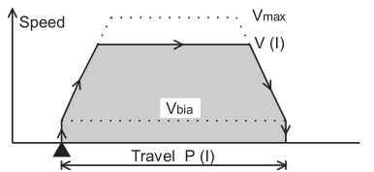

Interrupt Single-Speed Positioning Operation
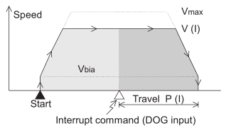
When the start command is received, the motor starts operation. When the INTERRUPT input is received, the motor moves by the specified distance, then stops (The relative travel exclusively can be specified.) The current value is cleared by the start command. The current value starts to change by the INTERRUPT input, and becomes equivalent to the set position when the operation is completed.

Two-Speed Positioning Operation
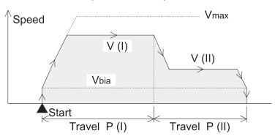
The motor performs the following operation by the two-speed positioning operation command. Approach at high speed as well as processing and moving forward at low speed can be performed. When the start command is received, the motor performs positioning at the operating speed V(I) (BFMs #20 and #19) until the set position P(I) (BFMs #18 and #17), then at the operating speed V(II) (BFMs #24 and #23) until the set position P(II) (BFMs #22 and #21) (two-step speed).

Variable Speed Operation
- When the operation command BFM #25 b12 is set to 1, the speed pulses specified in the BFMs (#20 and #19) are generated.
- This operating speed can be freely changed even while pulses are generated. However, acceleration and deceleration must be controlled by the PC.
- Only b0 (error reset) and b12 (variable speed operation) of the operation command BFM #29 are valid in this mode.
When b12 is set to 1, variable speed operation is performed.
When b12 is set to 0, pulse output is stopped.
- The pulse output does not stop even if “0” is written in BFM #21, #20
- As for the parameter BFM #3, only b1 and b0 (system of units) and b8 (pulse output format) are valid.
- The rotation direction (forward or reverse) can be specified by the sign (positive or negative) of the speed command (BFMs #20 and #19)
The procedure of changing the direction of the rotation
1) Turn OFF b12 of BFM #25.
2) Change the value at drive speed (BFM #20, BFM #19).
3) Again, turn ON b12 of BFM #25.

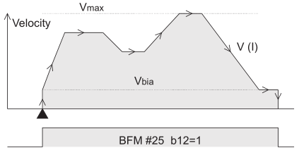

Common Matter for Operation Modes

Handling the stop command
In all operation modes, the stop command is valid at any time during operation. However, if a stop command is received during a positioning operation, the motor decelerates and stops. And after restarting, the motor doesn't travel by the remaining distance, but the next positioning operation.

About multiple commands
When the bits which determine operation modes such as b4, b5 and b8, b10 are turned on simultaneously in the operation command BFM #25, any operation is not executed. If other mode input is turned on while operation is being performed in any mode, such an input is neglected.

When travel time is small
When the travel time is small compared to the acceleration/deceleration time (Ta), the motor cannot realize specified speed.
- Single-speed positioning operation
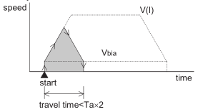

- Interrupt single operation
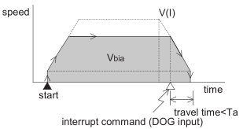

- Two-speed positioning operation
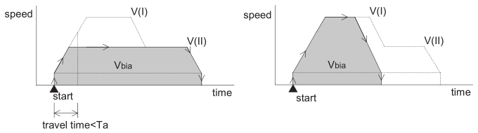

Connection of DOG and X Inputs and Handling of Limit Switches for Limit Detection
Various limit switch inputs are connected to the DOG input and the X input in accordance with the operation mode.
The polarity of these limit switch inputs is inverted by the state of the BFM #3 b12 and b6.
To assure safety, provide limit switches for detecting the forward and reverse limits on the servo amplifier also.
Make sure so that the limit switches on the PLC are actuated simultaneously with or a little earlier than the limit switches on the servo amplifier.
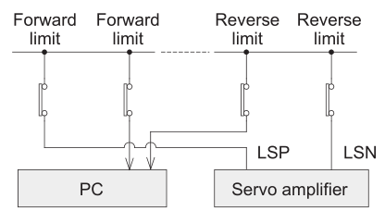
Because a drive amplifier for a stepper motor does not have these terminals, make sure to provide limit switches on the PLC.
Evade from the state of the pulse output stop by Jog in the opposite direction when forward pulse stop or reverse pulse stop is turned on.

Example
The reciprocation by single-speed positioning
Do not put the load on the motor for safety when you confirm the operation according to this program example.
- The position of the motor moves to the machine home position according to the home position return start instruction now. (Machine home position return operation) At this time, the machine home position address is assumed to be “0”.
- While the forward or reverse button is pressed and held, the motor is driven forward or in reverse. (Jog operation)
- The value of the motor advances 10000 mm according to the automatic drive start instruction.
- After wards, Y000 is turned on for two seconds as a stand by display stopping and at this time. Finally, the value of the motor retreats by 10000 mm. (Single-speed positioning operation)
Input |  | Output | 4PG terminals
X000: error reset | X005:JOG- operation | Y000: display | DOG: input return signal
X001: stop command | X006: start home return |  | FP: Pulse output to servo amplifier PP
X002: stop forward pulse | X007: Single-speed positioning operation |  | RP: pulse output direction
X003: stop reverse pulse
X004: JOG+ operation
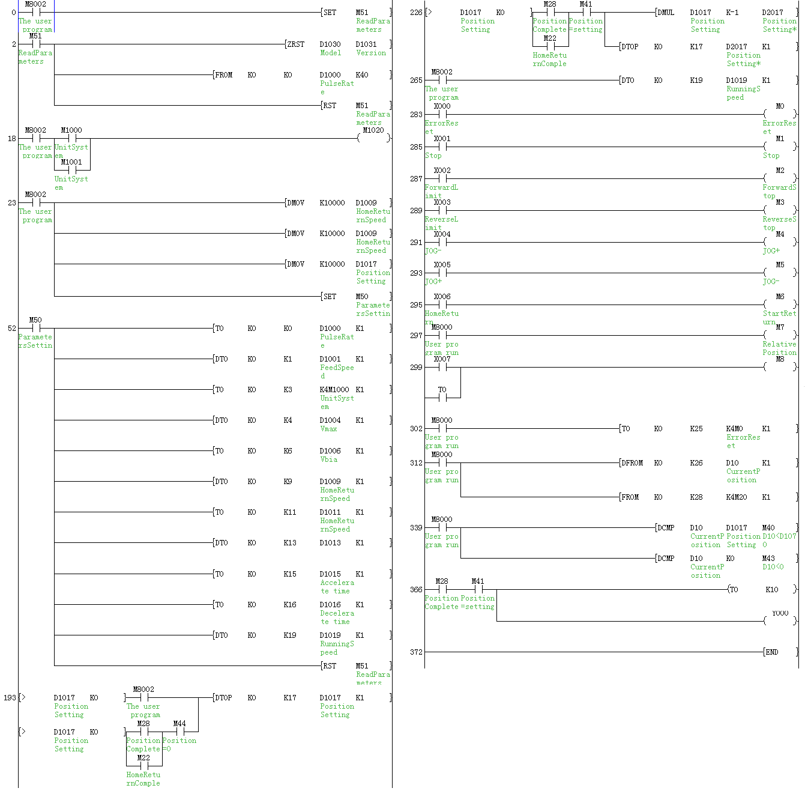

Diagnostic
Preliminary Checks and Error Indication
- To ensure correct operation
- Make sure that the PGU I/O wiring and the extension cable connections are correct.
Indicate clearly the special block No. on the panel face by adhering the labels offered as accessories.
- In any positioning operation, the specified data should be written preliminarily to the BFMs #0 to #24, then the BFM #25 should give an appropriate command. Otherwise, the PG does not function.

- Error indication
- LED indication
The PG panel has the following LEDs:
Power indication: The POWER LED is lighted when 5 V power is supplied from the PLC.
Input indication: When DOG or X is received by the PG, the corresponding LED is lighted respectively.
Output indication: When FP or RP is output by the PG, the corresponding LED is lighted respectively.
Error indication: When an error occurs, the ERR LED flashes.

- Error check
Errors are indicated by BFM#28 bit 7. Various errors can be checked by reading the contents of the BFM #29 to the PC.

